Sci 8 Workplace and Household Safety Name: __________________

- What does WHMIS stand for? _________________________________________________
- Name three differences between WHMIS and HHPS: _______________________________ __________________________________________________________________________
- For each WHIMS Symbol below, state the name of the symbol, describe what it means and what precautions (measures you should take to prevent dangers from happening) when using a product with that symbol:
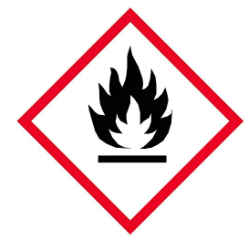 | Symbol Name:  Meaning/Warning:  Precaution:
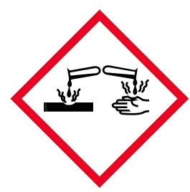 | Symbol Name:  Meaning:  Precaution:
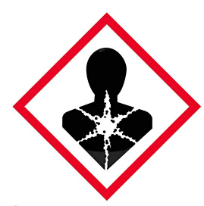 | Symbol Name:  Meaning:  Precaution:

Household Safety

- Many homes have hazardous materials. People often dispose of them by throwing them out in the regular garbage or down drains or toilets. What problems could happen with these practices? ____________________________________________________________ __________________________________________________________________________
- A product’s life cycle includes: making, distributing, selling, using and disposing of the product. Hazardous materials may be used and eventually become waste. Briefly describe THREE things that we can do to help prevent hazardous waste from entering the environment after we are done using the product. _________________________________ __________________________________________________________________________ __________________________________________________________________________

- What hazardous materials are in your home and where are they located? At home, find three products that have HHPS symbols on them and complete the chart. Some products may have more than one symbol. You can pick one as long as you list THREE different symbols.
Name of substance and its location in my home | Draw HHPS symbol | Precautions you should take

- Where were most of the hazardous materials located in your house? Explain why.

- Select two of the hazardous material identified in your home and propose a less hazardous alternative for each of the them. Clearly explain what makes your alternate choice less hazardous.
You are about to use a product that has this symbol on it:
- What does the symbol mean? ________________
- List some precautions should you take when handling the substance in the container. ____________________________________________ _________________________________________________________

