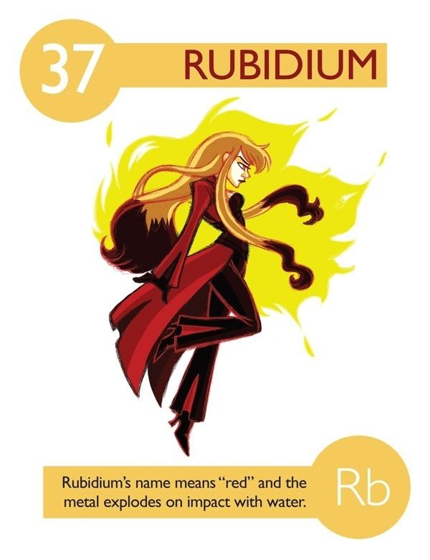
Element Superhero (or Villain) 33 pts
Protect our school! Byrne Creek Community School is under attack from a neighbouring school. The fate of the school is in the hands of this class of modern-day warrior.

Create an elemental superhero to protect the school (or villain attacking the school) from a list of common elements.

Your assignment should include:
ELEMENTAL INFORMATION: (10 PTS) In point form:
- Elemental name, symbol, atomic number, number of protons, electrons, neutrons (1 pt)
- Describe your element: characteristics/physical and chemical properties when in its natural state (eg. Metal, non-metal, metalloid, phase at room temperature, melting point, boiling point, density, colour, texture, hardness or softness, odour, reactivity, conductivity, ductility, etc) –minimum of 6 (3pt)
- What family is your element in (Nobel, halogen, etc)?
- What features define your element? (something unique about your element)
- Where it is commonly found in nature? (2pt)
- Can it be found pure or is it always in compounds?
- What types of compounds does it form?
- How can the element be isolated from its compounds?
- Importance: How is your element used today? What is the economic importance of the element in Canada or elsewhere in the world? Eg. superconductor, semi-conductor, jewelry, fertilizer, disinfectant, etc) (2 pts)
- Historical perspective (1pt)
    - Where/When/Who/How your element was discovered. This could be when your superhero was born, or when they got their powers—any important moment in that superhero’s life
PROFILE OF YOUR SUPERHERO (10pt) - Incorporate your element’s properties into a character. Paragraph form.
- Name your character (incorporate either element name or symbol AND Identify whether is it a hero or villain (1pt)
- List least three super powers and/or weaknesses based on element’s properties (3pt).
- Tell a story describing how your hero came to be (based on the elements history). (3pt) AND how/why your character uses the super powers when fighting opponents or protecting civilians. (3pt)
- Bonus if you include some of its main allies (elements with which it forms compounds) and enemies (elements which it cannot/hates forming compounds) – you may want to use the names of your friends’ heroes and villains.

IMAGE OF YOUR SUPERHERO (10pts)
  - On Standard sized (8.5x11), clean sheet of white paper.
  - Drawing should incorporate at least 2 of the characteristics/properties of your element. You will need to note the properties on the back of the drawing.
For example, if sulfur is your element, the superhero’s uniform or hair or skin, etc. could be yellow since sulfur has a characteristic yellow color. Bonus points for little details. (6pt)
  - Effort and good use of colour and space. (4pt)
  - You can either draw your image or use graphic design (Hero Machine 2.5 or Hero Machine 3.0 are useful resources)
  - Not copied from the internet

REFERENCES (3pt)
- You must include a WORKS CITED section
- Minimum of three sources (Print or Internet)
- Wiki is not a reliable source. Nor is prezi or weebly.

Begin by checking out www.periodicvideos.com to see short videos about different elements and its properties.

Bonus if you discuss what similarities your character shares with others in it’s “family”.

 | Emerging | Developing | Proficient | Extending
Communicating: Content | Much Content missing or incorrect | Some content present or some is incorrect. | All content is present and correct | All content is well explained and correct
Communicating: Organization and Neatness | Presentation is disorganized and/or difficult to read or understand | Most of presentation is organized and understandable | All content is organized and easy to understand | All content is well organized and easy to understand
Innovate | Image and story do not reflect element’s properties | Image and story mostly reflect element’s properties | Image and Story reflect elemental properties | Image and Story expertly reflect elemental properties

Please attach this sheet to the back of your project.
Character’s Name  Villain or Hero? |  | 1
Six super powers  - Six superpowers based on elements’ chemical and physical properties and description of how they are used. |  | 6
Superhero’s allies and enemies  - Other elements with which it forms compounds  - Elements with which it won’t form compounds |  | 2
Portrait  - A portrait that is clear, neat, and demonstrates properties of the element  - Good use of color and space |  | 3  2
Superhero’s story  - In complete sentences  - Incorporates element’s history and some characteristics |  | 5
Element Info (can be in point form)  - Elemental symbol, Atomic number, #protons, electrons, neutrons  - Family  - Characteristics (physical and chemical properties) of element  - Where it is commonly found in nature |  | 1  1  5  1
Overall creativity and effort |  | 4
References  - Cited  - Minimum of 3 reliable sources |  | 2
Total |  | 35

