Sci 9 Atomic Theory Practice Quiz
Atomic History: Who said what?
- Atoms cannot be created, destroyed, or divided into smaller particles.
- Electrons occupy specific energy levels or shells.
- Most of the mass of the atom is in the tiny, dense, positively charged nucleus.
- Most of the atom is empty space.
- All atoms of the same element are identical.
- Atoms contain negatively charged particles.
- Nucleus contains positive particles called protons and neutral particles called neutrons.
- Electrons move around a central nucleus

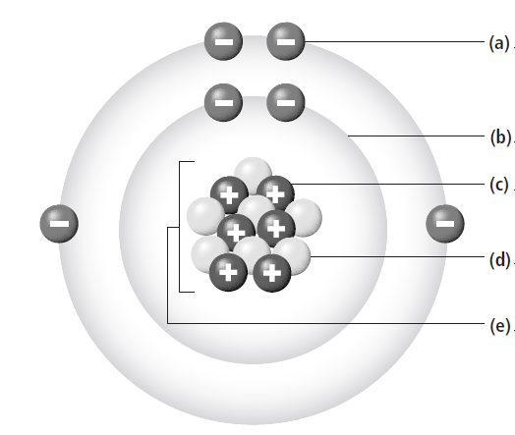
Label the parts of the atom:

How many protons, neutrons, and electrons does one atom of mercury (below) have?

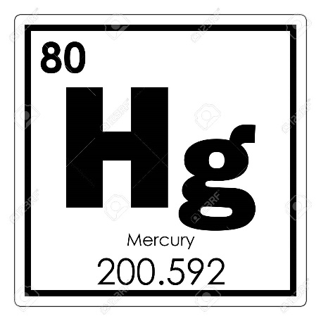
- What is the definition of an atom? __________________________________________________________
- What two things does a Bohr model show? _________________________________________________

- What subatomic particles make up the atom’s mass?

- What is the charge of an atom?

- What is the charge of an atom’s nucleus?

- What is the definition of a composite particle?

- Give two examples of composite particles.

- Give three examples of elementary particles.

