Moss and Fern Worksheet

- Mosses have adapted to life on land but share a lot of similarities with algae. What similarities do mosses share with algae?

- What adaptation do mosses have that enabled them to live on land?

- Ferns have some new adaptations different from mosses. List the three most important differences and what the advantages are.

- How does sporophyte generation of a fern differ from the sporophyte generation of a moss?

- What stage of a fern’s life cycle requires more water to survive? Why?

- Briefly describe the functions of the two main types of vascular tissues.

- Label the diagram of a fern’s life cycle below using the word bank.

Frond
Sorus
Mature Gametophyte
Sporophyte
Archegonium
Antheridium
Spores
Sporangium
Egg
Sperm
Rhizoids
Prothalium
Germinating spore
Zygote
New sporophyte
Spore dispersal

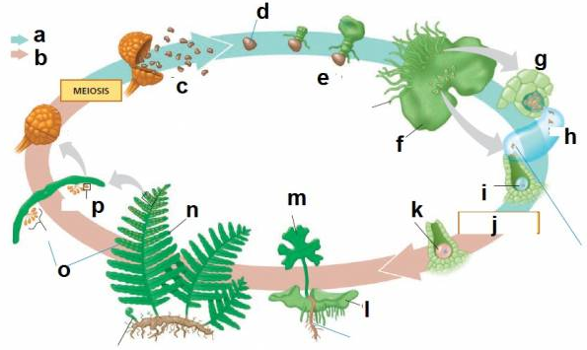

- Draw fern sporophyte. Label rhizome, roots, frond, and sori.

- What are two ways in which ferns are used by people?

Extra:
- Draw fern sporophyte. Label rhizome, roots, frond, and sori.
- Draw gametophyte. Lab prothallium, rhizoids, archegonia, and antheridia.

- What are the characteristics of club mosses, horsetails, and ferns?

