Sci 9 Abiotic Factors and Biomes WS Name:
- Which are the two most important abiotic factors affecting biomes?

- What other abiotic factors play a role in defining biomes?

The figure below shows biomes in relation to average annual precipitation and average annual temperature. Identify each biome using the chart below.
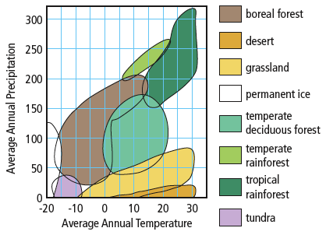
- Identify the biome that has an average annual precipitation of about 175 cm and an average annual temperature of 5C.

- Identify the biome(s) that ranges in temperature between 0 C and 20C and receives about 100cm rain.

- Identify the biome(s) that has low average annual precipitation and an average annual temperature that ranges between -18C and -8C.

- Identify the biome(s) that has high average annual precipitation and an average annual temperature of 15C.

Read pages 20-28 on biomes to answer questions 7 - 17
- List three characteristics of the tundra biome.

- List two characteristics of the boreal forest biome.

- Describe the plant life of a temperate rain forest.

- Identify the two types of grassland.

- Explain why grassland plains can survive drought and prairie fires.

- Which biome has the greatest variety of plant and animal species?

- Identify the two types of desert.

- Give two examples of desert pant adaptations.

- What limits the variety and numbers of living things that can survive in the permanent ice biome?

- Give two examples of animal adaptations for life in Antarctica.

