Bio 12 FEMALE REPRODUCTIVE SYSTEM
- Label the parts of the diagram
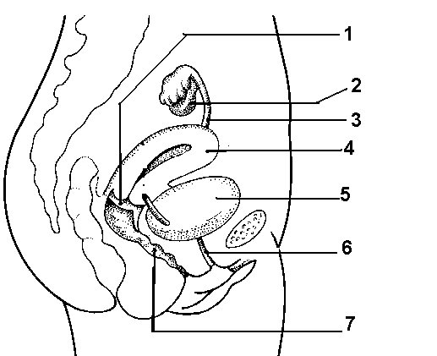
- Complete the chart of female reproductive organs and their functions
Organ |  | Function
Ovaries

Oviducts
 | Houses developing fetus
 | Contains opening of uterus
 | Receives penis during sexual intercourse, serves as birth canal and as the exit for menstrual flow

- Complete the chart of the Ovarian and Uterine Cycles (assuming 28 day cycle)
Ovarian cycle | Events | Uterine Cycle | Events
Days 1-13 | FSH secretion begins | Menstruation
 |  | Days 6-13 | Endometrium rebuilds
Day 14 | LH spike occurs
Days 15-28 |  | Secretory phase  Days

