Graphing Practice Name: ______________
Introduction
Line graphs compare two variables. Each variable is plotted along an axis. The independent variable (manipulated)
goes on the x-axis, the dependent or responding variable goes on the y-axis.
Line graphs are important in science for several reasons such as:
- showing specific values of data. If one variable is known, the other can be determined.
- showing trends and relationships in data clearly.
- they visibly depict how one variable is affected by the other as it increases or decreases.
- allowing the viewer to make predictions within recorded data, called interpolation, and to make predictions
- about data not yet recorded, called extrapolation.

Interpolation vs. Extrapolation
Determine which of the examples below is interpolation and which is extrapolation. Explain why.
1. The value of Sarah’s car in 2008 was $17,500. ______________________________________________________
2. The value of Sarah’s car in 2023 was $1,900. _______________________________________________________

How to Construct a Line Graph:
1. Identify the Variables & Label the Axes
a. Independent Variable – factor that is varied in an experiment and specifically controlled by the experimenter
i. Label along the x-axis (horizontal) – include units
ii. Typically found on the left side of a data table
b. Dependent Variable – factor that is measured in an experiment and will change as a result of the independent variable
i. Label along the y-axis (vertical) – include units
ii. Typically found on the right side of a data table
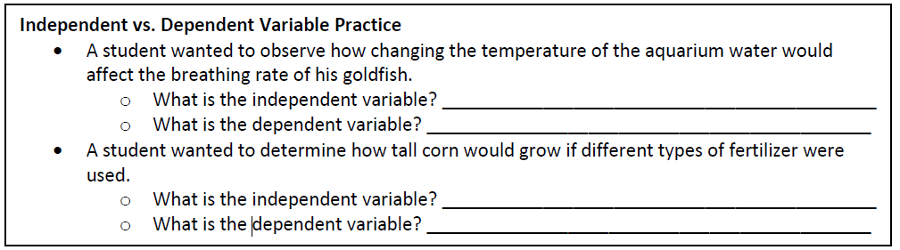
2. Determine the Graph Scale
a. Determine the magnitude (numeric value) of each variable
b. Establish a scale that best fits the range of each variable
c. Spread the graph to use the MOST available space (use at least ¾ of the graph)
d. Be consistent throughout each axes’ scale
3. Plot the data points
a. Plot each data value on the graph with a dot
b. If multiple sets of data are being plotted, use different colored lines and include a key

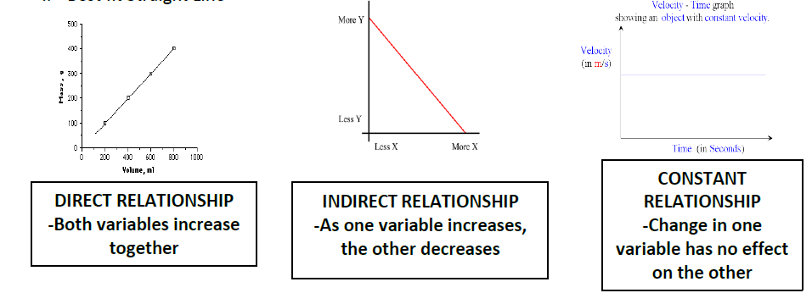
Relationships:

Graphing Practice
Background: The thickness of the annual rings indicates what type of environmental situation was occurring the
time of the tree’s development. A thin ring usually indicates a rough period of development such as lack of water,
forest fires, or insect infestation. On the other hand, a thick ring means a prosperous period of development. Use
the information from the data table below to create a proper scientific graph and to answer the corresponding
questions.
Age of Trees (in years) | Average Thickness of Annual Rings in Forest A (millimeters) | Average Thickness of Annual Rings in Forest B (millimeters)
10 | 20 | 24
20 | 24 | 28
30 | 30 | 35
35 | 34 | 38
50 | 41 | 45
60 | 46 | 51

1. What is the dependent variable? ________________________________________________________________
2. What is the independent variable? _______________________________________________________________
3. What was the average thickness of annual rings for 40 year old trees in Forest A? _________________________
4. What is it called when you make predictions within given data, such as made in question #3? ________________
5. What was the mean thickness of annual rings for all trees found in Forest B? _____________________________
6. Based on the data shown, what can be concluded about the comparative health of Forest A & B? ____________ ___________________________________________________________________________________________
7. What type of relationship (constant, direct, or indirect) exists between the age of trees and the average thickness
of the tree’s rings? Explain. ____________________________________________________________ ___________________________________________________________________________________________

Title: __________________________________________________________________________
