Sci 8 States of Matter Name: _____________
Block: ______________
- What is Kinetic Energy?
Energy of Motion
- What are the three main points of the Kinetic Molecular Theory?
- All matter is made up of particles
- There is space between the particles
- The particles are in constant motion (interacting with each other)

- Complete the chart below describing states of matter:
 | Solid | Liquid | Gas
Shape | Fixed, does not change | Not fixed,  Takes shape of container, dependent on gravity | Not fixed  Takes the shape of the container, not gravity dependent
Volume | fixed | Fixed volume | Not fixed, will expand to fit the container
Space between particles | Tightly packed | More space | Lots of space
Attractive forces between particles | strong | moderate | weak
Arrangement of particles | Tightly packed | Randomly arranged  Particles are touching, but able to move past one another
Movement of particles | Can only vibrate | Can slide past each other. | Can move freely and quickly in all directions in the container
Example | Rock | Milk | Helium gas from a balloon
Draw a picture of the particles

Changes of State
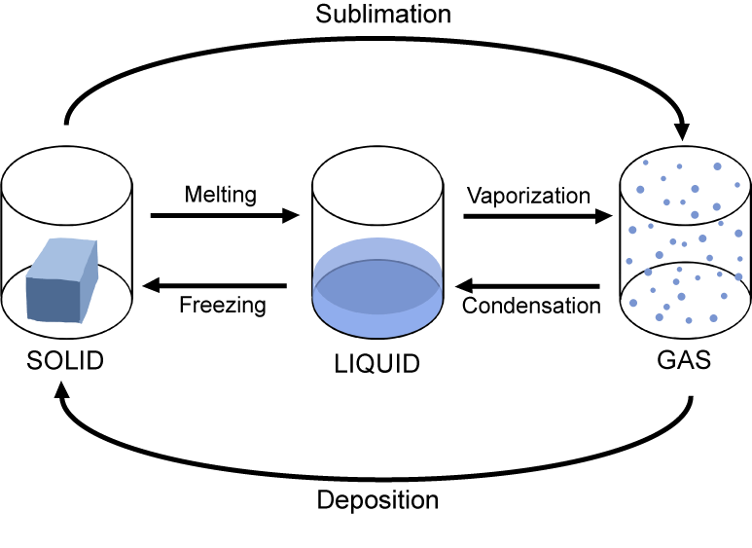
- Label the diagram below using the following terms: condensation, deposition, vaporization, melting , freezing, and sublimation.

- Complete the following table by indicating the initial and final states of matter and whether kinetic energy is added or removed. Give an example of each of the changes of state.
State Change | State of Matter |  | Kinetic Energy Added or Removed | Example
 | Initial State | Final State
Melting | Solid | Liquid | Added
Freezing | Liquid | Solid | Removed | Candle wax drips hardening
Deposition | Gas | Solid | Removed | Frost forming on car windshield
Sublimation | Solid | Gas | Added | Dry ice
Vaporization | Liquid | Gas | Added | steam
Condensation | Gas | Liquid | Removed | Water droplets form on a bathroom mirror after a hot shower

