Sci 8 Name:
Thermal Expansion Worksheet Block:
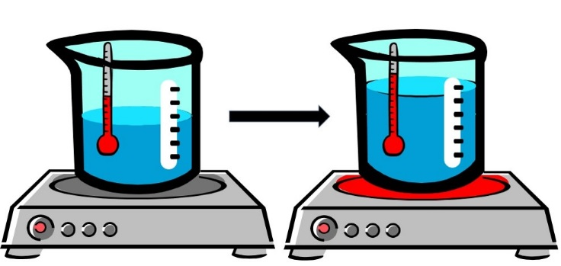

- In your own words, define the term thermal expansion.
Thermal Expansion is when a substance increases in volume when heated due to particles moving farther away from each other.
- In terms of SPACING and ENERGY, describe what’s happening to the air particles inside a hot air balloon that enables it to rise.
When air particles inside the balloon are heated, they have more energy and move farther away from each other, expanding the volume of the balloon. The air inside the balloon become less dense (less particles) compared to surrounding air. When objects are less dense than surrounding they float, even in air.
- Why does running a jar under hot water make it easier to open?
Hot water heats up the particles in the lid, causing them to more farther apart, expanding the entire lid, making it loose.
- The Eiffel Tower in Paris is 324 meters tall. Would you expect it to be taller or shorter on a hot day?
Taller, due to thermal expansion.
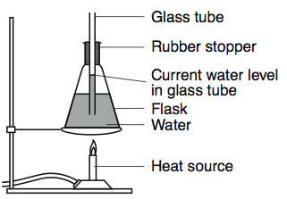 | - If the flask on the left were heated, what evidence would indicate the water expands?  Explain your answer using KMT.  The water level in the tube will rise because the water particles will have more energy and will move farther apart.
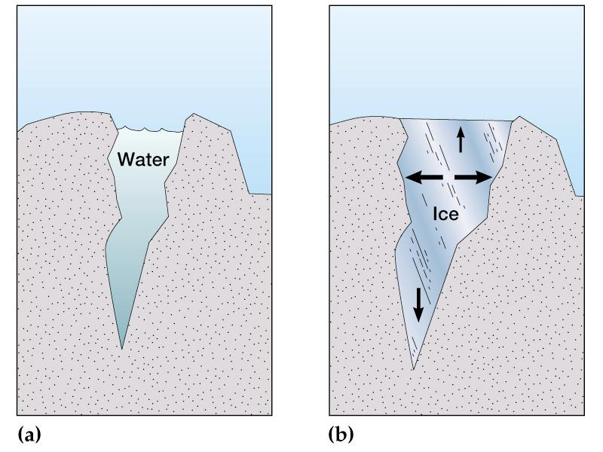 | - Explain using the word volume, how a small amount of water can break rock over time.  Water is unique in that it is the only substance that INCREASES in volume when it freezes. So when a little bit of water enters a crack and then freezes, the increased volume of the ice can push apart the rock, allowing more water to trickle in next time. The cycle will repeat itself with each freeze/thaw.
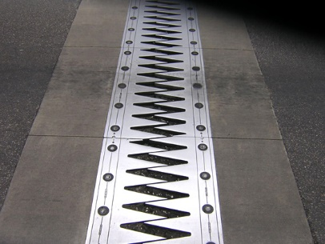 | - What structure is this and why is it important for bridges?  This is an expansion joint which allows large structures like bridges to expand on a hot day and not buckle or crack.

- Water on Earth is constantly being cycled from water vapor in the atmosphere which then falls down as precipitation, collecting in rivers, lakes and oceans and then evaporating back up to the atmosphere again. A significant amount water in the form of ice and snow in the polar ice caps remain frozen year round. What would happen to the ocean levels if these stored sources of water were to melt?
Ocean levels would rise a few feet, causing problems for coast cities.

- The average elevation of most areas of New Orleans is 1-2 feet below sea level. Parts of Richmond are at 0 m above sea level. These cities must maintain dykes and levees (embankments) to prevent flooding. What might happen to these cities if the ocean levels rise a few feet?
They might flood.

