Part 1: HISTOLOGICAL CLASSIFICATION OF TUMOURS

Review the following information on how benign and malignant tumours are named according to the tissue or cell types affected, and answer the questions included in this section.

Benign and malignant tumours are generally named according to the tissues and cells from which they arise.

Benign tumours are named according the tissue prefix and the suffix “-oma”.

Naming malignant tumours is more specific. Malignant tumours of epithelial tissues are called carcinomas. Malignant tumours of connective tissue (connective tissue proper, muscle, bone) have the suffix “-sarcoma”.

Tumours that form in lymph nodes and bone marrow are always malignant. Malignant tumours of lymphatic tissue are called lymphomas. Malignant tumours of blood-forming cells in bone marrow are called leukemias. Malignant tumours of plasma cells (antibody producing cells) are specifically called multiple myeloma.

Table 1: Nomenclature for Benign and Malignant Tumours

Tissue Type | Cell Type | Benign | Malignant
Epithelial tissue |  | tissue prefix + -‘oma’ | carcinoma
Surface Epithelia | squamous cells | papilloma | squamous cell carcinoma
 | basal cells | papilloma | basal cell carcinoma
 | melanocytes |  | malignant melanoma
 | blood vessel endothelium | hemangioma | hemangiosarcoma
 | lymph vessel endothelium | lymphangioma | lymphangiosarcoma
 | choroid plexus | choroid plexus papilloma | choroid plexus carcinoma
Glandular Epithelia |  | adenoma | adenocarcinoma
Connective tissue |  | tissue prefix + ‘oma’ | tissue prefix + ‘sarcoma’
 | adipose tissue | lipoma | liposarcoma
 | fibrous connective tissue | fibroma | fibrosarcoma
 | cartilage | chondroma | chrondosarcoma
 | bone | osteoma | osteosarcoma
 | meninges | meningioma | meningeal sarcoma
Nervous tissue | nerve cells | neuroma | neuroblastoma
 | Schwann cells | Schwannoma | malignant Schwannoma
 | astrocytes | glioma | astrocytoma
 | oligodendrocytes | glioma | oligodendroglioma
Muscle tissue | smooth | leiomyoma | leiomyosarcoma
 | skeletal | rhabdomyoma | rhabdomyosarcoma

- Which of the following describes a benign tumour involving the epithelial surface of the esophagus?

  - lipoma
  - adenoma
  - glioma
  - squamous cell carcinoma
  - papilloma

- A 14-year-old boy died of osteosarcoma that had metastasized to the lungs. Where did this tumour most likely arise?

  - bone tissue
  - cartilage
  - skeletal muscle
  - glandular epithelium
  - adipose tissue

- What is a uterine leiomyosarcoma?

  - benign tumour of the uterine epithelium
  - benign tumour of uterine glands
  - malignant tumour of uterine glands
  - malignant tumour of smooth muscle of the uterine wall
  - malignant tumour of skeletal muscle of the uterine wall

- Which of the following describes a malignant tumour that has originated in the glandular tissue of the pancreas?

  - adenoma
  - fibrosarcoma
  - astrocytoma
  - hemangiosarcoma
  - adenocarcinoma

- A patient is diagnosed with lymphoma. This patient’s tumour:

  - contains fat cells.
  - is benign.
  - is malignant.
  - is located in the brain.
  - originates in the bone marrow.

Part 2: TUMOUR GRADING AND STAGING

Grading: reflects the degree of differentiation in the tumour cells. High-grade tumours are poorly differentiated and more aggressive than low-grade tumours.
- 1, 2, 3, or 4, depending on the amount of abnormality.
- Grade 1 tumors, cells and the organization appear close to normal. These tumors tend to grow and spread slowly. In contrast, the cells and tissue of
- Grade 3 and Grade 4 tumors do not look like normal cells and tissue. Grow rapidly and spread faster than tumors with a lower grade.
Grading an Unspecified tumor:
- GX: Grade cannot be assessed (undetermined grade)
- G1: Well differentiated (low grade)
- G2: Moderately differentiated (intermediate grade)
- G3: Poorly differentiated (high grade)
- G4: undifferentiated (high grade)

Staging: reflects the size of the primary tumour and the extent of local and distant spread. The TNM classification is commonly used:
- T = tumour size and local invasion; T0 = carcinoma in situ (no local invasion), followed by T1-T4
- N = regional lymph node involvement; N0 = no nodes, following by N1-N3 in increasing number of nodes
- M = distant metastases; M0 = no metastasis, follow by M1 for metastasis

- Jake has a grade I tumour of the lung. Tom has a grade IV tumour of the lung. Compared to Jake, Tom’s tumour:

  - contains more cells that resemble the tissue of origin.
  - contains more cells that vary in size and shape.
  - is benign.
  - is well differentiated.
  - is slower growing.

- Sophie is scheduled for a staging procedure. She wants to know what that means. Which response is correct?

  - It is a histologic examination to determine the degree of tumour differentiation.
  - It involves the surgical removal of all tumour cells.
  - It is used to determine the genetic basis of the tumour.
  - It is a procedure for determining the extent of tumour spread.
  - It is a procedure for locating the tissue of origin of the tumour.

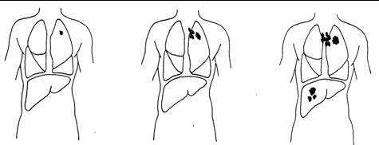
- The above image shows 3 different stages of lung cancer. Which image best indicates T₃N₂M₁?

  - The image on the left.
  - The centre image.
  - The image on the right.

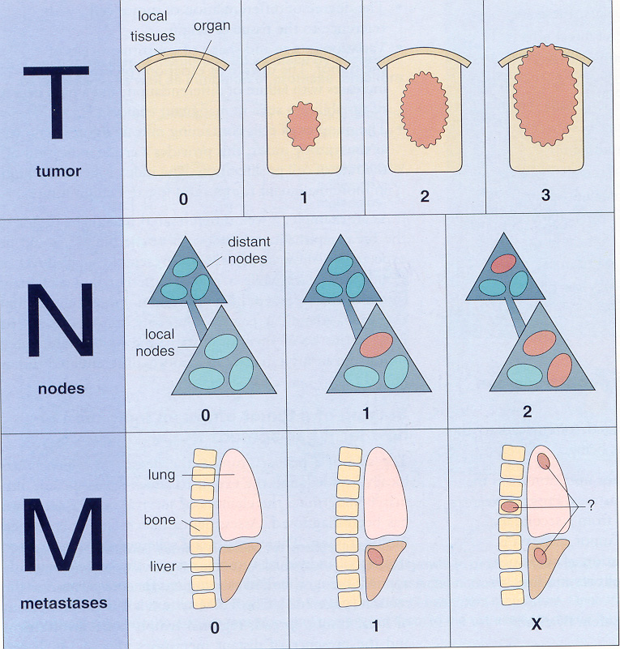
TNM system – breast tumours:

T₀ = no tumour in breast
T₁ = lesion < 2 cm in size
T₂ = lesion 2-5 cm in size
T₃ = skin and/or chest wall invaded

N₀ = no local (axillary) nodes involved
N₁ = local nodes involved
N₂ = distant nodes involved

M₀ = no metastases
M₁ = metastases detected

- Review the TNM system above that is used to stage breast tumours. What is the stage for a tumour that is 2.5 cm in diameter, which has spread to a local lymph node, but not to distant sites?

  - T₀N₀M₀
  - T₁N₀M₀
  - T₂N₀M₀
  - T₂N₁M₀
  - T₂N₂M₁

Part 3: CARCINOGENESIS

View the online recording and read the sections of the text titled “Carcinogenesis” (pages 556 – 557) and “Carcinoma of the Cervix” (pages 537 – 538).

- Which of the following is NOT a carcinogen?

  - cigarette smoke
  - radon
  - hepatitis B virus
  - radiation from power lines
  - asbestos

- Carcinogenesis is the process in which normal cells become cancer cells. In the process of carcinogenesis, the carcinogen that causes the first permanent genetic change in cells is called:

  - a promoter.
  - an initiating factor.

- Which of the following is the most common route of exposure to carcinogens?

  - inhalation
  - swallowing
  - injection
  - absorption through the skin

- Nitrites in preserved foods can be converted to carcinogenic nitrosamines following ingestion. Where is the most likely site of action of nitrosamines in tumour development?

  - airways
  - liver
  - pancreas
  - bladder
  - stomach

- Which of the following is a carcinogen found on stored grains and peanuts that is metabolized by the liver and is associated with liver cancer?

  - radon
  - acetaldehyde
  - aflatoxin
  - hydrocarbons
  - aniline dyes

- Radon produced by the decay of uranium naturally found in the ground, soil and water is associated with which of the following cancers?

  - lung cancer
  - thyroid cancer
  - leukemia
  - skin cancer
  - cervical cancer

- The human papilloma virus (HPV) types 16 and 18:

  - cause testicular cancer in men.
  - cause mutations in tumour suppressor genes.
  - release chemical carcinogens during infection.
  - are transmitted by unprotected sexual intercourse.
  - cause cervical cancer in the majority of infected women.

- Mary receives the results from a recent pap smear and is told that she has severe cervical dysplasia. Her doctor indicates that it is graded as CIN III. What does this grading system indicate?

  - Mary has disorganized cervical cells that are well-differentiated.
  - Mary has cervical carcinoma in situ.
  - Mary has cervical carcinoma that has infiltrated the wall of the cervix.
  - Mary has cervical carcinoma that has spread to the uterus.
  - Mary has cervical carcinoma that has spread to distant organs.

- Cervical carcinoma:

  - is asymptomatic.
  - occurs within 5 years of an HPV infection.
  - occurs if the immune response is ineffective in clearing a cervical HPV infection.
  - is most commonly treated using chemotherapy.
  - has a poor prognosis if in situ.

