Water
- Most abundant and important molecule in living organisms,
- About ______________ of our total body weight.
- Important for ______________________________________ and overall cell health.
- We lose from 4-9 cups of water each daily from ________________________________.
- We have adaptations for __________________ water levels.
- Regulated by ____________________________________________________________.
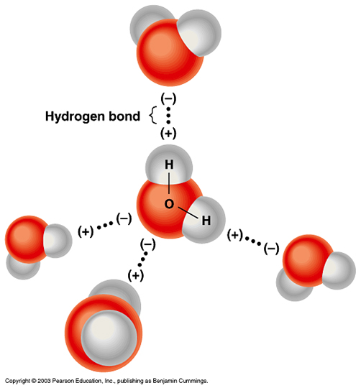
Water is ________________bonded
- electrons are shared _______________.
- covalent bonds are ___________than ionic or hydrogen bonds.
Water is a ____________Molecule
- ________spend more time orbiting around the larger oxygen atom rather than the smaller hydrogen atom.
- hydrogen atoms have a partial ___________charge and the oxygen a partial _______________ charge.
Water forms ________________ Bonds
- partially positive H is attracted to a partially negative oxygen.
- represented by a _________________ because it is _______________________.

Ted Ed video on polarity of water:
http://ed.ted.com/lessons/how-polarity-makes-water-behave-strangely-christina-kleinberg
Many of water’s unique properties are due to its polarity and hydrogen bonding:

Unique Properties of Water:
- Water is a _______________ because it can dissolve both _______________ molecules.
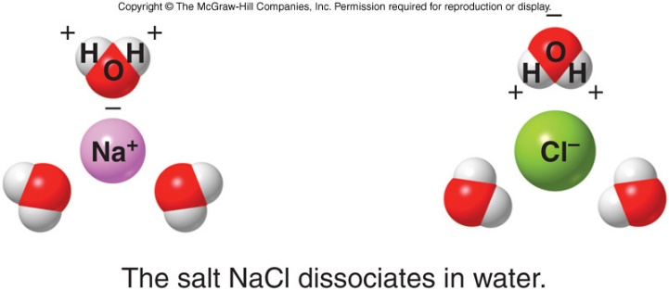
eg When a salt like NaCl is put into water, the negative ends of the water molecules are attracted to the Na+ and the positive ends of the water molecules are attracted to the Cl-, causing the salt’s ions to ____________ and the salt _____________in the water.
- Molecules that interact with water are ________________.
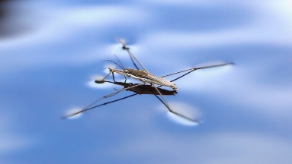
- Molecules that do not interact with water are ______________.
- Water has high ________________. Water molecules cling to each other yet flow freely, making it an excellent transport system inside and outside the cell.
- The _______________of water rises and falls __________, preventing sudden or drastic changes, allowing us to maintain a relatively _________________________________.
Water has a low freezing point and high boiling point so that it is liquid at body temperature.
- Water has a high heat of ____________________:
  - efficient way to release _______________. When we sweat, body heat vaporizing the sweat, cooling the body as sweat evaporates.
  - keeping the body from _________________.
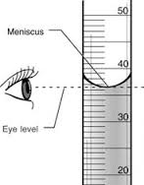
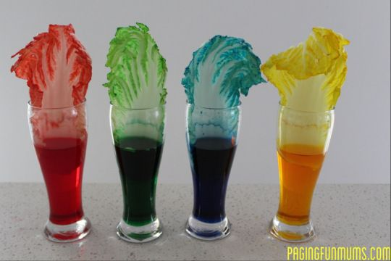
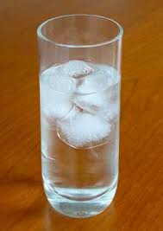
- Frozen water is _____________ than liquid water so that ice ________ on water.

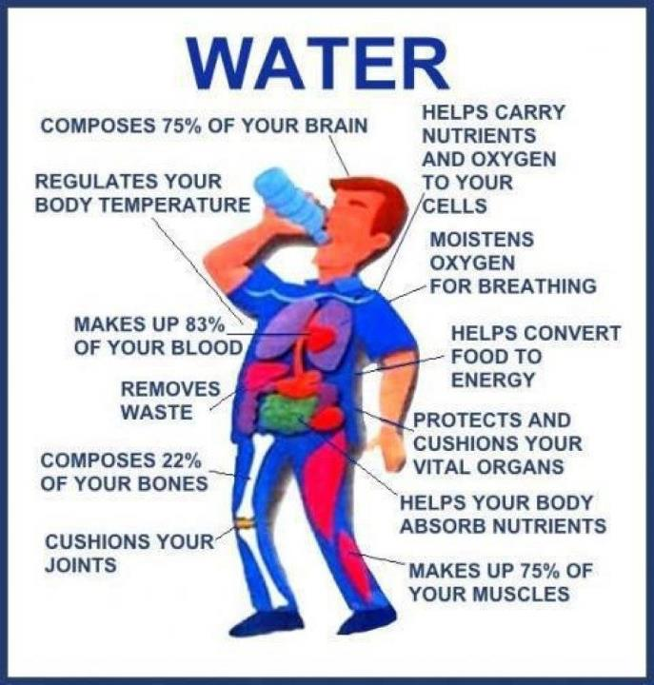
Benefits of Water
- Only substances dissolved in water _____________________________ of our cells (glucose, amino acids)
- _________________________ from our cells and wastes excreted in liquid (sweat, urine).
- ______are necessary for many body processes (Ca²⁺ for movement, Na+, K+ for generation of nerve impulses).
- High surface tension of water and water-based solution act as ______________. (Joints are lubricated by synovial fluid)
- Water ________________. Water doesn’t heat up or cool down as easily as most other substances. Enabling us to maintain a relatively ______________internal temperature.
- Our brains are partially _______________________ by layer of cerebral spinal fluid.
- _____________________ require water:
  - eyes are filled with vitreous humour, hearing depends on fluid-filled cochlea to detect and transmit vibrations.
- Hydrolytic enzymes in our bodies require water to function.

How is Water regulated?
- When the ______ detects too little water in our blood, it signals _________ to remove less water from the blood. We pee less, our urine is more ___________________ and ____________ in color.
- The brain tells us we are thirsty. We drink. Water levels return to normal.
- When our ___________________ either from fever, working out, or being in a warm environment, our bodies sweat. When sweat ___________ from our skin, it takes some heat with it, helping to _____________us off.
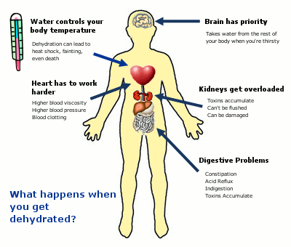
Dehydration:
- blood volume _________which lowers our blood pressure and heart rate, causing our hearts to ___________, headaches, dizziness.
Too Much Water:
- _____________________ to keep up
- ___________________ which can impair brain activity.
- healthy kidney can excrete _____________________________.

Can that really happen?
In 2007, a 28-year-old California woman died after competing in a radio station's on-air water-drinking contest. After downing some six liters of water in three hours in the "Hold Your Wee for a Wii" contest, she vomited, went home with a splitting headache, and died from water intoxication.
Club-goers taking MDMA (ecstasy) have died after consuming copious amounts of water trying to rehydrate following long nights of dancing and sweating.
A 2005 study in the New England Journal of Medicine found that close to one sixth of marathon runners develop some degree of hyponatremia, or dilution of the blood caused by drinking too much water.
Drink when you are thirsty.

Water Questions
- How is water important to living organisms?
- How is water regulated in our bodies?
- What is a covalent bond?
- Why is water called a polar molecule?
- Describe how a hydrogen bond is formed.
- List 5 unique properties of water.
- List 5 ways our bodies benefit from water.
- List 3 things that can happen when we are dehydrated.
- How much water would you have to drink to get water toxicity?

