Name:______________________

**Scientific Method**

The **Scientific Method** is a **process** that scientists follow in order to answer **Questions** about the world around us

Big Deal. WHY should I follow this method?

1. It ensures your experiment will actually answer your question.
2. It shows the world how you obtained your results.
3. It allows other scientists to recreate your experiment to support/disprove your conclusions.
4. It allows other scientists to build and extend on your research. 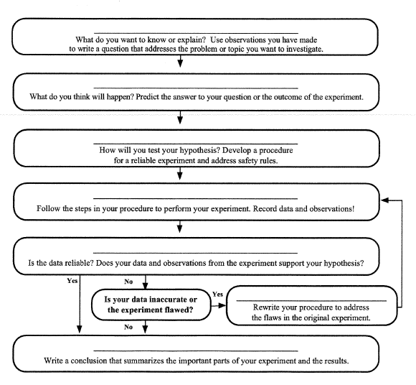

**How is it done?**

