Sci 9 Biomagnification Activity Name:

Introduction:
Polychlorinated biphenyls (PCBs) are highly toxic industrial compounds used around the world since the 1930s and were finally banned in 1970s and 1980s in several countries. But they are still around because they decompose very slowly and accumulate in the fatty tissues of living animals. PCBs absorbed by smaller animals get progressively more concentrated the higher up the food chain.
Orcas are an apex predator—they sit at the top of the food web. They eat fish, seals, sea lions, sharks, or whales, and have no natural predators. They have been shown to have the highest levels of PCBs in their systems.
Studies have shown that animals with PCB levels as low as 50 milligrams per kilo of tissue may show signs of infertility and severe impacts on the immune system. Researchers have measured values as high as 1300 milligrams per kilo in the fatty tissue (blubber) of killer whales. Research indicates the current concentrations of PCBs could lead to the disappearance of half of the world's populations of killer whales from the most heavily contaminated areas within a period of just 30 to 50 years. Moreover, PCBs are passed down to orca offspring through the mother's fat-rich milk.

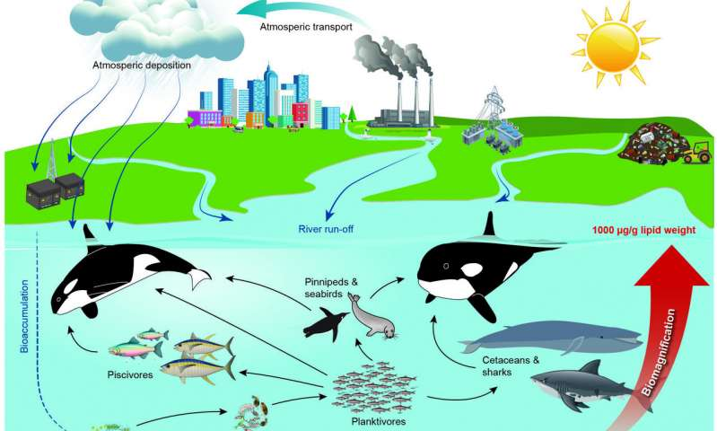

Materials:
- Name tags: Krill (x15), Minnow (x9), Salmon (x4), Orca (1)
- White and black beans as “phytoplankton”
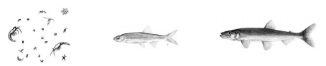
- Cups (x30)

What to do:
Round 1:
- Krill, simulate feeding on phytoplankton (beans) by gathering the ‘food’ distributed in the classroom. Put your collected ‘food’ in the container provided. You have 45 seconds to ‘feed’.
- Count the number of white and black beans. Record your results on the board.
- The calories gained from phytoplankton is used for growth and energy. Krill count beans eaten, remove 90% of white beans. Black beans remain in fatty tissues (cups) of the krill.
Round 2:
- Minnows enter the food chain and feed on krill by tapping the prey on the elbow and obtaining all the ‘food’ from the prey. If they prey is eaten, they must sit down this round as they are dead.
- Minnows count the white and black beans, record results on board, remove 90%.

Round 3:
- Previously eaten krill restart.
- Minnows continue feeding as before.
- Salmon enter the food chain and feed on minnows by tapping them on the elbow and dumping contents into their cups.
- Salmon count white and black beans and record results on board.
- Survivors remove 90% of white beans.
Round 4:
- Previously eaten organisms restart. Salmon continue feeding.
- Orca feeds on salmon by tapping them on the elbows and taking the contents of their cups.
- After 45 seconds, orca counts white and black beans, record on board.
- Copy the results from the board into the chart below.
 |  | White beans | Black Beans | Percent | Health
Round 1 | Krill
Round 2 | Minnows
Round 3 | Salmon
Round 4 | Orca

- Complete the “Percent” column of the chart by dividing the number of black beans by the total number of beans for each round.
- Determine the “Health” of the group in each round: If an organism has between 0-29 % black beans, it is considered healthy, 30-49 % Sick, > 50% black beans it should be Dead.
Questions
- What is the difference between bioaccumulation and biomagnification? (Notes)

- Some orcas eat mostly sealions and large fish such as tuna and sharks whereas some eat mostly salmon. Which of these populations would you expect to have the highest PCB concentrations? Why?

- What do you think would happen to an orca population whose PCB levels remained at 50 mg/kg of tissue? (Hint: read the intro again).

- Besides PCBs, another common toxin that builds up over time is mercury (Using the scenario from the activity, answer the following questions:
  - Who would have a greater concentration of mercury in their body – A person eating fish daily? A person who eats fish weekly? A person who eats fish only every now and then? Why?

  - If one does enjoy fish, why is it recommended that you eat salmon, sardines, and smelt, but not swordfish, pickerel or tuna? (Hint: look at what each of those fish eat)

Critical Thinking
- DDT, a popular crop pesticide, was banned in many countries due to its persistence in the environment and detrimental effects on wildlife and humans. DDT is effective against mosquitoes that carry malaria. Over one million people die from malaria each year. Do you think the use of DDT should be reinstated in countries where malaria is prevalent? Justify your answer.

