Venn Diagram Comparing Animal and Plant Cells Name:
Date:
Block:

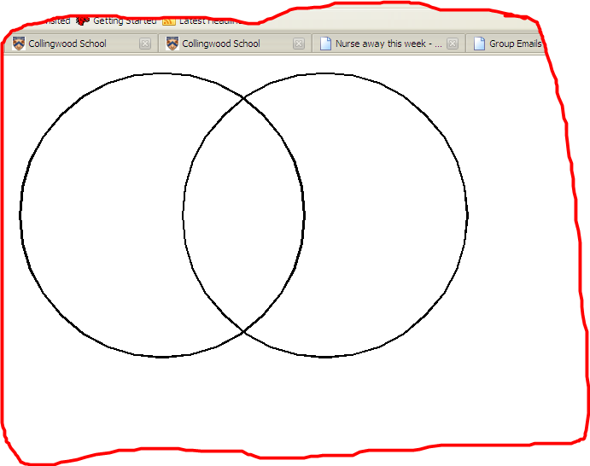
Animal Cells Both Plant Cells

Venn Diagram Comparing Prokaryotic and Eukaryotic Cells

Prokaryotic Cells Both Eukaryotic Cells

