Oreo Cookies and Plate Tectonics Name:____________
The Theory of Plate tectonics suggests that large features on Earth’s surface, such as Volcanoes, mountain ranges, Ocean Trenches result from interactions along the edges of large plates of Earth’s outer shell. This outer shell is called the lithosphere from the Greek “lithos,” meaning hard rock. The plates, composed of Earth’s crust and uppermost mantle, ride on a warmer, softer layer of the mantle, called the asthenosphere. In our experiment, the upper cookie will represent the lithosphere, the creamy filling the asthenosphere, and the lower cookie the lower mantle. The lower cookie is the mesosphere, a solid, rigid part of the Earth's mantle below the asthenosphere, but above the outer core.
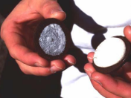
Plates move in three basic ways. Let’s look at them one by one.
Choose a cookie. Don’t eat it…yet!
Divergent Boundary
- First, carefully remove the upper cookie (a “twisting” motion is required).
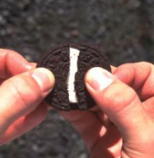
- Slide the upper cookie over the creamy filling. This motion simulates the movement of a rigid lithospheric plate over the softer asthenosphere.
- Next, break the upper cookie in half. As you do so, listen to the sound it makes. What sound do you hear? What does that breaking represent?
- Now push down on the two broken cookie halves and slide them apart. What happens to the creamy filling?

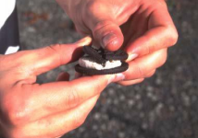
Convergent Boundary
- Take the two cookie halves and slowly push them toward each other. What happens to the filling as the plates slide together? What happens to the cookies as they push against each other?
- Gently push one half of the top cookie layer under the other. What type of convergent boundary does this represent?

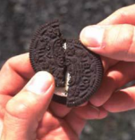
Transform Boundary
- Try sliding the two cookie pieces laterally past one another, over the creamy filling. What do you notice about the cookie edges? Do the “plates” slide past each other easily? What do you feel and hear? What does this represent?
- Some of Earth’s landforms are created by hotspots where a plate rides over a fixed “plume” of hot mantle, creating a line of volcanoes. Imagine if a piece of hot, glowing coal were imbedded in the creamy filling – a chain of “volcanoes” would be burned into the overriding cookie.

Convergent Boundary
- If time, simulate another convergent boundary where neither half “subducts”. You may need to quickly dip the straight edges of the two top halves in water to soften the edges. Replace them onto the creamy layer and gently push them towards each other. You should see some softened cookie bunching up. What land structure would this represent in real life if two plates were colliding but neither subducting?
- Clean up. Answer and hand in the question sheet. Return the procedure sheet to the teacher.
https://www.youtube.com/watch?v=dR4-n9XKNSY

Oreo Cookies and Plate Tectonics Name:____________
- Sliding the top cookie layer over the filling simulated the movements of a rigid _______________ plate over the softer __________________.

- When you broke the top half in two, what did it sound like? Relate this to the Earth’s Crust.

- What does divergent mean?

- What happens to the creamy filling when you pushed the two top halves together?

- What does convergent mean?

- What is it called when one plate moves under another?

- True or False: Transform Boundaries cause many mountain ranges.

- Label the cookie diagram:
- Complete the Chart:
Boundary Type | Draw what the Oreo looked like | Movement of the plates (Directions) | Resulting Landforms or Geological Activity
Divergent
Convergent:
Continent – Oceanic
Convergent:
Continent – Continent
Transform

