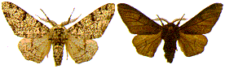
Peppered Moth Simulation
Objective: Simulate changes in moth population due to pollution and predation, and observe how species can change over time.

Introduction: Charles Darwin accumulated a tremendous collection of facts to support the theory of evolution by natural selection. One of his difficulties in demonstrating the theory, however, was the lack of an example of evolution over a short period of time, which could be observed as it was taking place in nature. Although Darwin was unaware of it, remarkable examples of evolution, which might have helped to persuade people of his theory, were in the countryside of his native England. One such example is the evolution of the peppered moth Biston betularia.
Go to https://askabiologist.asu.edu/peppered-moths-game/
There are four sections you can read to learn more about the peppered moth: “Peppered Moth”, “Natural Selection”, and “Dr. Kettlewell”. If you need it, there is a link to learn “How to Play” the game as well.
Choose “Play”.

Part A – Simulation

1. What is the independent variable you will be testing in this simulation?

2. What role are you playing in the environment?
You will have one minute to eat as many moths as you can. You will need to run your simulation at least twice for each environment (light forest and dark forest). Record your percentages on the following table.
 | Number of Peppered Moths Eaten | Population Percent of Dark Moths | Population Percent of Light Moths
Light forest - trial 1
Light forest - trial 2
Dark forest - trial 1
Dark forest - trial 2
Post simulation questions
1. Explain how the color of the moths increases or decreases their chances of survival.

2. Explain the concept of "natural selection" using your moths as an example.

3. Predict what would happen if there were no predators in the forest? Would the colors of the moths change over time? Defend your answer.

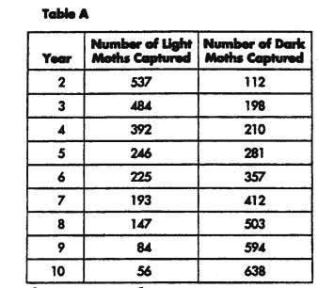
Part B: Data & Analysis – Create a graph from given data.
The following table contains data from a 10-year study of two varieties of the same species of peppered moth. The numbers represent moths captured in each of 20 consecutive years. The traps were in the same area each year.
Use the data provided in Table A to construct a line graph.
Plot the years of study on the x-axis. Your graph should have: a title, labelled axis, 2 lines on your graph of different colour - one for light moths, and one for dark moths, include a legend.

Title: _______________________________________________
Borrowed from – http://www.biologycorner.com/worksheets/pepperedmoth.html & http://cardinalbiology.weebly.com/uploads/1/2/0/8/12085546/peppered_moth_survey_1.pdf

Legend:

4. Explain in your own words what the graph shows. What type of environment do you think these moths live in?

