Star WS
Part A: Match the word on the left with the definition on the right.
- ____ black dwarf a. star left at the core of a planetary nebula
- ____ white dwarf b. a red super giant star explodes
- ____ nebula c. what a medium-mass star becomes at the end of its life
- ____ protostar d. a large cloud of gas or dust in space
- ____ supernova e. exerts such a strong gravitational pull that no light escapes
- ____ neutron star f. the earliest stage of a star ’s life
- ____ black hole g. the remains of a high mass star

Part B: Complete the Concept Map using the word bank.
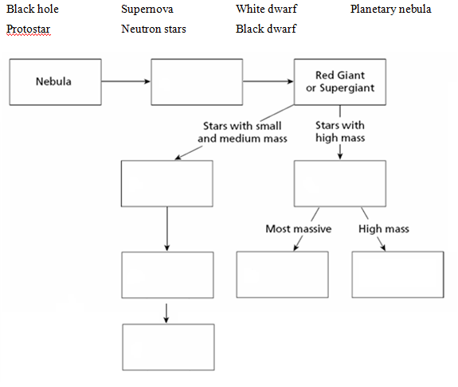

Part C: Hertzsprung-Russell Diagram
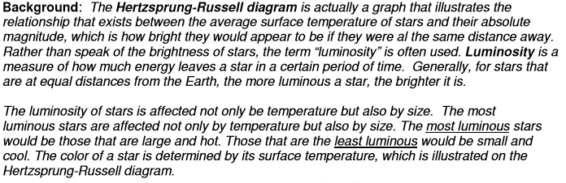
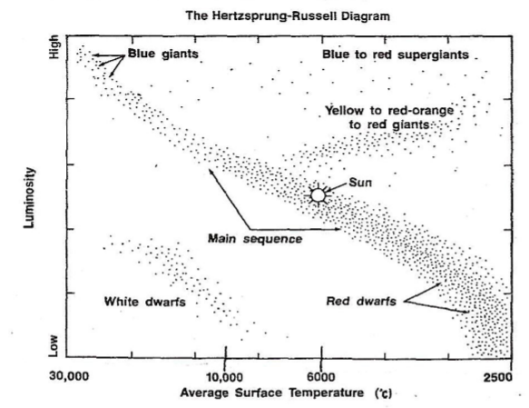

1. What is the approximate surface temperature of the sun?
2. Would the surface temperature of white dwarf stars be higher or lower than red super giants?
3. What is the color of the stars with the highest surface temperature?

4. What is the color of the stars with the lowest surface temperature? (Use the PPT note or google a colour picture if you are not sure).

5. List the color of the stars from hottest to coldest:

6. Most of the stars on the HR Diagram are classified as which type of star?

7. How is it possible for white dwarf stars to have lower luminosity than the sun even though the sun is cooler than white dwarfs?

8. Plot the following stars on the above diagram.

Star A = 4,000 0C and low/medium brightness
Star B = 6,000 0C and high brightness
Star C = 20,000 0C and low/medium brightness
Star D = 6,000 0C and medium brightness

- Identify the type/color for each star:

- What is the name of our most popular star located at point D?

- Describe the characteristics of stars in the area called Main Sequence. What do all types of stars located here have in common?

