KMT and Thermal Expansion - HAND IN Name: _____________

- What is the difference between temperature and heat?

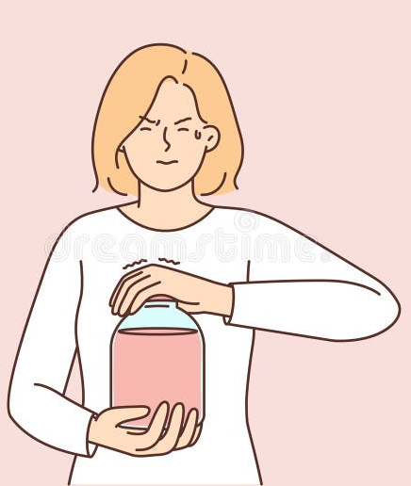
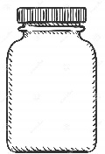
- When the lid of a jar is stuck tight, which method will help to loosen the lid: running the lid under cold water or hot water? Explain, using KMT

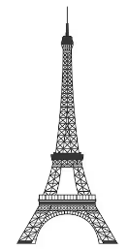

- The Eiffel Tower in Paris is 324 meters tall. Would you expect it to be taller or shorter on a hot day? Explain.

- What structure is this and why is it important for bridges?

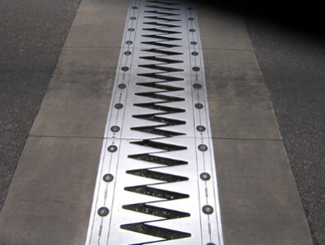
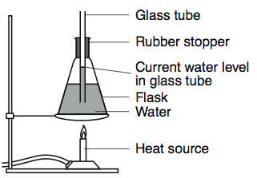
Consider the experimental set up on the left to answer the following questions.
- If the flask on the right were heated, what would happen to the water level in the tube?

- Use KMT (using terms like spacing and particle energy) to explain the relationship between volume and temperature of water.

- Earth’s atmospheric temperature is rising from global warming. What effect do you think rising ocean temperatures will have on sea levels?

- How is the model from question 5 similar to an ocean? (How is this model useful?)

- How is this model different from an ocean? (What are the deficiencies/limitations in this model?)

- Parts of Richmond are at 0 m above sea level. These cities must maintain structures like dykes and levees to prevent flooding. What might happen to these cities if the ocean levels rise a few feet?

