Sci 8 Name:
Thermal Expansion Worksheet Block:
- In your own words, define the term thermal expansion.

- In terms of SPACING and ENERGY, describe what’s happening to the liquid particles inside a thermometer that enables the fluid level to rise.

- When the lid of a jar is stuck tight, explain, using KMT which method will help to loosen the lid: running the lid under cold water or hot water?

- The Eiffel Tower in Paris is 324 meters tall. Would you expect it to be taller or shorter on a hot day?
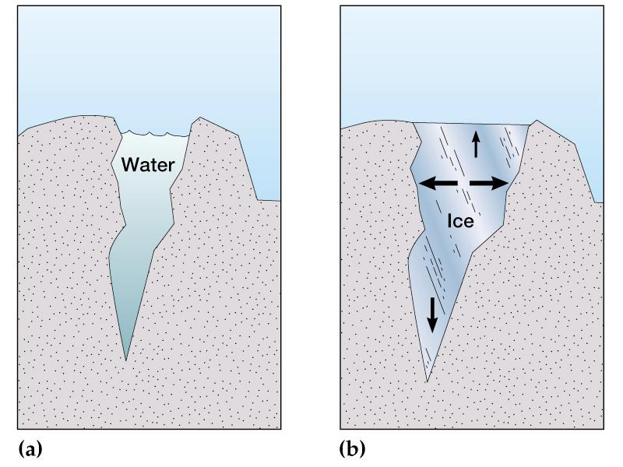
- Explain using the word volume, how a small amount of water can break rock over time.

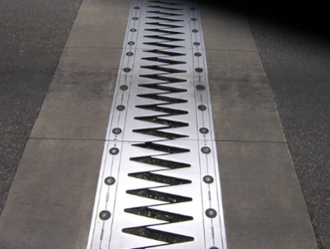
- What is the structure on the right and why is it important for bridges?

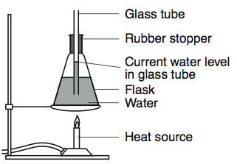
Consider the experimental set up on the left to answer the following questions.
- If the flask on the left were heated, what would happen to the water level in the tube?

- Use KMT (using terms like spacing and particle energy) to explain the relationship between volume and temperature of water.

- How is this model is like, and not like, an ocean? (How is this model useful? What are the deficiencies?)

- As Earth’s atmospheric temperature rises from global warming,
- What will happen to the temperature of the water?

- Will this have any effect on sea levels?

- As global temperatures rise, what will happen to the land ice? How will this affect sea levels?

- Parts of Richmond are at 0 m above sea level. These cities must maintain dykes and levees (embankments) to prevent flooding. What might happen to these cities if the ocean levels rise a few feet?

