INVESTIGATING CURRENT AND VOLTAGE IN SERIES AND PARALLEL CIRCUITS Name:

Part 1: Current

- Build the circuits one at a time without the ammeter.
- Add the ammeter into the circuit at each place shown on the circuit diagram. Record the ammeter readings and bulb brightness below.

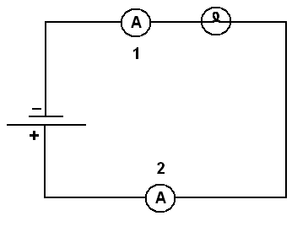 | Circuit A  Build the circuit without any ammeters.  Is the light bulb bright or dim? ________  - Add Ammeter #1, What is the reading? ______________  - Add ammeter #2. What is the reading of ammeter in position #2? _______________.
Circuit B  - Build Circuit B without any ammeter. Compared to circuit A, are the bulbs brighter or dimmer? _______________.  - Add ammeter to position #1. What is the reading? __________________.  - Place ammeter in position #2. What is the reading? __________________.  - Ammeter #3: _________________. |  |  | 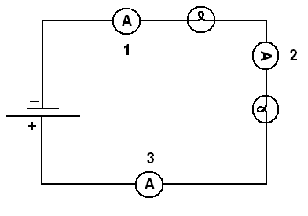
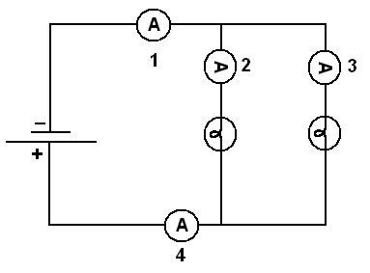 |  | Circuit C  - Build Circuit C. Compared to circuit B, are the bulbs brighter or dimmer? ___________________.  - Ammeter Reading 1: _____________  - Ammeter Reading 2: _____________  - Ammeter Reading 3: _____________  - Ammeter Reading 4: _____________

Part B: Voltage

- Again, build the circuits one at a time.

- Once each circuit is working, use a voltmeter to measure the voltage across the points shown on the circuit diagram.

- Record the bulb brightness and the voltmeter readings below.

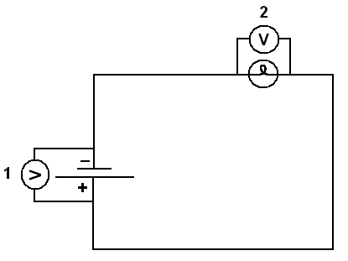 | Circuit D  Is the light bulb bright or dim?  - Add a voltmeter to position 1. Voltmeter Reading 1: _____________________  - Voltmeter Reading 2: _____________
Circuit E  - Compared to circuit D, are the bulbs brighter or dimmer?  - Voltmeter Reading 1: _________________  - Voltmeter Reading 2: _________________  - Voltmeter Reading 3: _________________ | 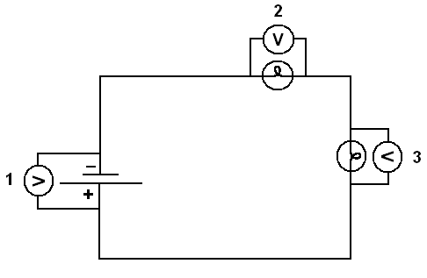
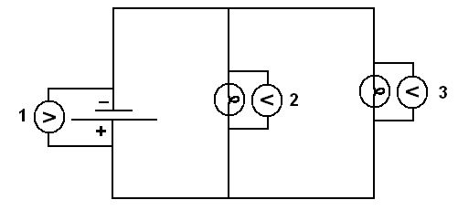 | Circuit F  Compared to circuit E, are the bulbs brighter or dimmer?  Voltmeter Reading 1:  Voltmeter Reading 2:  Voltmeter Reading 3:

