ES11 TAKE HOME DENSITY LAB

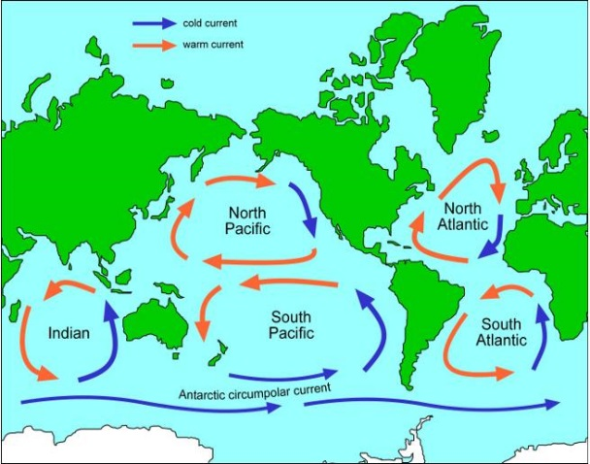
Background information

The ocean has a complex circulation system called the Global Ocean Conveyor. It moves water, heat, salt and nutrients around the world. Surface currents are driven mainly by wind. Deeper currents are driven by changes in water density. Both types of currents work with the atmosphere to help shape the Earth’s climate.
Melting land ice and increased rainfall – as consequences of climate change – have the potential to disrupt the oceans’ chemical and physical properties, which will impact this complex circulation system. Rivers contain freshwater and will also mix in with the oceans when they meet.
Salinity is the amount of dissolved salts in water. Although there are many dissolved salts in seawater, sodium chloride (common table salt) is the most abundant.
Seawater is denser than freshwater. This is because seawater has additional chemicals like sodium chloride dissolved in it. In regions where evaporation is high, the concentration of salt increases as the water evaporates. The opposite occurs in areas of heavy precipitation and or high runoff (where large rivers enter the ocean). The addition of freshwater dilutes the seawater and lowers its salinity. Since the factor that determine the concentration of salts in seawater vary from the equator to the poles, the salinity of seawater also varies with latitude.
Salinity affects buoyancy of objects (ability to float) in the water. The Navy pays close attention to ocean salinity to be sure they know how submarines will travel as they move through the different waters of the world.

Temperature plays a role in determining density. Cold water is denser than warm water, so it tends to sink. This is because water expands when it warms up – heat energy makes its molecules move around more and take up more space. When water cools, it contracts, becomes denser and sinks.

Purpose: To explore the impact of temperature and salinity on water density.
You will need:

clear drinking glasses
Hot tap water
Cold (ice) tap water
Table Salt
Spoon
Medicine dropper (if you have it, but not necessary).
pencil crayons/markers (red, blue, green)

red, blue, green food colouring
plain piece of paper

Procedure
- Make some really cold water by adding some ice into it.
- Make some really salty water by adding about 3-4 large spoonfuls of salt to a regular sized cup of room temperature water. Stir until dissolved. If the salt doesn’t dissolve all the way after a few minutes, that’s okay – you have created a saturated salt solution. Simple d……
- Safely heat up some tap water with a kettle, stove, microwave.
- On a plain piece of paper, write a title: Density Lab, Your name, Date.
- Create a subheading: Part I: How does Salinity affect Density?
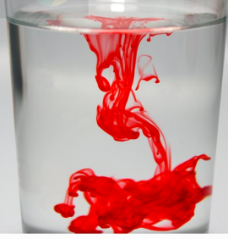
- Follow instructions for each section below. For each section (A,B,C,D) draw a diagram of your results. Make sure you label your diagrams with each layer (salt, fresh, cold, hot) and use appropriate colour. Your diagrams may not look like these but here are some ideas:

- Then answer questions #1-9 at the very end in complete sentences.

Part I: How does Salinity affect Density?
A – Salty water into Fresh Water

- Fill small drinking glass with CLEAR TAP water that’s at room temperature. Leave about 1-2 cm from the top.
- In a separate, small cup or glass, pour some VERY SALTY water that’s at room temperature.
- Add a few drops of green food colouring to the salty water. Mix with a spoon.
- Using medicine dropper, or just pouring very carefully AND SLOWLY,, add a few drops of very salty green water to the top of the clear tap water.
- After a minute or two, Draw, label, and colour a diagram of what you see onto your sheet.

B - Fresh Water into Salty Water

- Fill small drinking glass with CLEAR SALTY water that’s at room temperature. Leave about 1-2 cm from the top.
- Fill another small glass with TAP water that’s at room temperature.
- Add a few drops of BLUE food colouring to the plain tap water. Mix with a spoon.
- Using medicine dropper, or just pouring very carefully and SLOWLY, add a few drops of to BLUE tap water to the top of the clear salt water.
- After a minute or two, Draw, colour, label what you see on your sheet.

Part II: How does Temperature Affect Density?
C – Cold water into Hot Water

- CAUTION: IF WATER IS TOO HOT, IT WILL BREAK AN ORDINARY DRINKING GLASS. Check with a parent if you’re not sure, then proceed: Fill a clear jar/glass container/sturdy drinking glass with CLEAR HOT water.
- In a separate glass, pour a small amount of ice COLD water.
- Add some BLUE food colouring to the COLD water. Mix.
- SLOWLY pour the cold BLUE water onto the top of the hot water.
- After a minute or two, draw, label, and colour what you see.

D – Hot Water into Cold

- Fill a drinking glass with CLEAR COLD water. Leave about 1-2 cm from the top.
- In a separate coffee mug pour a small amount of HOT water.
- Add some RED food colouring to the HOT water. Mix.
- Slowly pour a bit of the the hot red water (about 1 cm) into the cold water.
- After about a minute, draw, label, colour what you see on your page.

- Answer the questions 1-9 below in complete sentences. You may need to read the Background information at the beginning to answer some.

Analysis QUESTIONS:
- When you put the very salty green water into the colourless tap water, which one sank?

- Using your observations from Parts A and B, what conclusions can you arrive at about the relationship between salinity and density of water?

- Using your observations from Part II, what conclusions can you arrive at about density and temperature of water?

- Explain how waters with different densities will act when they meet.

- Describe what happens when fresh water from a river meets salty ocean water.

- What causes salt water and fresh water to mix in the ocean?

- How would extra fresh water entering the oceans affect the Global Ocean Conveyor?

- What causes more fresh water to enter oceans? Name three.

- What is the role of climate change in affecting the Global Ocean Conveyor?

