FLOW OF ENERGY WORKSHEET Name: ____________
Food Chain
- What travels through a food chain or web?
- What is the ultimate energy for all life on Earth?
- Food chains start with what?
- The 1st organism in a food chain must always be what type of organism?
- Name 2 food making processes.
- Define herbivore.
- Herbivores are also called _________________________.
- What are animals called that feed on herbivores?
- Secondary consumers are eaten by larger ________________.
- _________________ consumers eat secondary consumers.
- Make a food chain with a producer and 3 consumers:

- What happens to energy as we move from step to step in a chain or web?
- The 1st trophic level consists of _______________ consumers called _________________.
- Name the 2nd trophic level (both names).
- Secondary consumers may be _______________ eating meat or _______________ that eat both plants and animals.
- What is the 4th trophic level called?
- At the 5th trophic level would be _____________ consumers that eat _____________ consumers.
- What type of organism feeds on dead plants and animals and helps recycle them? Give an example.

- Can an organism fill more than one trophic level --- yes or no? Give an example.

Food Pyramid:
- In food chains and webs, what trophic level must you have more of than others?

- Each trophic level has how much LESS energy?
- What may happen if a species goes extinct?
Quiz: Circle the Correct Answer
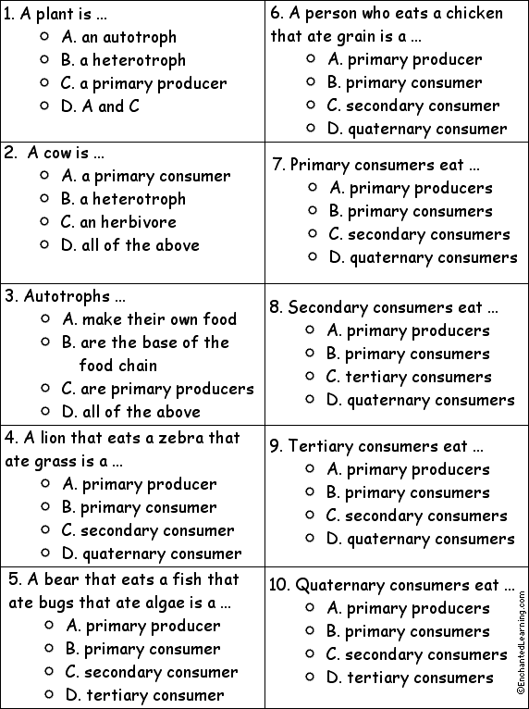
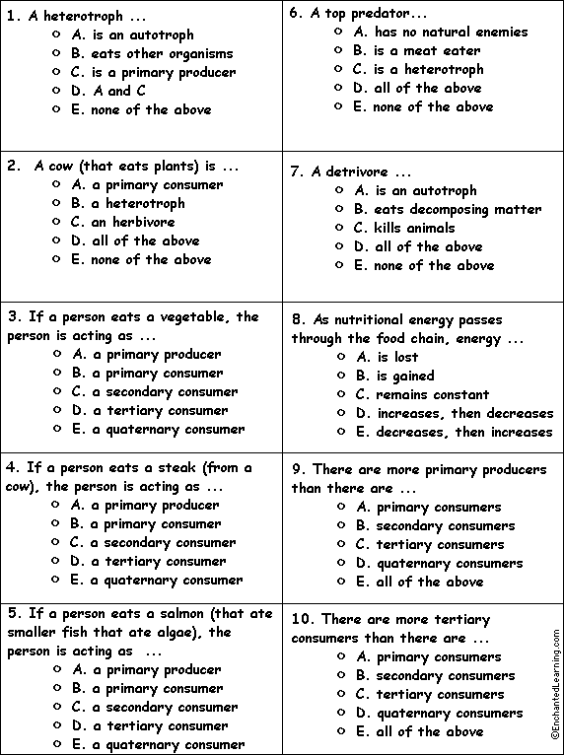
Match each Food Chain Word to its Definition.
