Microscope Calculations Practice:
- Calculate the diameter of the Field of View (FOV) on low power for each diagram which shows the lines of a ruler. Pretend the distance between all lines is 1.0 mm. Objects in the field of view are usually measured in micrometers (um) To convert, a field of view of 0.8mm, times it by 1000 to get 800um. 0.8mm x 1000 = 800 um.

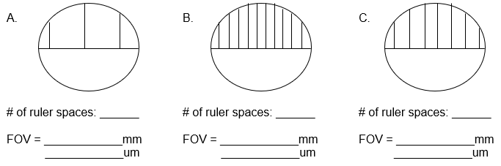

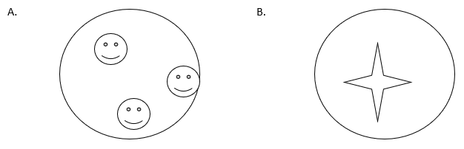
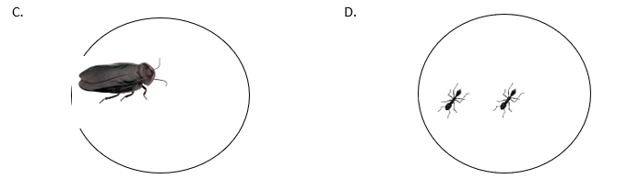
- Estimate the size of each specimen assuming the FOV is 5.0 mm.

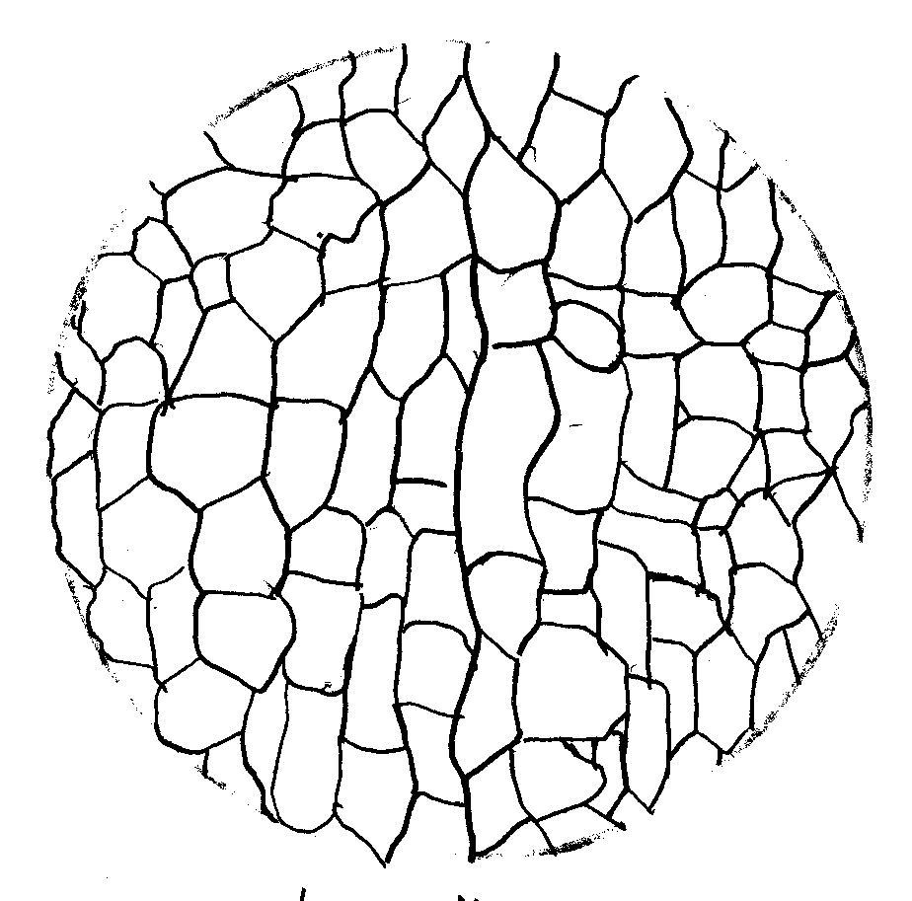
- Determine the diameter of ONE onion cell shown using the following microscope drawing where the diameter of the field of view is 3.7 mm on low power.

- A cell is observed to stretch half way across the high power field that has a Field of View of 0.2 mm. How long is the cell?

- 15 cells are observed across the centre of the high power field of FOV 0.4mm. How long is each cell?

- A student draws a cell diagram 24mm long. She writes 400x below the diagram. How large is the actual cell?

- A cell is 80μm in length. If drawn 600 times actual size, how long will the drawing be in cm?

- A cell is observed under high power to be about half the diameter of 0.4 mm. A student draws the cell 25cm in length. What is the magnification of the drawing?

- A fine hair is estimated to be, in diameter, one tenth of the diameter of the high power field of 0.2mm. It is drawn 4cm wide by a student. What is the drawing magnification?

- A paramecium is observed to travel across the low power field of 4 mm in five seconds. Calculate its speed in μm/s.

- 5 onion cells are counted across the centre of the med power field of 2mm. One cell is drawn 16mm long. Calculate the drawing magnification.

- 40 potato cells are counted across the centre of the low power field of view of 4mm. One cell is drawn 2cm long. What is the drawing magnification?

