TEMPERATURE, SALINITY, DENSITY LAB

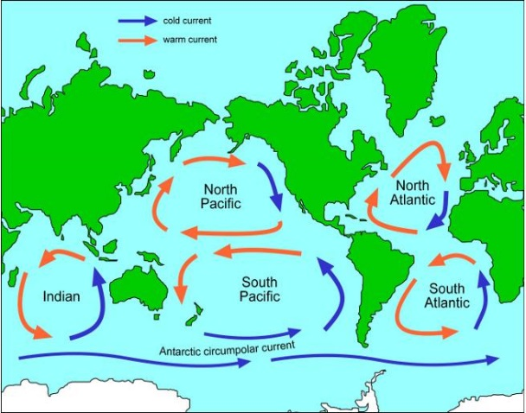
Background information

The ocean has a complex circulation system called the Global Ocean Conveyor. It moves water, heat, salt and nutrients around the world. Surface currents are driven mainly by wind. Deeper currents are driven by changes in water density. Both types of currents work with the atmosphere to help shape the Earth’s climate.
Melting land ice and increased rainfall – as consequences of climate change – have the potential to disrupt the oceans’ chemical and physical properties, which will impact this complex circulation system.
Salinity is the amount of dissolved salts in water. Although there are many dissolved salts in seawater, sodium chloride (common table salt) is the most abundant.
Seawater is denser than freshwater. This is because seawater has additional chemicals like sodium chloride dissolved in it. In regions where evaporation is high, the concentration of salt increases as the water evaporates. The opposite occurs in areas of heavy precipitation and or high runoff (where large rivers enter the ocean). The addition of freshwater dilutes the seawater and lowers its salinity. Since the factor that determine the concentration of salts in seawater vary from the equator to the poles, the salinity of seawater also varies with latitude.
Salinity affect buoyancy of objects in the water. The Navy pays close attention to ocean salinity to be sure they know how submarines will travel as they move through the different waters of the world.
Temperature plays a role in determining density. Cold water is denser than warm water, so it tends to sink. This is because water expands when it warms up – heat energy makes its molecules move around more and take up more space. When water cools, it contracts, becomes denser and sinks.

Purpose: To explore the impact of temperature and salinity on water density.
Materials:
graduated cylinder Food colouring clear very salty water
Small beaker Hot tap water very salty water with green food coloring
stirring rod Cold tap water
medicine droppers

Directions:
Part I: How does Temperature Affect Density?
A – Cold water into Hot Water | B – Hot Water into Col
- Fill a graduated cylinder with clear hot water up to a rubber band mark near the top of the cylinder.  - Fill a test tube with cold water and add some blue food colouring.  - Slowly pour the cold coloured water into the graduated cylinder of hot water.  - Draw and label what you see: | - Fill a graduated cylinder with clear cold water up to a rubber band mark near the top of the cylinder.  - Fill a test tube with hot water and add some red food colouring. Mix.  - Slowly pour the hot coloured water into the graduated cylinder of cold water.  - Draw and label what you see:

Part II: How does Salinity affect Density?
C – Salt water into Fresh Water | D – Fresh Water into Salty
- Fill beaker 3/4 full with clear tap water.  - Fill medicine dropper with very salty green water.  - Place a few drops of very salty green water into the beaker with clear water.  - Draw and label what you see. | - Fill beaker 3/4 full with clear salt water.  - Fill the other medicine dropper with blue tap water.  - Place a few drops of blue tap water into the cup with clear salt water.  - Draw and label what you see.

Analysis QUESTIONS:
- Using your observations from Part I, what conclusions can you arrive at about density and temperature of water?

- Using your observations from Part II, what conclusions can you arrive at about density and salinity of water?

- Predict what you think would happen if you added cold fresh water on top of room temperature salty water.

- What do you think would happen if sea ice which is mostly frozen fresh water melted?

- What difference does freshwater make to the chemistry of the oceans?

- What difference may this make to the Global Ocean Conveyor?

- Why is climate change a factor in these changes?

Table 1 lists the approximate surface water salinities at various latitudes in the Atlantic and Pacific Oceans, Using the data, construct a salinity curve for each ocean. Use different colored pencils for each ocean. Place Latitude on the X-axis and Salinity in ppm on the Y-axis. Label your graph and make a legend.

Table 1 All measurements are in parts per million (ppm) Title: ______________________
Latitude Atlantic Ocean Pacific Ocean
60oN 33.0 31.0
50o 33.7 32.5
40o 34.8 33.2
30o 36.7 34.2
20o 36.8 34.2
10o 36.0 34.4
Oo (Equator) 35.0 34.3
10oS 35.9 35.2
20o 36.7 35.6
30o 36.2 35.7
40o 35.3 35.0
50o 34.3 34.4
60o 33.9 34.0

Legend:

- At which latitudes are the highest surface salinities found? Suggest a reason why.

- Of the 2 oceans, which has the higher average surface salinity?

- Suggest a reason for the difference in average surface salinities between the oceans

