Name: ___________
Partner: _________

Chromatography Lab: Separating Soluble Mixtures

Introduction: Paper chromatography is a method of separating the components of a mixture by passing it through a medium (in this case, chromatography paper). If the components of the mixture are soluble in the solvent being used, the mixture will be carried up the paper strip as the solvent travels. Different substances in a mixture may have different solubilities, and therefore move at different rates up the paper. The more soluble substances are, the faster and farther they travel up the paper. Chromatography is used to separate and identify all sorts of substances in police work. Drugs ranging from narcotics to aspirin can be identified in urine and blood samples, often with the aid of chromatography.
Materials
2 strips of Chromatography paper, markers, solvent (water), one large 400-600ml beaker, tape, pencil.

Procedure
- Pour enough water to cover the bottom ofa large beaker.
- Cut a point at one end each of two chromatography strips.
- Place a small but heavy dot of marker (EITHER red OR blue) about 4 cm up from the tip of one strip. Reapply a few times over the same spot.
- Label the strip at the top with the colour of marker used.
- Do the same with the other strip using either a BLACK or BROWN marker. Label the top with the colour of marker used.
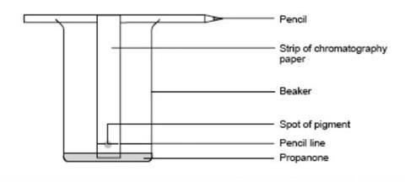
- Tape the far ends of each filter paper to a pencil. Check the length by holding it beside the beaker. Adjust length so only the tip of the paper strip will touch the water, not the dot.
- Place the filter papers into test tubes so just the tip in the water. THE Dot of DYE MUST BE ABOVE THE WATER LINE.
- Allow enough time for the water to rise up the paper to about 1 cm from the top, then remove the paper.

Questions
- Use your notes to define the following terms and give an example of each:

Solubility - ___________________________________________________________
Homogeneous Mixture - __________________________________________________
Heterogeneous Mixture – _________________________________________

- What property of matter does paper chromatography use?

- Compare the colour(s) you see on both filter papers. Are there any colours that appeared on both strips? If so, what are they?

- In your own words, explain why some colours were higher up on the filter paper than others.

- Using your knowledge of Kinetic Molecular Theory, PREDICT what effect do you think it would have if you tried the experiment with hot vs cold water? Explain your reasoning.

- Name three different ways heterogeneous mixtures can be separated.

- Summarize what you learned from this activity. How could this be applied to real life?

