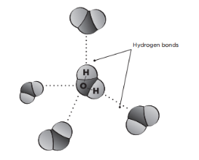
Sci 9 How many drops fit on a penny?
INTRODUCTION
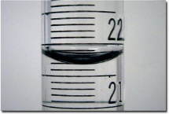
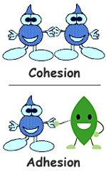
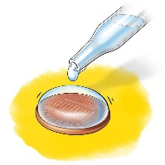
Water molecules are polar, meaning it has a positive end and a negative end. These different charged ends cause a weak attraction between other water molecules, making them “stick” together. This is called cohesion and results in surface tension. Some substances, such as soap, may reduce the cohesive force of water, which will reduce the strength of the surface “skin” of the water.

The polarity of water molecules can also cause them to be attracted to other polar substances. This is called adhesion.
Different liquids will have different molecular structures and therefore different intermolecular forces (attractions). So the surface tension of each liquid is different. The number of drops you can put on a coin without spilling is also different.
Materials: Penny, dropper, water, other liquid like alcohol, soap, 100ml beaker

What To Do
- Rinse a penny in tap water. Dry it completely with a paper towel.
- Examine the penny and consider how many water drops you think will fit on the penny. Write down your prediction on the next page.
- Place the penny on a flat surface that can get wet.
- Fill a small beaker with water.
- Use a dropper to draw water and carefully put individual drops of water onto the penny. Make sure dropper is VERTICAL, pointing straight down, and not at an angle or sideways. Make sure not to touch the tip of the pipette to the penny when dropping water onto it.
- Count the water drops as you add them, one at a time, until water runs over the edge of the penny.
- Repeat the experiment with a different liquid. Pay attention to the shape of the liquid puddle on the penny and the number of drops before it spills over

Extensions
- Add a drop of soap/detergent to the beaker of water you use. It reduces the surface tension causing a dramatic reduction in the number of drops that will fit on the coin.
- Start with a full glass of plain water (with a dry rim to prevent the water from dripping down the side of the glass). How many coins can we add to the water without the glass overflowing?
Gently add coins one by one. Because of surface tension, the water will rise above the rim of the glass before it spills (just like the initial experiment). Compare your original prediction with the number of coins you were able to add.

HOW MANY DROPS FIT ON A PENNY? Name: _________

Question: How many drops of water can you drop on a penny before the surface tension is not strong enough to counter the gravitational pull on the water?

Prediction: Drops of water: __________ Drops of ethanol: ___________

Variables:
Independent Variable: _____________________
Dependent Variable: _____________________
Controlled Variables: _____________________

Observations:
Liquid | Trial 1 | Trial 2 | Trial 3 | Average

Tap Water

Alcohol

Soap + Water

Questions
- Were your predictions correct? Extension: By what percentage were you off?

- Why was it necessary to perform multiple trials on the same liquid?

- It was important to keep the dropper vertical when dropping the liquid. Why do you think it was important?

- Explain in your own words, using scientific terms how it is possible to get so many water drops on a coin. (Read the intro again if you are not sure).

- Extension: Explain in your own words and using scientific terms why the ethanol held more/less drops than water. (Read the intro again if you are not sure).

- Would a dime coin hold more or less drops? Why?

- Does it matter if the coin is heads or tails? Why do you think this?

- Did you encounter any problems in your trials? What would account for the variation in your trials?

