Evolution of Barbellus

(adapted from http://faculty.montvilleschools.org/bhayes/Biology/Handouts/Evolution_of_Barbellus.pdf, Macmillan Publishing Co., Inc and the work of John Bannister-Marx)

Purpose:
To create an evolutionary tree using fossil evidence and to hypothesize (using the language of natural selection) the steps in the evolution of these imaginary organisms.

Background:
Evolution may be defined as “changes in populations over time.” Some evidence for these changes comes from fossils. By comparing extinct organisms (fossils) with extant (still in existence) organisms, we can see that there have been major changes that have taken place over long periods of time. There are many organisms that lived in the past that no longer exist today.

Most fossils are found in sedimentary rock. Organisms that are trapped in mud and sand remain there after the sediment has turned to rock over millions of years. Over time, the strata (layers) of rock build up as new mud and silt is laid down on top of the existing layers. The organisms that are trapped can be dated if we know the age of the rocks in which they are found. However, earthquakes and other movements of the earth can disrupt the “picture” we have of the strata.

The information we get from fossils is not always complete because not all organisms form fossils. Some transition organisms might be missing and we have to hypothesize what they might have looked like and hope that someday we will find fossil evidence to support our hypothesis.
The following diagram shows where these Barbellus species were found in exposed layers of sedimentary rock along a stream. Your task is to build an evolutionary tree showing these species and then write a paragraph explaining how the evolution of these species might have happened.

Procedure:

- Cut out the pictures of the Barbellus species on the attached page and arrange them into evolutionary order using their morphology (form and structure). Be sure to include the names. Don’t glue them down yet. ......

- Use the strata in Figure 1 below to determine relative ages and place them in order. Consider the similarities of features and place the descendants above their inferred ancestors.

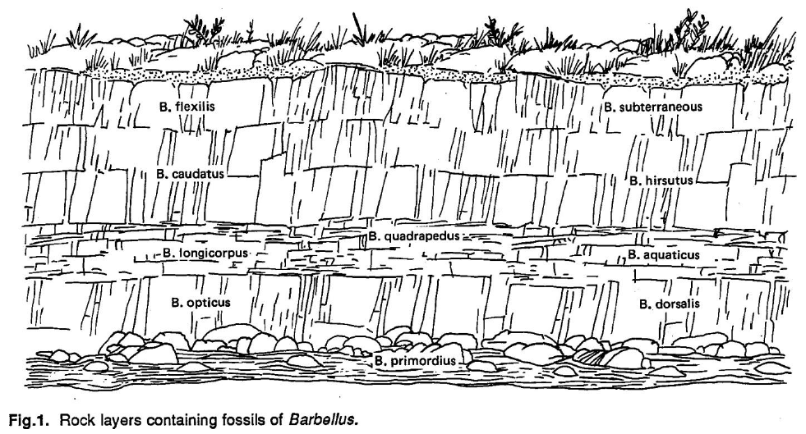

- Your tree will likely have branches. Use what you know about slow changes over time to connect ancestors to the most probable descendants. Use as much of the page as possible. Leave a space for any “missing” organisms.

- Now, look at your connections. Find a connection between an ancestor and a descendant where you think there are so many differences that there must be an intermediate organism that has not been found yet. Draw this “missing link” organism on your poster.

- Title the page and tape/glue your pictures in place. Draw the connecting lines so you have an evolutionary tree (Cladogram).

Questions:
- Of the members in this study, which one is the oldest? Explain how you know.

- Why is it important to have variation in a population of organisms?

- How does the environment affect natural selection and evolution?

Discussion/Analysis:
- Explain how mutations in DNA account for the differences in the physical characteristics of the various species of Barbellus.

- Explain your reasoning for the morphology of the intermediary form of Barbellus that you drew. (Why it has the structures you gave it) Be sure to include the names of the ancestor and descendant.

- Summary Paragraph: Hypothesize the evolution of the Barbellus from the oldest (B. primordius) to most current descendant in terms of environmental changes, natural variation in populations, adaptations, mutations, and natural selection. Be sure to include the observed physical changes (adaptations), and how these changes evolved. Avoid language such as “B. opticus wanted to see better so he grew bigger eyes.”

