Cell Review
- Label the following organelles on the diagram of the cell below:
Cell membrane, cytoplasm, mitochondria, mitochondria, nucleus, nucleolus, vacuole, endoplasmic reticulum, Golgi apparatus, lysosomes, nuclear membrane, ribosomes.

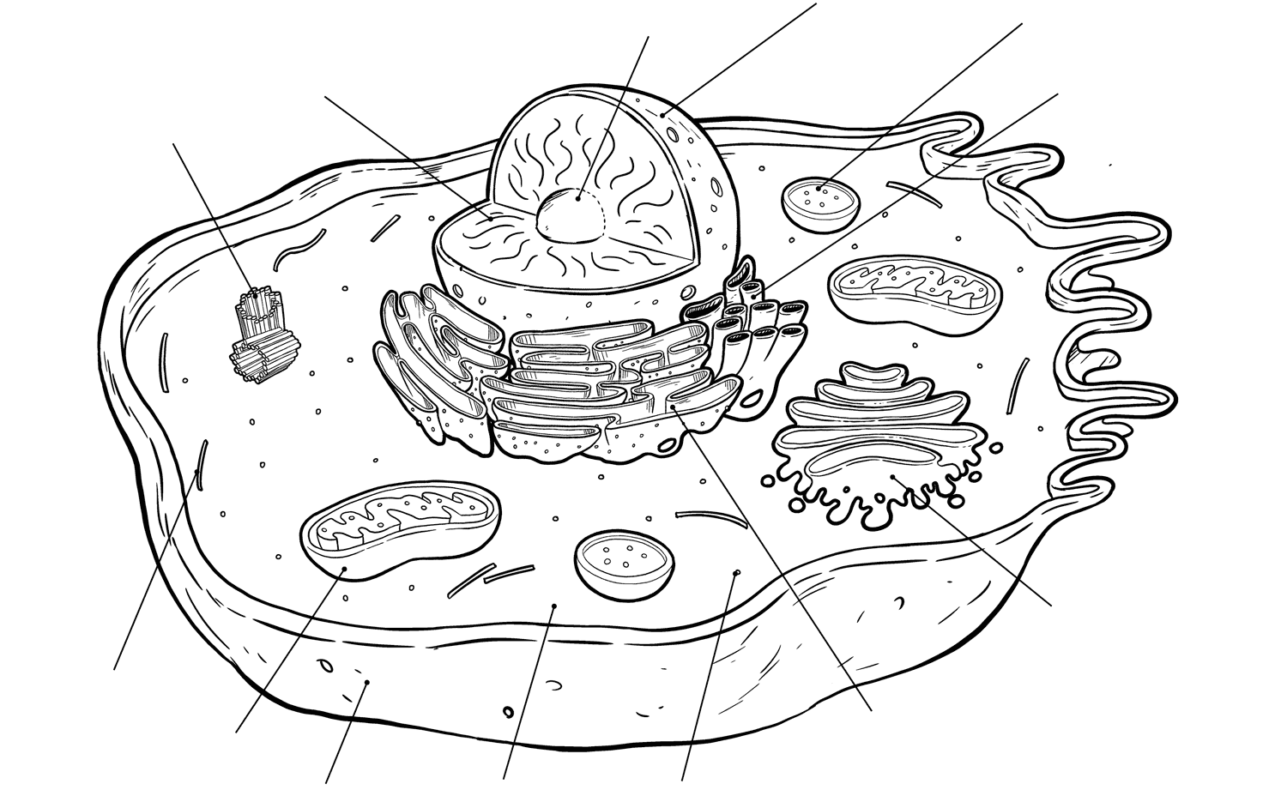

- Is this a plant cell or an animal cell? How do you know?

- How are vacuoles in animal cells different from those in plant cells?

- How are prokaryotes different from eukaryotes? (size, complexity, organelles)

- Give an example of a prokaryotic organism. _________________________
- Name three example of eukaryotic organisms. _______________________________________
- Name two things you would find inside a nucleus.______________________________________
- The storage place inside the cell is the ________________.
- The watery fluid that is found filling the cell is the ___________________.
- What is the function of the cell membrane?
- Tiny organelles that make proteins for the cell ______________________.
- Organelle that produces energy for the cell _____________________.
- The recycler and cleaner organelles __________________________.
- Series of folded membranes that carry material through the cytoplasm and come in a rough and smooth type: _____________________________
- This organelle takes up way more space in a plant cell than in animal cells. _________________.
- Structural component of the cell that protest and supports the cell _______________________.

Similarities between plant and animal cells | Differences between plant and animal cells

- Name the process of when a cell converts nutrients into chemical energy.

- In your own words describe the process of photosynthesis.

- Summarize the main points of cell theory:

- Compare viruses to bacteria in terms of size, genetic material, and complexity. Give an example of each – Not covered this year.

