Acids, Bases and Buffers

Acids are compounds that dissociate in water and _____________________-
- Eg. HCl, H₂CO₃, H₂O, CH₃COOH, lemon juice, tomatoes, coffee.
- Strong acids dissociate ___________________.
HCl H⁺ + Cl-

Bases are compounds that dissociate in water and release OH- ions.
- Eg NaOH, KOH, H₂O.
- Strong bases dissociate completely.

NaOH Na⁺ + OH-

__________________ and releases hydrogen ions (H⁺) and hydroxide ions (OH⁻).

pH is a measure of the ____________________________ in solution and
ranges from 0 to 14.
The _____________the number the more acidic the solution. pH < 7.0 is acidic.
The _____________the number the more basic (alkaline) the solution. pH of >7.0 is basic.
A pH of 7.0 is neutral. Pure water is neutral.
pH is a ____________________ scale.
- Each number on the pH scale represents a difference of magnitude of 10.
- pH of 2 is ten times more acidic than a pH of 3.
- pH of 3 is 100 times more acidic than 5.
- moles/liter
1 x 10 ^{–6} [H⁺] = pH 6
1 x 10 ^{–7} [H⁺] = pH 7
1 x 10 ^{–8} [H⁺] = pH 8
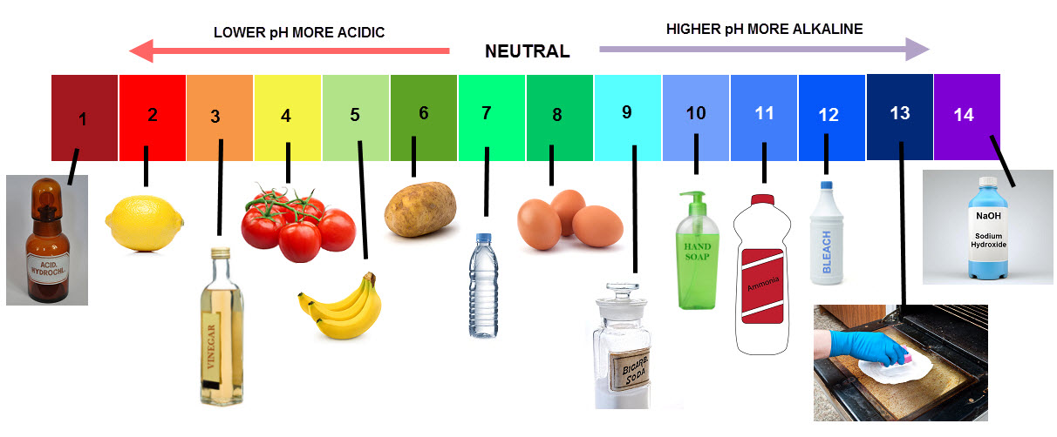

Most bodily functions operate within a very narrow range of pH.
- Small change in pH can cause ________________________ (change shape).
- ____________________are substances that resist a change in pH
- The normal pH value for the body fluids is between ______________.
- pH value of body fluids is < 7.35, the condition is called ______________.
- the pH is > 7.45, it is called _________________.
- A rise or drop greater than 0.05 (on a pH scale) would require hospitalization
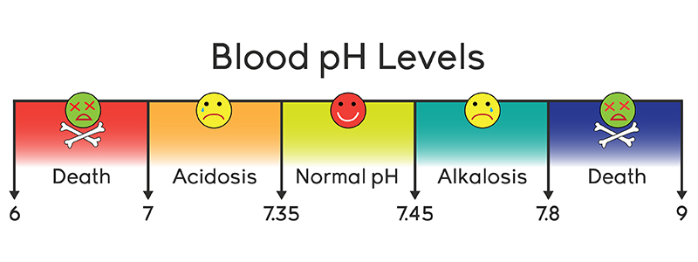

What are the signs and symptoms?
Acidosis can cause depression of the __________________________.
- _________________
- _________________
Alkalosis can cause ________________________of the nervous system.
- Muscle spasms, _____________
- ________________
4 Main types of imbalances:
metabolic respiratory
acidosis acidosis
alkalosis alkalosis
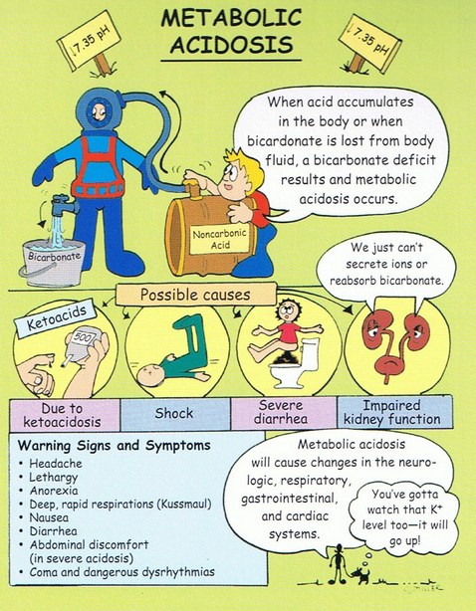
Metabolic Acidosis
- kidneys can’t eliminate enough ________________________________
- Eating acidic foods, ________________
- lipid metabolism produces fatty acids.
- carbon dioxide, a by-product of metabolism, combines with water to form _________________.
- _________________ lactate and acid
- _________ acidosis occurs in people with diabetes.
Risk Factors include:
- high-fat diet low in carbohydrates
- ___________________
- obesity
- ___________________

Diabetic ketoacidosis (DKA)
- life-threatening problem that affects people with diabetes.
- occurs when the body ___________________ (glucose) as a fuel source because there is _______________ or not enough insulin.
- ________________is used for fuel instead.
- when fat is broken down to fuel the body, chemicals called _____________ build up in the body.
Metabolic alkalosis
- May be caused by ____________________, diuretic use.
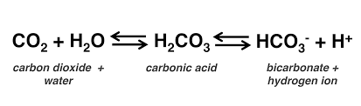
Respiratory imbalances are caused by _____________ of the respiratory system.

Respiratory acidosis occurs when too much CO₂ builds up in the body.
- Lungs not removing fast enough.
- Excess CO₂ reacts with water to form carbonic acid.
- carbonic acid dissociates to form hydrogen ions and bicarbonate ions.
- increased hydrogen ion concentration causes the pH of the body fluids to decrease.
Respiratory acidosis can be caused by:
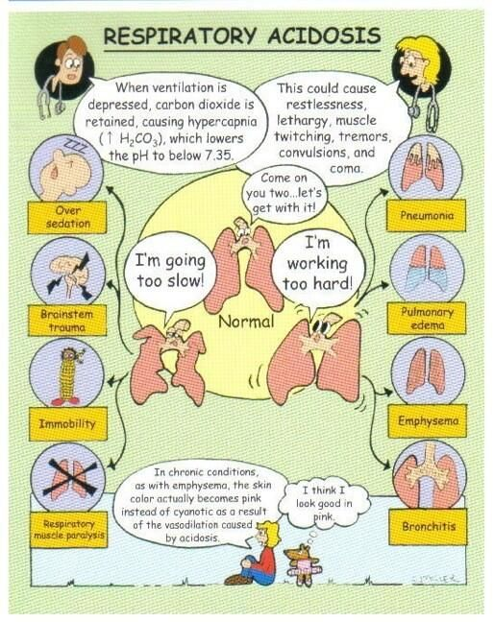
- __________________
- _________________to the chest
- ________________, which can make breathing difficult
Respiratory alkalosis
- _________________: increases the rate carbon dioxide elimination, decreasing [CO2] in the body, raising the pH. The reaction is pushed to the left.
Prolonged acidosis may lead to:
- ___________________________
How do we compensate?

Buffers in our blood:
- Extracellular buffers: ____________,_______________,_______________
- Intracelluar buffers: proteins, phosphate
Respiratory System
- Reduced pH stimulates the respiratory center to begin hyperventilation, eliminating CO2 at a greater rate. In turn also eliminates excess hydrogen ions.
Kidneys
- help compensate for failure of the lungs by adjusting the _____________ ________________into the filtrate and reabsorption of bicarbonate ion.
- _______________ response time than buffers and respiratory
Questions
  - What is the normal range for our blood pH?
  - Hyperventillation may cause our blood pH to ________?
  - What is the name for this condition?
  - What condition may be caused by eating a high protein diet low in carbohydrates?
  - What organ works to compensate for this?
  - What may happen if the condition persists?
  - Name two risk factors for metabolic acidosis.
  - What are the three most important systems in our body that keep our blood pH within normal range?
  - Describe diabete ketoacidosis.

