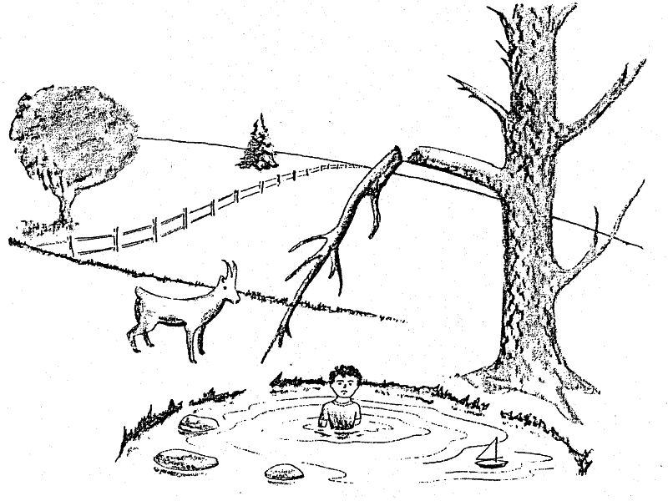
Observation: ____________________________________________________________________________________________________________________________________________________________________________________________________________________________________

Inference:
________________________________________________________________________________________________________________________________________________________________________________________________________________________________________________________________________________________________________________
Use the picture of the goat by the water to determine if the following statements are observations, or if the statements are inferences. Place an “Inf” in the blank for inference and an “Obs” in the blank for observation.

________ 1. The kid is in the water.
________ 2. The weather is cold.
________ 3. The tree branch is broken.
________ 4. If the kid crawled out of the water, the goat would push him/her.
________ 5. The kid fell off the branch.
________ 6. The goat is standing by the pond.
________ 7. The branch will fall on the kid’s head.
________ 8. The kid fell off the rocks.
________ 9. There is a sailboat in the water.
________ 10. The sailboat belongs to the kid.
________ 11. The goat will soon leave the pond.
________ 12. The tree by the pond has no leaves.
________ 13. There are three rocks in the pond.
________ 14. The tree by the pond is dead.
________ 15. If it rains, leaves will grow on the tree.
________ 16. The goat pushed the kid into the pond.

Make your own inference:

