Name: ____________________

Biology 12: Respiratory System Worksheet

Part A: Label the following diagram.
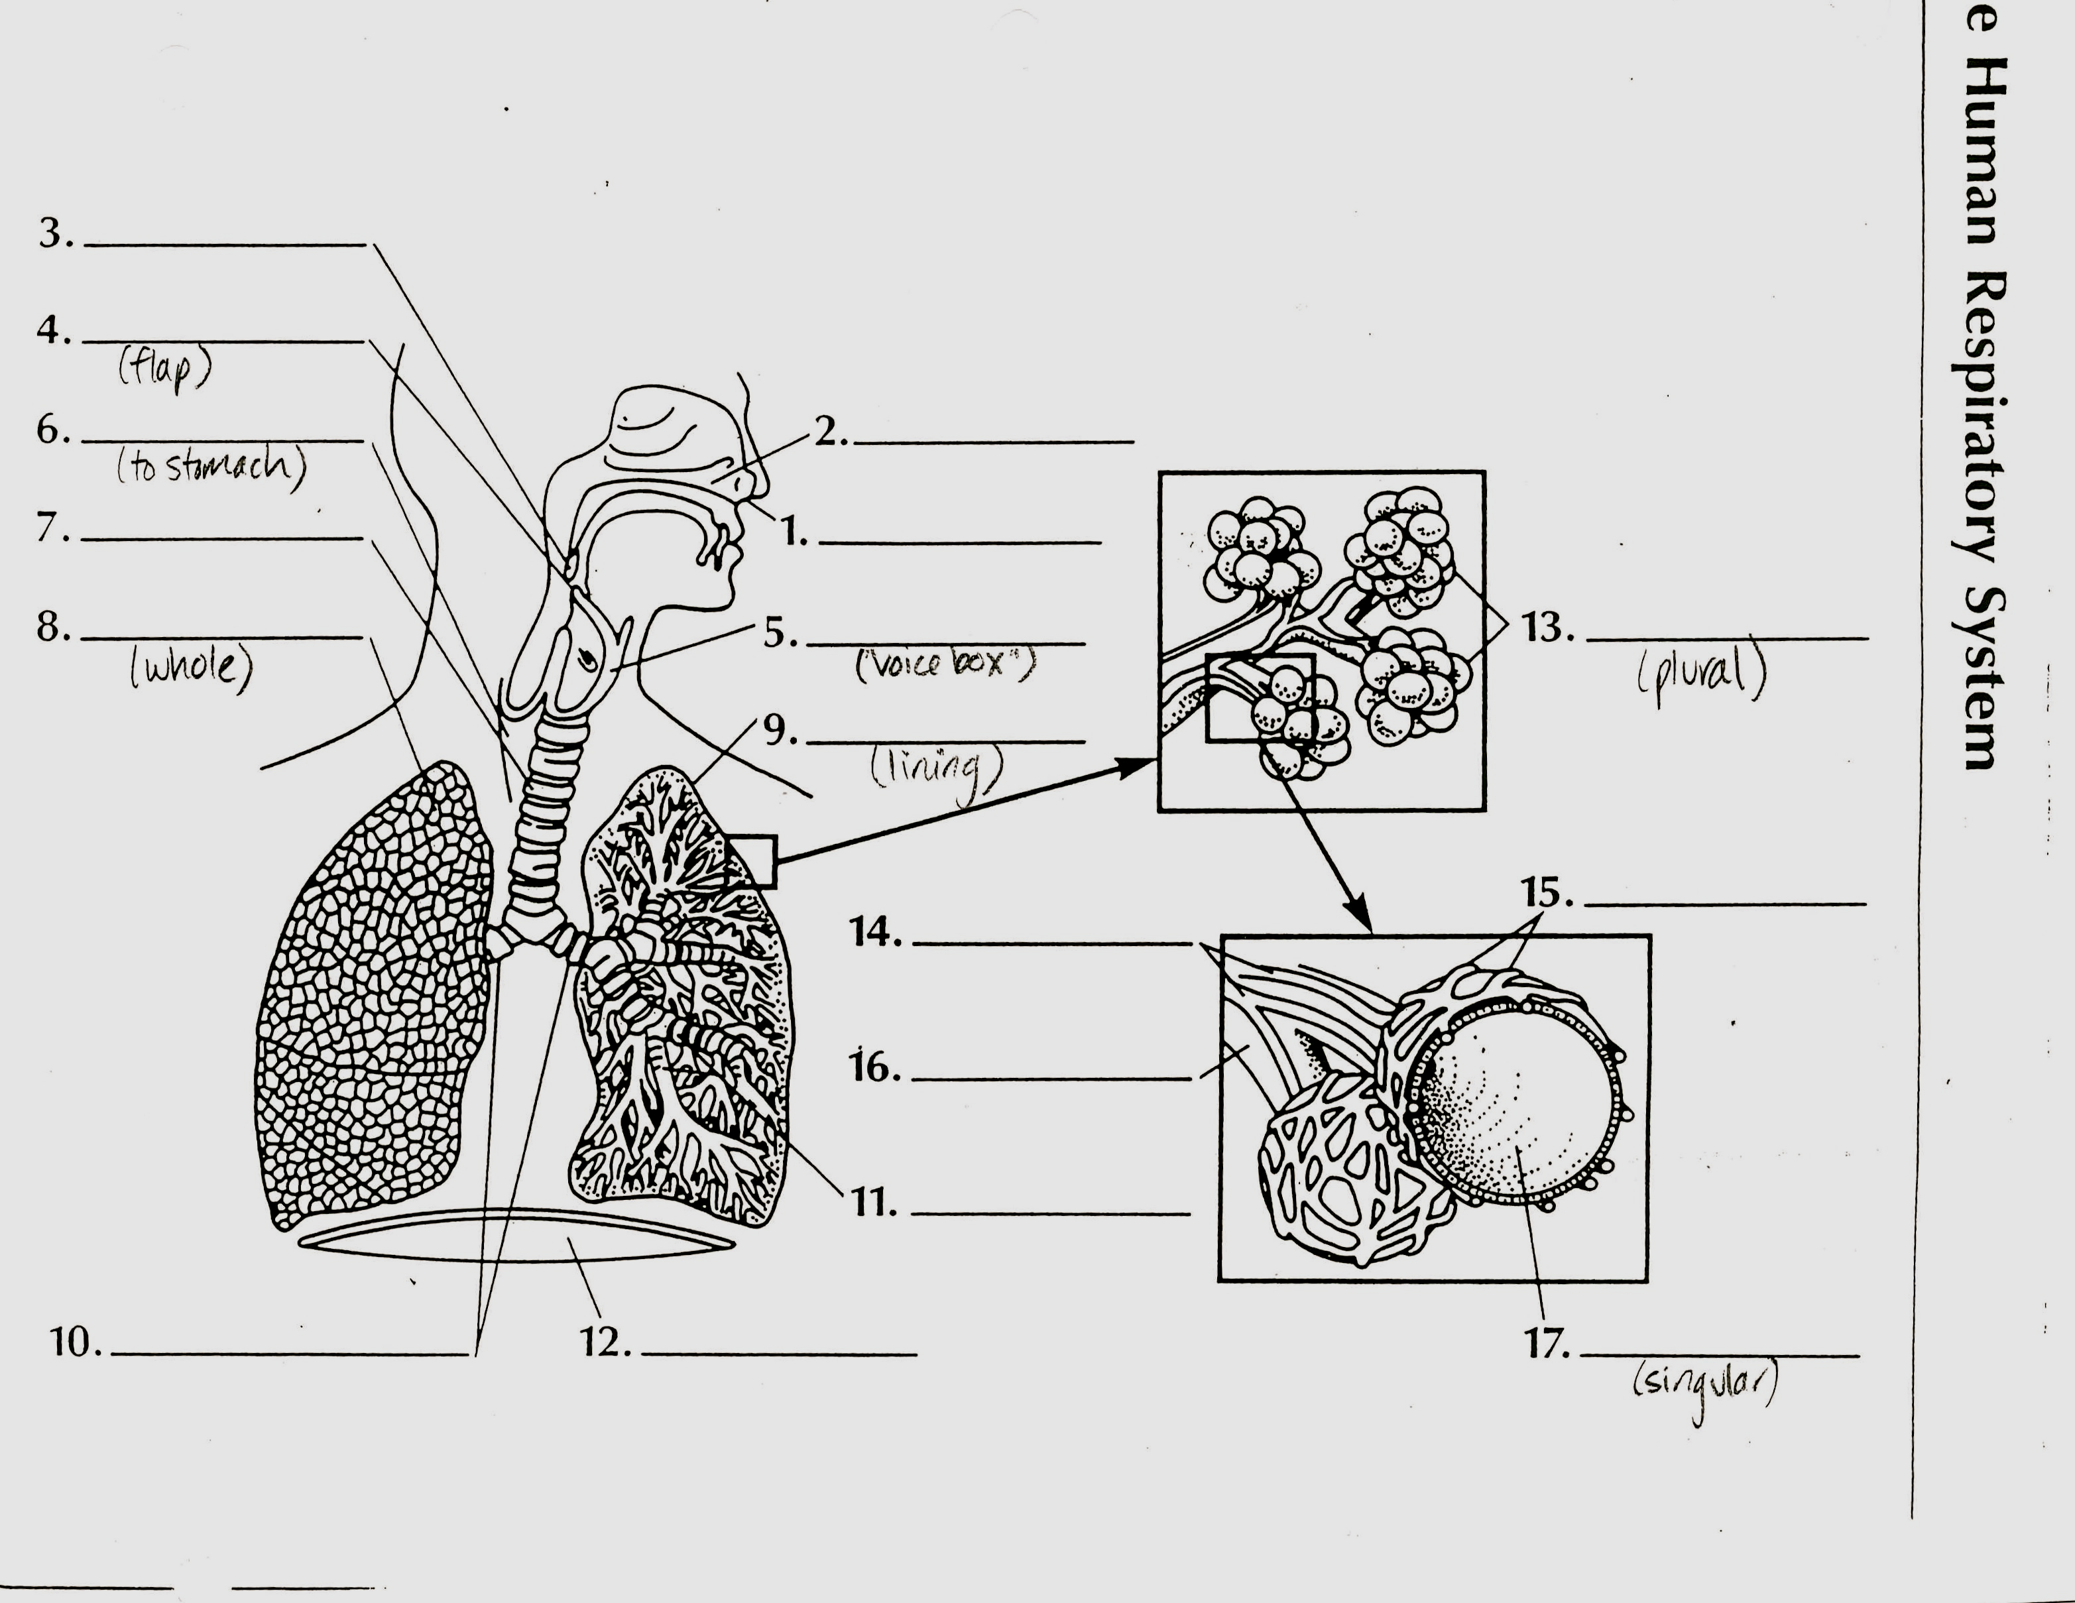

Part B) Fill in the blanks.
1. Inspiration and expiration are involved in the process of ___________ .
2. During inspiration, the rib cage moves up and ________; the diaphragm moves ________
3. The primary stimulus for breathing is the amount of _______________ in the blood.
4. Oxygen moves from the alveoli to the capillaries by means of _________________
5. Most carbon dioxide is carried in the plasma as the ________________ ion.
6. Hemoglobin readily takes up oxygen in the lungs, where the pH is ___________and the temperature is____________ .
7. At the tissues, _____________diffuses out of the blood and ___________ diffuses into the blood.
8. In which structures does gas exchange actually occur?

9. How is the trachea (larynx) closed off?
10. Indicate whether the following phrases describe INSPIRATION or EXPIRATION:
i) lungs expanded ii) muscles (diaphragm and ribs) relaxed
iii) diaphragm dome-shaped iv) chest enlarged
v) less air pressure in lungs than environment
11. Where does oxygen enter the blood? ____________. Where does oxygen leave the blood?
12. Where does carbon dioxide enter the blood? ____________ Where does it exit from the blood?
13. Put these statements in the proper sequence:
 | Event
a | Respiratory center stops sending messages to diaphragm and rib muscles
b | Respiratory center sends excitatory message to diaphragm and rib muscles
c | Diaphragm becomes dome-shaped and rib muscles relax
d | Chest expands as diaphragm goes down and rib cage goes out.
e | Air goes rushing out as lungs recoil.
f | Air comes rushing in as lungs expand
g | Expanded lungs send message to respiratory system
Correct sequence: -______________

Part D) Answer the following questions.
1. Describe how debris and particulate in air is removed from the lungs by mucus and cilia (3 marks)

2. Carbon dioxide is transported from the tissues to the lungs primarily in plasma. In what form is carbon dioxide found in plasma? Give the name of the enzyme that aids the conversion of carbon dioxide both in the tissues and in the lungs. How does hemoglobin help with carbon dioxide transport? List two other ways carbon dioxide in smaller quantities is transported in the blood. (6 marks)

3. Give the full name for the following abbreviated compounds related to respiration and gas exchange.
(5 marks)
O2 - CO2 –
Hb - HbO2 -
HHb – HbCO2 –
H+ - H2CO3 –
HCO3- - H2O –

4. List the set of equations that describe external respiration in the alveoli of the lungs.
Remember the alveoli supply oxygen to the blood and receive carbon dioxide and water from the blood for removal. (4 marks) See diagram below.

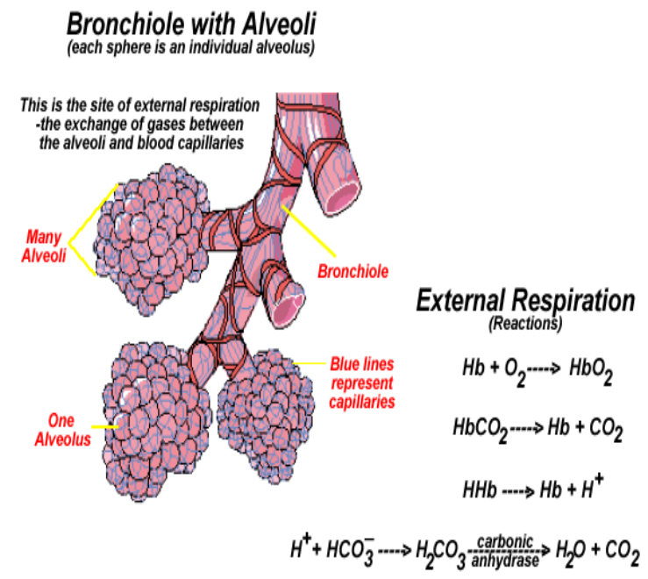

5. List the set of equations that describe internal respiration in the capillary bed between the capillary and the tissue fluid. Remember the tissues receive oxygen from the blood and dump carbon dioxide and water into the blood. (4 marks) See diagram below.

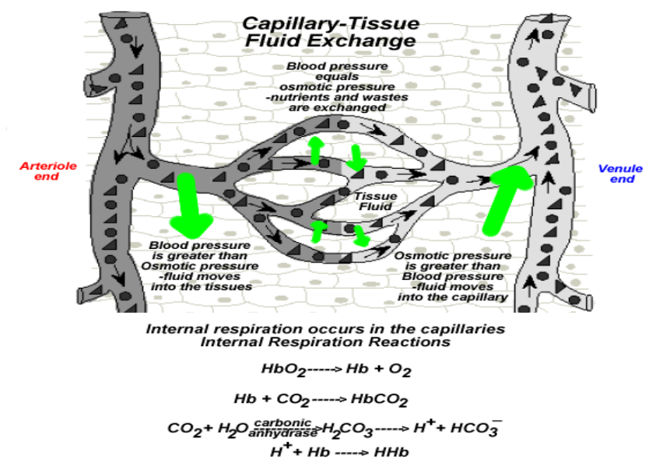

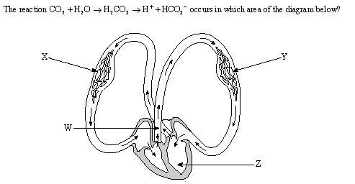
6.

7. What is the role of hemoglobin in maintaining blood pH? (2 marks)

8. Identify and describe the processes illustrated by each diagram. (4 marks)
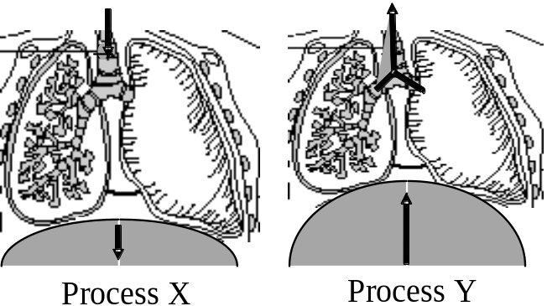

9. | Give at least one function of each of the following. (3 marks)  - Cilia in the trachea:  - Chemoreceptors:  - Hemoglobin: .
10. What role does each of the following have in breathing? (2 marks)
- Medulla oblongata:

- Pleural membrane:

11. | Describe the pathway of an Oxygen molecule from entering the human body to its use in the cell. Where does it go and how does it get there? Include respiratory and circulatory structures. (5 marks) .  12. Write the complete chemical equation for cellular respiration. Describe where and why this process occurs.(2 marks)
13. In your lab, you exhaled into a beaker of water and caused the pH indicator to change colour. What reaction caused to the pH to change? How is this similar to what occurs in your blood during Internal respiration? (3marks)

.

