Unit I Review #3 : Answer KEY
- The Pancreas.

- Insulin directs liver and muscle cells to take up blood glucose and store it as glycogen when blood glucose is too high. This will help lower your blood glucose level.
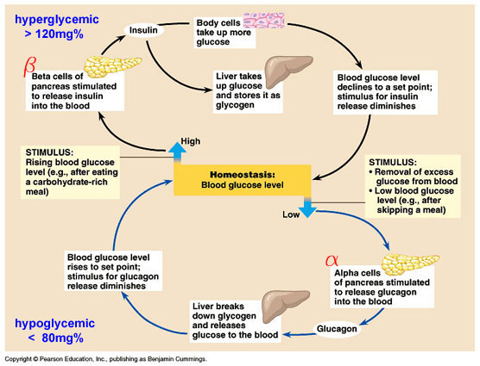
- Excess glucose converts to GLYCOGEN and is stored in muscle and liver cells.
- GLUCAGON – Which tells liver cells to convert Glycogen back into glucose for the blood. GLUCAGON will raise your blood sugar level.

- ENDOCRINE

- Bile breaks up fat clumps into smaller fat droplets, this is known as emulsification.
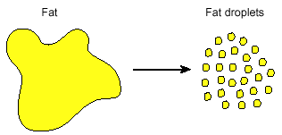
- Bile is produced in the liver.

- Bile is stored in the Gallbladder.
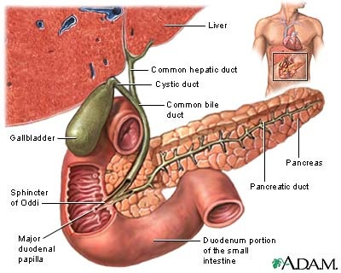
- JAUNDICE.
Jaundice is the accumulation of Bilirubin in the blood as it is unable to be excreted with the bile. Some causes could be: blocked bile ducts, blood infections that cause Hemolysis (rapid rupturing of red blood cells), or overall liver failure (Hepatitis). Symptoms include yellowing of the skin and scleras (whites) of the eyes.
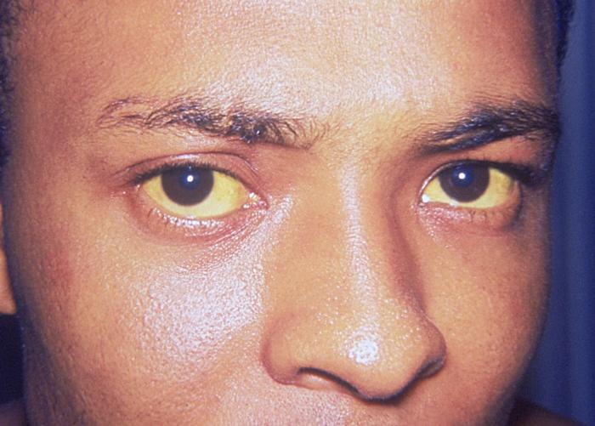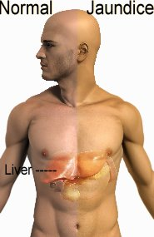

Key Functions covered in earlier review:
- Detox, Production of Plasma Proteins, Manufacturing and excretion of Cholesterol, Production of Bile, Receive and process sugars and amino acids, Deamination (Converting ammonia into urea), Blood glucose homeostasis. Red blood cell recycling.

2. Amino groups are taken off of amino acids and ammonia is produced, then 2 ammonia molecules are combined with one carbon dioxide molecule to form UREA.
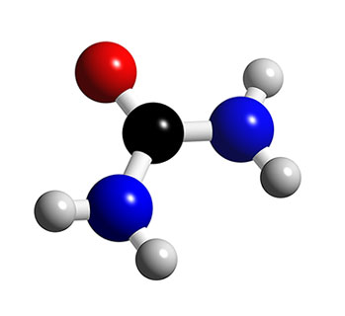
3.Vitamins A, D, E, K are all Fat Soluble.

4.The liver manufactures important plasma proteins. Some of these plasma proteins are important for proper blood clotting.

9
- The small intestine uses Plicae, Villi and Microvilli to increase surface area for adequate absorption.
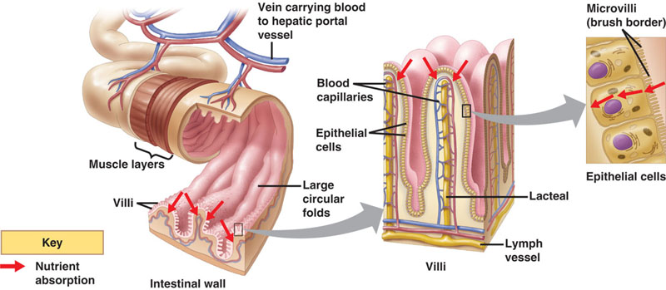
- Amino Acids, and Monosaccharides (glucose) are absorbed into the capillary bed. The other function of this capillary bed is to drop off oxygen and processed nutrients to these hard working cells of the villus.
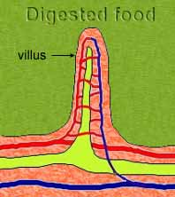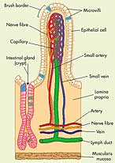
- Lacteals absorb the products of fat digestion.

- Active Transport would be required to move substances from the lumen of the small intestine into the blood, as we want to absorb all of the nutrients.

- The HEPATIC PORTAL VEIN.

- Nucleosidases break Nucleotides down into the separate Pentose Sugar, Phosphate Group and Nitrogenous Base.

10
- The bacteria in the large bowel are important for : A) Production of some vitamins (Vit K)
B) Breaking down indigestible wastes to free up other vitamins and minerals.
C) These bacteria colonize the gut and prevent the overgrowth of harmful bacteria.
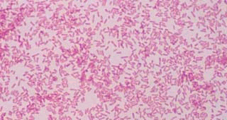
- FLATULENCE – Gas – Fluffs – Farts Etc.
- Vitamin K
- Vitamin K plays an essential role in Blood Clotting.
- Diarrhea. If diarrhea is severe or prolonged an individual may become dangerously dehydrated.

