Sci 10 Organic Compound Notes Name: _______________

Organic compounds contain __________________________________________________________
- Organic compounds have __________________ bonds
  - Every living thing contains _______________ and it therefore organic but not all organic compounds are from living things.
  - _____________________compounds are compounds that ____________ have carbon.
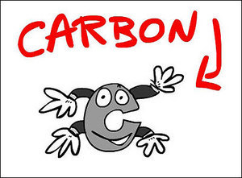
Not all compounds that contain carbon are organic:
- CaCO₃ and NaCO₃ (carbonates)
- Al₄C and SiC ( Carbides)
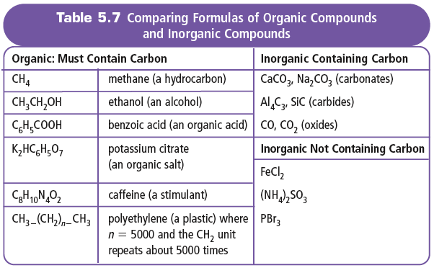
- CO, CO₂ (oxides)

- Organic molecules always have ________________________ in their formulas.
- This differentiates organic compounds from ____________, which almost always start with ___.
Carbon is unique
- Carbon has ________________________ in its ________________ shell, which allows for ______ _______________________________________________ than any other element.
- Long chains of carbons form ___________________ and ___________________.

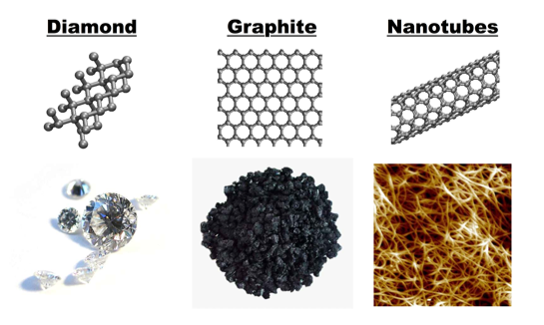
Examples of Carbon:
Diamond, Graphite, nanotubes

Hydrocarbons
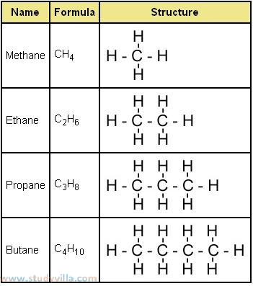
- The ____________________ of organic compounds contain only carbon and hydrogen are called ________________________ (alkanes)
  - The simplest hydrocarbon is methane (CH₄), followed by
  - __________________ (C₂H₆),
  - __________________ (C₃H₈),
  - __________________(C₄H₁₀), and
  - __________________ (C₅H₁₂).
  - All hydrocarbons are __________________________
  - most are ______________________at room temperature.
______________, __________________, and _________________________ are the most common natural source of hydrocarbons

Alcohols
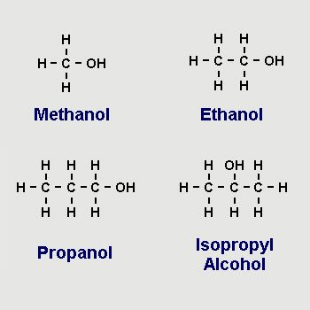
Alcohols are organic compounds with _________________
The simplest alcohols are _______________ (CH₄O),
  - __________________(C₂H₆O), and
  - __________________ (C₃H₈O).
Alcohols are very good ________________(they dissolve other substances).
Alcohols are generally very ____________________.
Methanol is a good ______________ (dissolves many substances water cannot)
Ethanol found in ________________________________________________________
  - Isopropyl alcohol (rubbing alcohol) – ________________________________________ ______________________________________________________________________
  - Methanol, ethanol and isopropanol are _____________________________________

