Biological Molecules

The human body requires both organic and inorganic molecules to function properly.

Inorganic molecules = make up non-living matter and play important roles in living organisms.
Ex. water, salts, acids, bases
Organic molecules = “The molecules of life”:
- contain _____________and __________ are found in every living organism.
- Ex. glucose, phospholipid, amino acids

Carbon is unique:
- has ____ available _____________ bonds allows for other atoms to bind
- capable of forming __________ bonds with __________
- can form _____________ -- can be straight or branched --> great VARIETY of possible combinations.
- Carbon atoms in chains can _________, forming single, double, and multiple____ structures ( eg. Glucose, nucleotides, lipids, proteins)
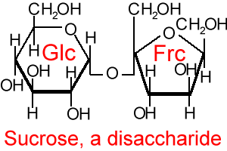
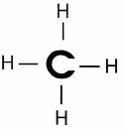
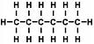
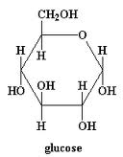

General structure of Organic Molecules
- Contain carbon and hydrogen
- Have characteristic ________________ (carboxyl –COOH, amino –NH2)
Functional Groups:
- Each type of organic molecule has its own specific type of functional group.
- play an important role in the formation of molecules like DNA, proteins, carbohydrates, and lipids.
- hydroxyl, methyl, carbonyl, carboxyl, amino, phosphate, and sulfhydryl.
- Eg carboxyl group – COOH
- Important because it can give up an H+ and ionize to –COO-.
- hydrocarbon chain is _________ and ______________ but once ionized it becomes ______________ and ______________.

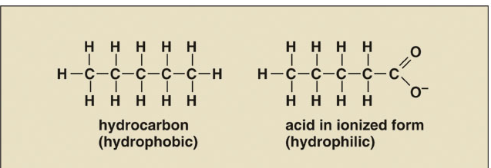
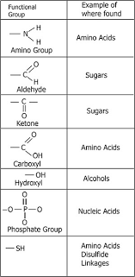
Many organic molecules important to living organisms are large _____________ (polymers).
- Polymers are composed of smaller subunits called __________________.
      - Monomers are small ____________ molecules
      - Can either exist _______________or can be bonded together into long chains to form ____________
      - Mono = “______”: a simple organic molecule that exists individually and has the potential to link with other monomers to form a polymer
      - Poly = “________”: organic molecule made of linked monomers.
      - Protein, starch and DNA are all polymers.
      - Each polymer has a characteristic monomer

Monomer | Macromolecule | Function
Amino acid | Protein | Enzymes speed up chemical reactions, structural components (muscle proteins)
Glucose | Carbohydrates:  Starch  Glycogen  Cellulose | Energy storage in plants  Energy storage in animals  Plant cell walls
Glycerol, fatty acids | Fats and Oils | Long-term energy storage
Nucleotides | Nucleic acids | Genetic material

Polymer Formation:
Common ways to _________ monomers into polymers: synthesis or _______________ polymers into monomers (hydrolysis):

- Dehydration Synthesis
  - one monomer forms a ___________bond to another monomer
  - water is _______________
  - The OH- group from one monomer and H+ from another monomer are removed (and form water)
  - Generally requires ________________
  - Monomer + monomer → polymer + water
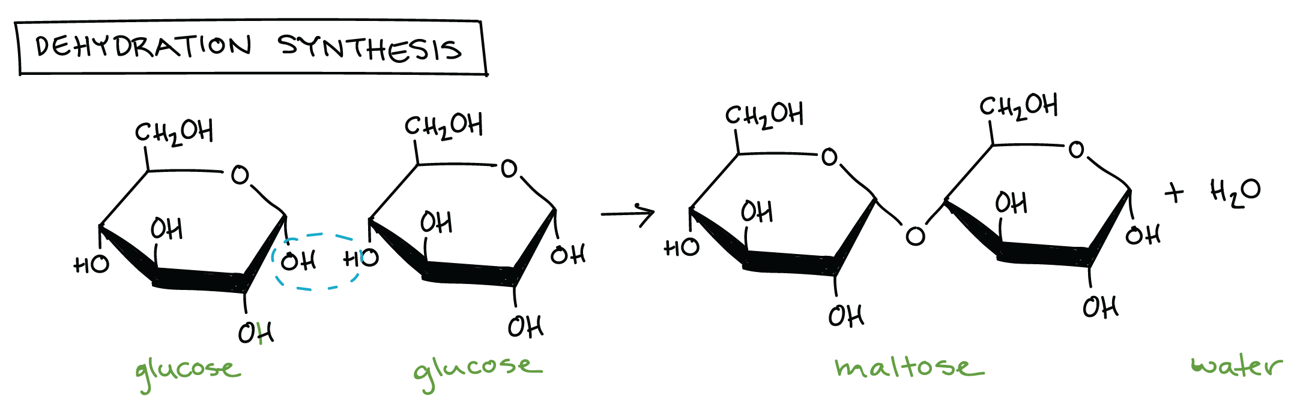

- This is a common link between ____ of a glucose molecule and _____ of a second glucose.
- 2 glucose monomers combine to form a single molecule of the sugar maltose.
- One of the glucose molecules ____________,
- the other ______________group,
- water molecule is released as a _________________ forms between 2 glucose.
- more monomers can join by the same process and the ___________________
- Same process for building _________________ from amino acids:
  - More AA can join to either end to form polypeptides.
  - Large polypeptides are called ________________.

- Hydrolysis
- Polymers are _______________ into monomers via hydrolysis reactions, in which a bond is broken, or lysed, by ___________ of a water molecule.
- hydro = __________, lysis = ____________
- One molecule ______________ and the other takes an __________.
- requires the action of helping molecules called ________________________.
- Occurs when the body needs to _________ one molecule to build a different one
- Water is ___________ and split: OH- & H+ bind to the ends of the free monomers
  - a water molecule __________ maltose to release two glucose monomers:
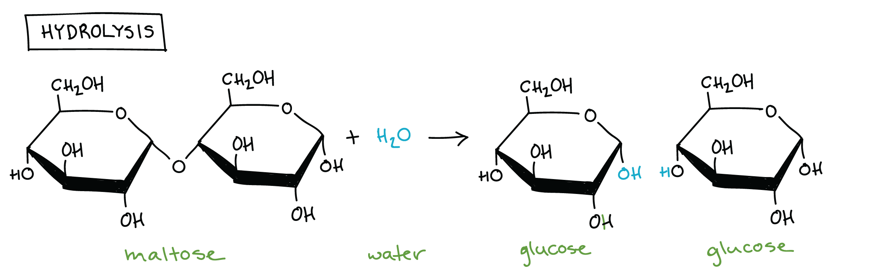
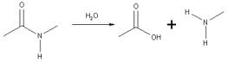
- Generally ______________

_____________ catalyze both dehydration synthesis and hydrolysis reactions
Enzymes involved in _______________ bonds often end with -______________:
- ____________ enzyme breaks down maltose
- ____________ breaks down lipids
- ____________ breaks down proteins

Dehydration Synthesis
- Carbohydrate
Glucose + Glucose -----> Maltose + Water
- Lipid
Glycerol + 3 Fatty Acids -----> Fat + Water
- Protein
Glycine + Alanine -----> Glycylalanine + Water
(Amino Acid) (Amino Acid) (Dipeptide)

- Hydrolysis
- Carbohydrate
Maltose + Water -----> Glucose + Glucose
- Lipid
Fat + Water -----> Glycerol + 3 Fatty Acids
- Protein
Dipeptide + Water -----> Amino Acid + Amino Acid
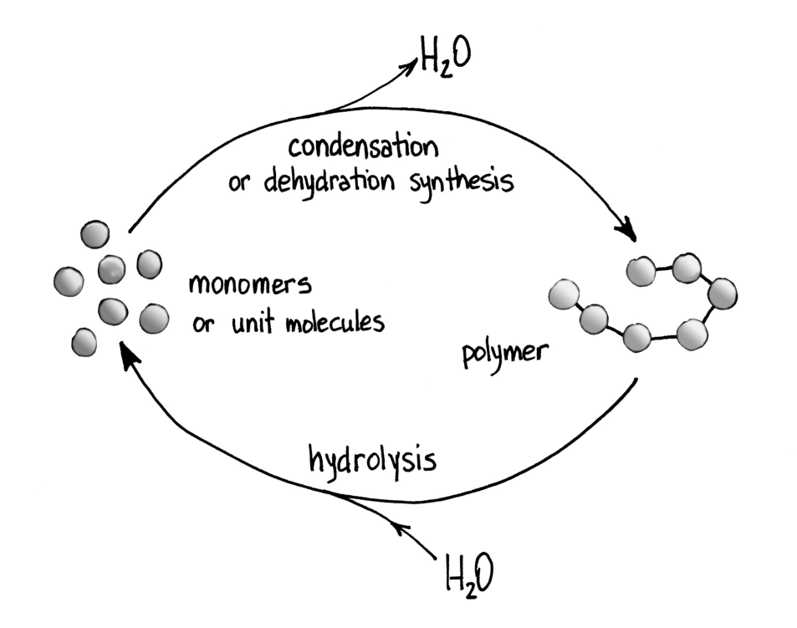

“Molecules of Life” Macromolecules:
Carbohydrates, Lipid, Proteins, Nucleic Acids

Carbohydrates
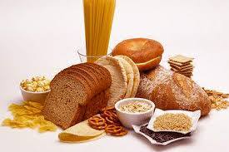
- Carbohydrates are molecules made of _____________,___________,__________
- all have the general formula: _____________
- "__________________" or "Carbo -Hydrate"
- all have general ratio of __________________________
- Carbohydrates are very important in living systems for the following functions:

- __________ energy supply (e.g. glucose is used by all cells to produce ATP energy)
- _________________ (e.g. glycogen is stored in liver and muscles and can be rapidly converted to glucose: starch has a similar role in plants)
- As ________________________________ (receptors & “identification tags”)
- As ___________________ (e.g. plant cell walls are made of cellulose, insect exoskeletons are make for the carbohydrate chitin)

- can be either (small) __________(monosaccharides, disaccharides)
  - most common monosaccharide is ______________
- or very large (___________) like starch and glycogen (polysaccharides).
- Carbohydrate chains come in different lengths, and biologically important carbohydrates belong to three categories: monosaccharides, disaccharides, and polysaccharides.
Ways to represent carbohydrates in pictoral form:

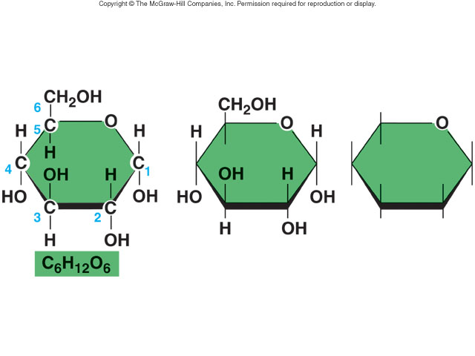

Simple Carbohydrates:
____________________(e.g. Glucose, ribose, galactose, fructose)
- simple sugars with only _____________ unit molecule
- (mono- = “_____”; sacchar- = “________”
- basic formula ___________
- Most carbohydrates end in “_______.”
- often named according to ________________ atoms
  - eg 6-C sugars "hexose" , 5-C sugars "pentose".
- Glucose is the most common monosaccharide in living systems
All cells “___________” glucose to make _________.

eg. 3 main dietary monosaccharies are glucose, fructose and galactose
- are absorbed directly into the blood stream
- are all called hexoses because the all have 6 carbons
- they have the same molecular formula C₆H₁₂O₆
- but have different molecular structures:
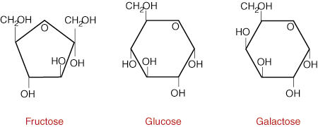
Another important monosaccharide is ribose and deoxyribose.
- Important part of _______________
- Found in DNA, RNA and ATP.

Disaccharides
- Composed of _______ monosaccharides
- ____________ of a disaccharide is a
  - ______________ reaction because water is removed
  - dehydration synthesis.
- ______________is a hydrolysis reaction because water is used to _____________.
- the OH group of one monosaccharide _____________ with the H of another, _________ water and forming a covalent bond known as a ___________________.

two monosaccharides (gluocose) join to form the disaccharide maltose:
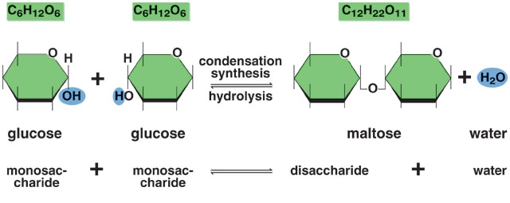

- sucrose (table sugar) is a disaccharide, which is made of glucose and fructose.
- Maltose is made when two glucose molecules join.
- Lactose is made when galactose and glucose join
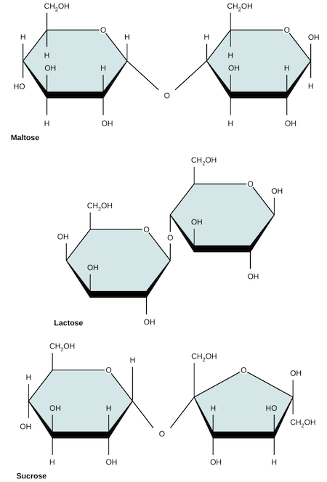
- Eating candy (sugar) provides quick energy because sucrose __________glucose _____________________.
- Cells use glucose as their primary source of energy.

Polysaccharides (Complex Carbohydrates)

- _______________________ energy storage
- A _______________ of monosaccharides linked by ______________bonds.
- The chain may be ____________ or unbranched and may contain different types of monosaccharides.
- molecular weight can be ______________, reaching 100,000 daltons or more
- Starch, glycogen, cellulose, and chitin are some major examples of polysaccharides important in living organisms.
- All are made of _____________ ____________ subunits

STARCH
- _______________ form of glucose in ________________.
- made of fairly ____________chains of glucose, with few side branches off the main chain.
- forms from ____________________ between many glucose molecules.

synthesis
n glucose<=======>starch + (n - 1)H2O
hydrolysis

GLYCOGEN
- storage form of glucose in _______________.
- chains of glucose have __________________
- __________stores ____________________ as glycogen and gradually _________it as glucose is used up for cell functions, maintaining blood glucose level
- Highly __________________

CELLULOSE
- Found in __________________, giving them _____________________
- Glucose units joined in slightly ________________ linkages
- Human digestive system can’t digest cellulose so it passes through the intestines __________________.
- Also called _______________ or roughage
- High cellulose content in fruits, vegetables and grains gives our diet recommended fibre necessary to help prevent __________________.
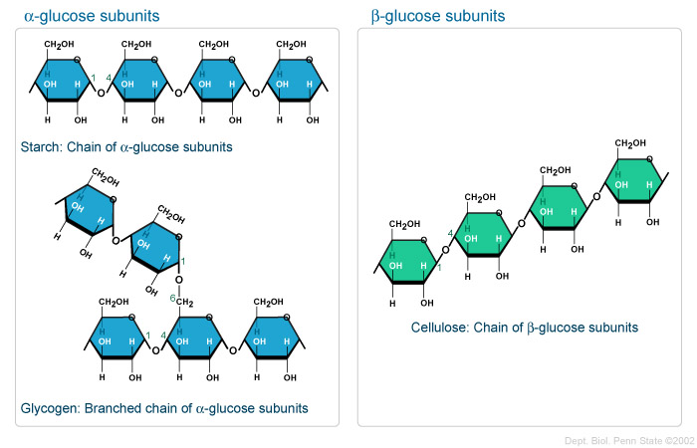

.

CHITIN
- Glucose may be modified by adding a nitrogen-containing group to C2
- Chitin is the polysaccharide made by joining many of these modified glucose molecules
- Chitin is in the exoskeletons of insects, spiders, crabs and other animals.
- Chitin is also found in fungi, such as mushrooms.
- Surgical thread made of chitin dissolves over time.

Carbohydrate Summary:
Smallest carbohydrates are called __________________
________________ is a common monosaccharide.
___________________ are made by joining many monosaccharides, forming _________ bonds between them by _________________ or _____________________

_________________ Polysaccharides:
- __________ in plants
- __________ in animals
_________________ Polysaccharides:
- _______________ in plants
- _______________ in animals & fungi

Lipids
- Common names: _________, _____________, ____________.
- All _____________ in water
- ________________ energy storage:(fat is excellent for storing energy in the least amount of space, and packs 9.1 calories of energy per gram, versus 4.4 for carbohydrates and proteins).
- _____________("blubber")
- _____________of vital organs
- _____________ (e.g.cell membranes are mostly composed of phospholipids, white matter of brain contains a high proportion of lipid material)
- ___________________ (e.g. steroid hormones like testosterone, estrogen, prostaglandins).

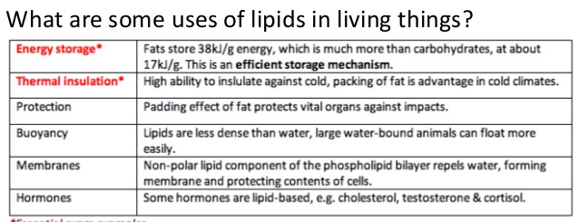

3 MAIN TYPES OF LIPIDS Fats, Phospholipids, Steroids

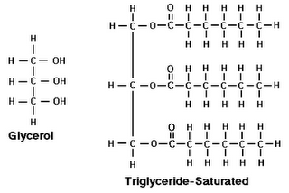
Neutral Fats (Triglycerides)
- ______________ (3C) and three ____________ each 8-22C ) via _________________
- ___________________ molecules form
- wide variety of compounds
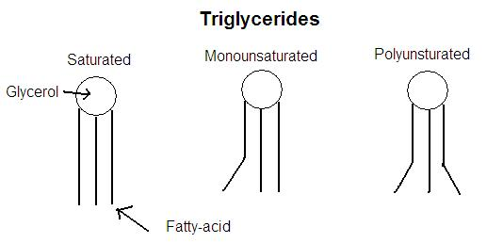
- ______________, _______________

FATTY ACIDS: carboxylic acid consisting of a hydrocarbon chain and a terminal ______________group, especially any of those occurring as esters in fats and oils.
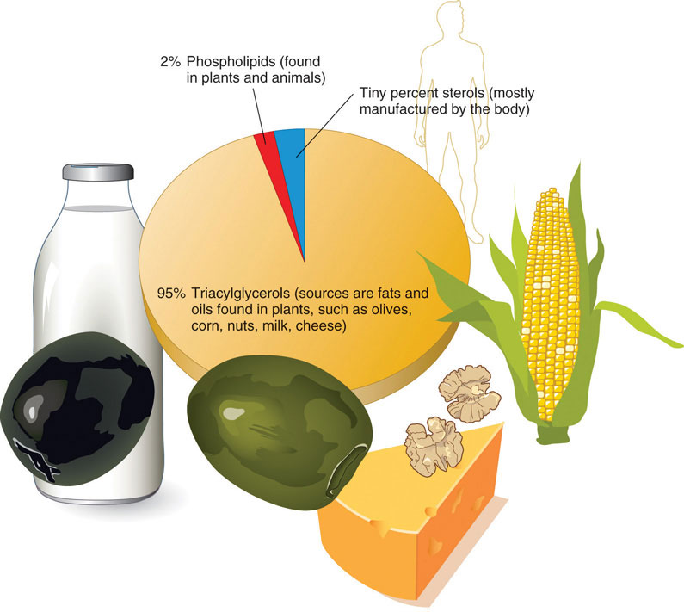
- Saturated or Unsaturated:

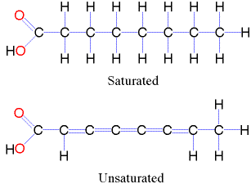

Saturated fatty acids
- ________________ between carbons.
- All carbons are "______________" with hydrogens.
- tend to be _________- at room temp.
- "______" dietary fats known to contribute to _____________, strokes, and cancer.
- butter, lard, meat fat

Unsaturated fatty acids
- monounsaturated have _____ double bond between carbons in chain.
- Polyunsaturated __________ double bond
- ie. carbons are ______ “saturated” with hydrogens.
- tend to be ___________ at room temperature. e.g.vegetable oils
- nuts, seeds, fish, algae, leafy greens, and krill
- Omega-3 unsaturated fatty acids.
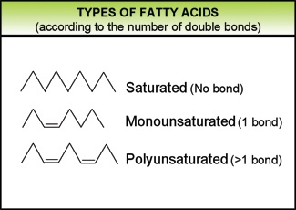
Fats can be emulsified
- A ________ is a salt formed from a _________ and an inorganic ____________.
- Soaps have a ____________, unlike fats, allowing it to __________with water.
- When mixed with oils, soap positions itself about an oil droplet so that its _______ ends ________________________, while its polar ends project ____________. 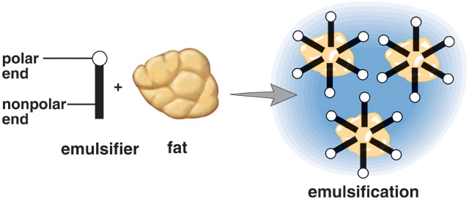
- Fats are emulsified by ________ in the small intestine to aid in digestion.

Phospholipids and Steroids
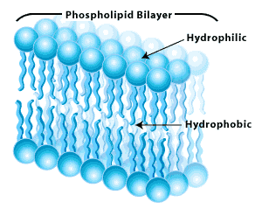
- Consist of:
  - Glycerol }
  - A phosphate group }Water-loving “head”
  - A nitrogen-containing group }
  - 2 fatty acids Water-hating “tails”
- Phospholipids have a fatty acid replaced by a ________________
- The phosphate group can __________ which may give the phospholipid a _____________ “head” and ______________ tail.
- Plasma membrane is made up of a phospholipid bilayer
- Phospholipids make _____________________ membranes like those around the yolk of an egg.

Steroids
- Are lipids with different structure from fats
- Include: Cholesterol and Sex hormones, such as testosterone and estrogen
- common structure of ________________________, as seen in cholesterol:
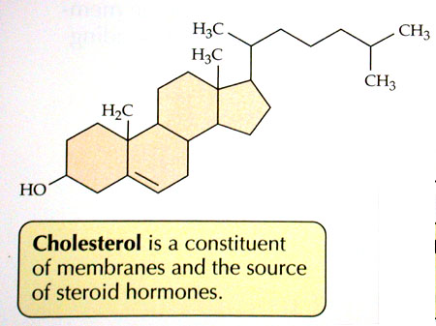

Functions of Steroids:
- Cholesterol maintains the __________________of a cell membrane
- We make cholesterol in our _____________and ________________ (animal fats)
- Steroid hormones direct our cells to do specialized tasks.
  - Sex hormones affect the growth and function of ______________________
  - _________ is active in carbohydrate metabolism and is used to treat allergic reactions.
- Derived from cholesterol →sex hormones _____________ and ______________
  - Essential molecule found in every cell
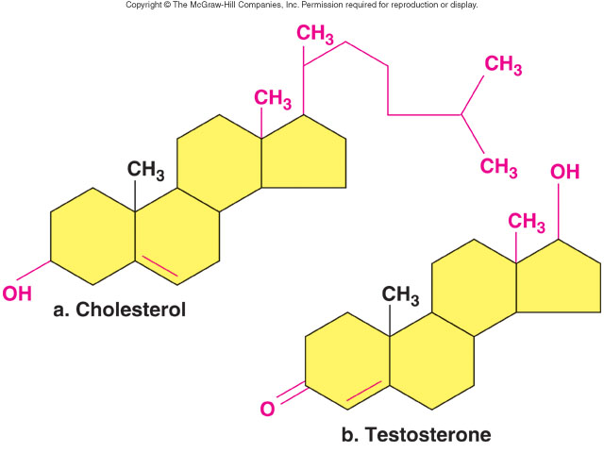
  - Diet _________in ____________ fats and cholesterol can lead to circulatory disorders. ____________________ accumulate in the arteries, restricting the flow.

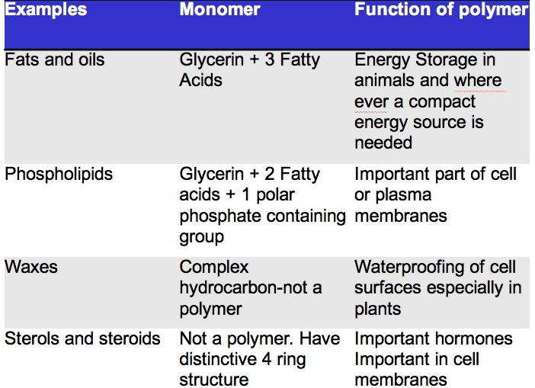

Summary of Lipids
- Fats, made of glycerol and 3 fatty acids, are used for long-term energy storage. Saturated and trans fats are unhealthy.
- Phospholipids have a hydrophilic head and 2 hydrophobic tails. Cell membranes consist of a bilayer of phospholipids.
- Steroids consist of 4 interconnected rings. Cholesterol and the sex hormones are examples of steroids.

Proteins
- Large complex macromolecules consisting of long chains of subunits called amino acids.
- three main functions:
- ____________________ (e.g. elastin, collagen in cartilage and bone, muscle cells)
- __________________ (actin and myosin etc. in muscle cells)
- ___________________:
  - _______________ (biochemical catalysts that speed up biochemical reactions). Crucial to life.
  - _______________: proteins of your immune system that fight disease.
  - ________________: hemoglobin is a protein that transports oxygen in your blood. Proteins in cell membranes act as ______________ for molecules entering or leaving the cell.
  - ______________: eg insulin. Hormones control many aspect of homeostasis.
- all proteins are composed of ___________ (like a train is made up of individual railway cars)

Amino Acids:
  - _______________ atom bonded to a hydrogen atom and three groups:
    - ________________ (– NH2)
    - ________________ (-COOH)
    - _________________ (R)
  - There are _____ different amino acids in living things.
  - Our bodies can make ______of these.
  - The other 8 we must get from food, “_______________________.”
  - Amino acids join together through _______________________
  - AA are joined together by ___________________

- 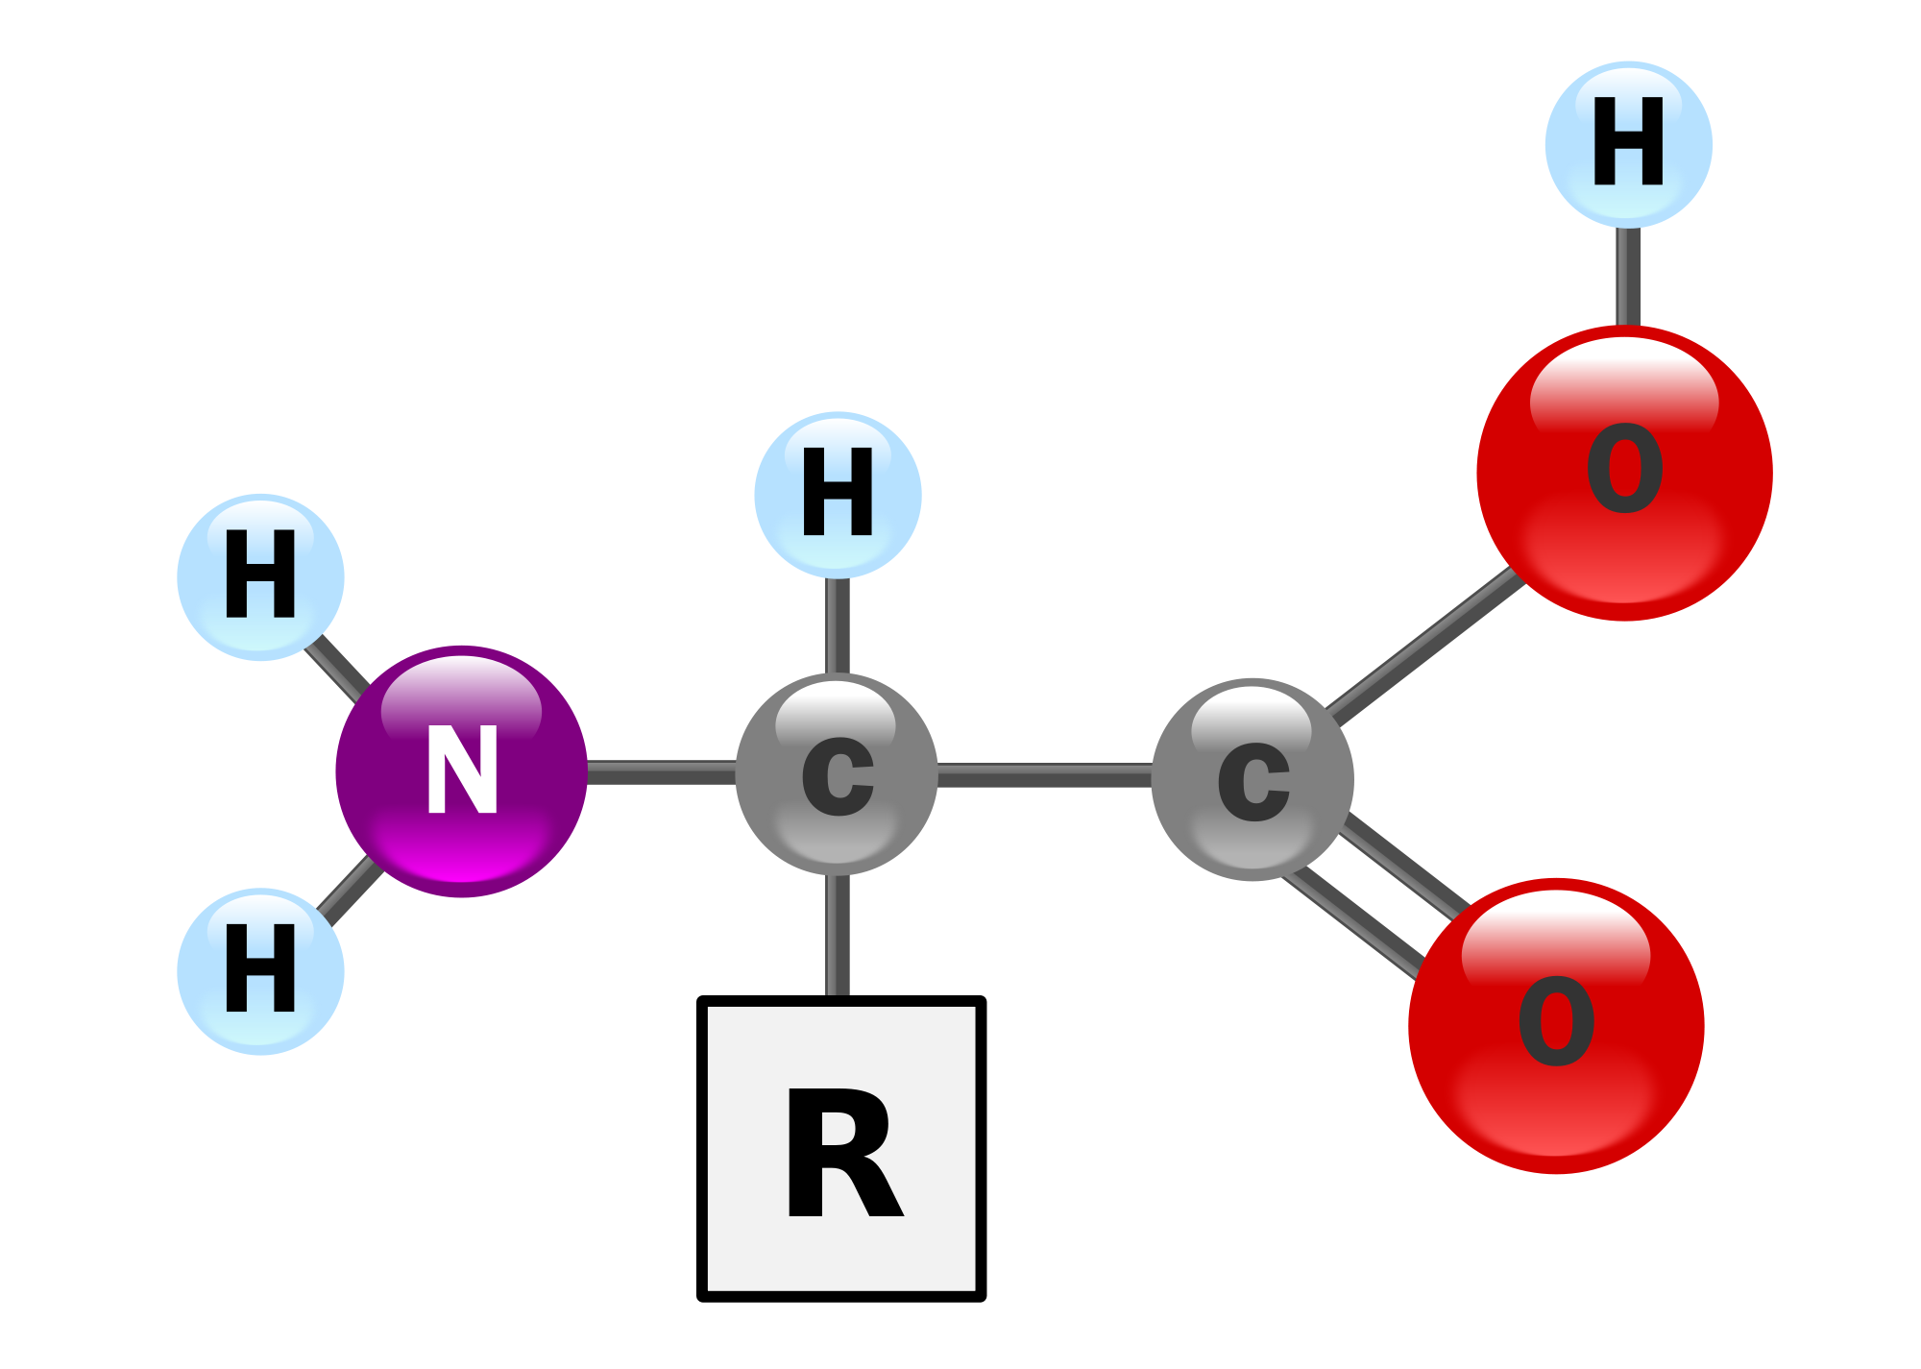

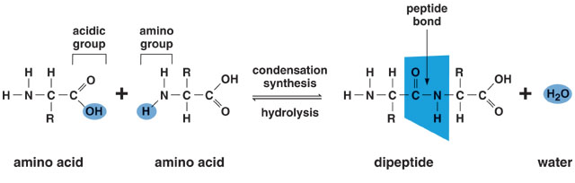
- Atoms associated with a peptide bond are ______,_____ ,_____and ______.
- Both H and O end up with _____________ making the peptide ___________.
- ________________: ______ amino acids joined together
- ____________________ is a ______________chain of amino acids
- Polypeptide (abreviation = ppt): >2 amino acids joined together. Usually short: less than 20 amino acids or so.
- a polypeptide chain is called a ______________ when it gets large (usually ~75 or more amino acids in length – though there is no absolute rule here)

Proteins have Four levels of organization
The ________________of the protein is critical to its ______________.
_____________________- linear sequence of the amino acids joined by the peptide bonds
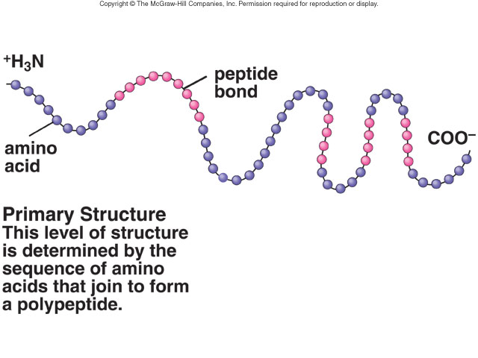
- two polypeptide chains that have _________________ primary structure (different sequence of the 20 amino acids):

1-2-4-4-6-4-8-9-12-3-5-6
3-5-7-8-9-12-13-19-23-24

Secondary Structure-_______________________
- Folding of regions of polypeptide
- since peptide bonds are polar, ___________ routinely occurs between amino acids in the primary line.
- may cause the chain to _________ up into a shape called an ________________.
- Or form layers called “________________________”.

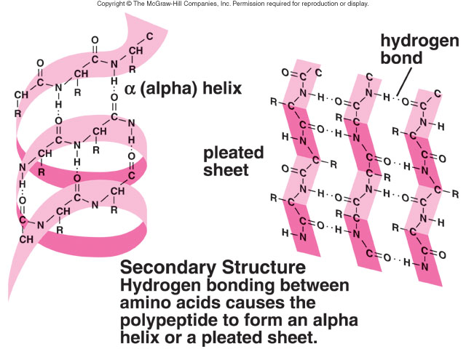
Tertiary structure- ________________
- Folding of the entire protein into a characteristic shape
- May be held together by _____________________ bonds between -R groups makes the alpha helix bend and turn, forming "globs" of protein of all shapes.
- May look random but the final 3-D shape is very _____________and precise.
- shape due to the ____________________ of amino acids (the primary structure), as this is what will determine which amino acids in the chain will bind with each other, and in what way.
- May be globular (enzymes) or fibrous (hair proteins)

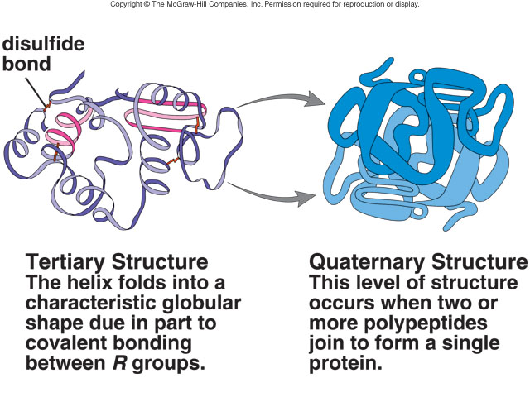
- In ____________, the helical chains of myosin forma rod shape that ends in ____________ heads.
- In ______________ the helix bends and twist in different ways:
- Hydrophobic portions are inside, hydrophilic on the outside
QUARTERNARY STRUCTURE:
- Association of 2 or more proteins
- For proteins with more than one polypeptide chains, it is the specific arrangement of polypeptide chains in that protein
- Example: ________________, the oxygen-carrying protein in blood, consists of a complex of four polypeptide chains of globin proteins interlocked in a specific way

Final shape of a protein determines its function
- changes in _____________ or _____, presence of certain _________or heavy metals, can ____________ the bonds that hold a protein together in its particular shape.
- If a protein is ________________, it has lost normal structure/shape because normal bonding between -R groups has been disturbed.
 Examples of denaturing include
-  heating an egg white (> 50°C will denature most animal enzymes)
-  adding vinegar to milk (changing the pH)
-  adding heavy metals such as lead and mercury also denature proteins.
Examples of Proteins
Hemoglobin that transports ______________
- Keratin in _________ and ____________
- _____________ in ligaments, cartilage, bones and tendons
- Part of __________
- Part of _____________ that catalyzereactions

Draw the structure of an amino acid:

Which of the following is not a major function of proteins in the cell?
a) structure
- b) catalysis
- c) energy storage
- d) transport of materials
- e) signaling
What is the primary structure of a protein?
a) the unique sequence of amino acids
b) repetitious twisting and folding of the polypeptide backbone
c) the three dimensional structure of a single polypeptide chain
d) the structure created when 2 or more polypeptides combine to form a single functional protein

Nucleic Acids
- Nucleic acids are macromolecules that store and transmit inherited information.
- DNA and RNA are two types of nucleic acids.
- DNA and RNA are long chains of subunits called nucleotides
  - Part of DNA – the ____________ code
  - Part of RNA – which aids in _______________ synthesis

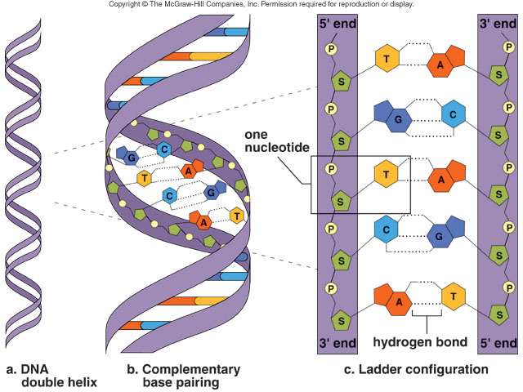

Nucleic acids are made up of ______________________
- Nucleotides made up of 3 parts:
- ________________ (monosaccharide), either deoxyribose or ribose
- _________________
- _________________ (single or double ring structure)
    - __________________ are have only 1 ring
    - Cytosine and Thymine are ________________
    - In RNA, Uracil is in place of Thymine
    - The _________________have 2 rings
    - Adenine and Guanine are __________________
    - A forms 2 hydrogen bonds with T
    - G forms 3 hydrogen bonds with C
- Nucleotides are joined so that the backbone consists of alternating phosphate groups and monosaccharides
- Nucleotide strands have ends: 5’ and 3’ (’ = “prime”)
- DNA is double stranded, RNA is single stranded
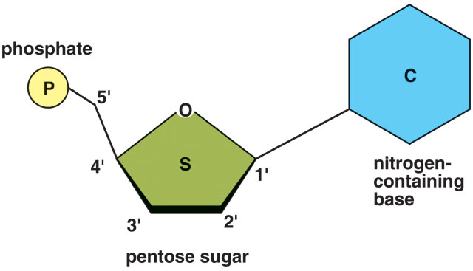

- formed by _________________
- function in the ____________and _______________of cells and organisms.
- _____ is composed of nucleotides having the sugar _____________, while RNA nucleotides contain the sugar _____________.
- _________ are composed of DNA, and with the help of RNA, DNA specifies protein synthesis.
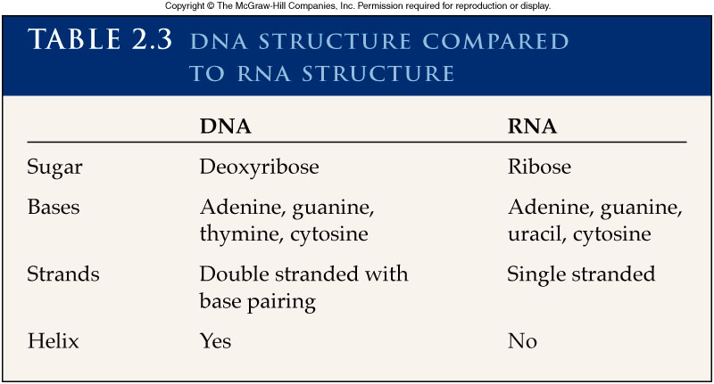

ATP is a nucleotide
- _______________________
- ________________ carrier in the cell
- Base ____________is joined to the sugar ________(together called adenosine) and 3 phosphate groups
- Energy is created when one phosphate group is _______________
- Energy released is used for many cell functions
    - ______________ of macromolecules
    - ______________ contraction
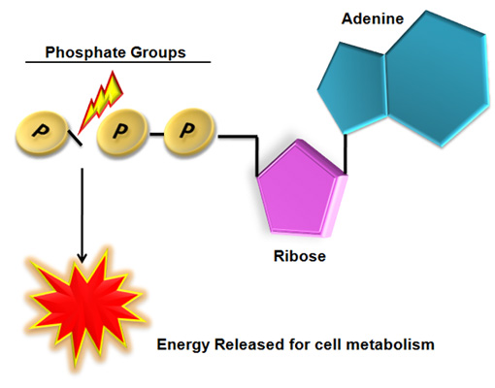
    - ______________ conduction
- ATP is reformed with input of energy

Circle which is true:
- DNA will have equal amounts of …
- A and G
- G and C
- T and G
- C and A

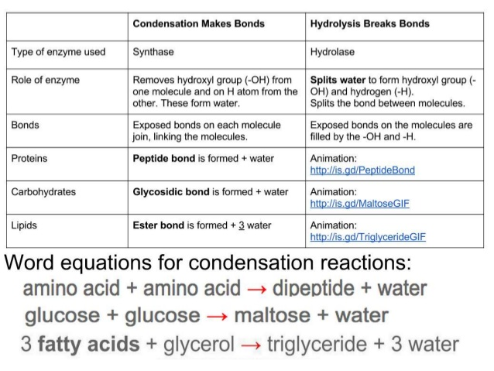

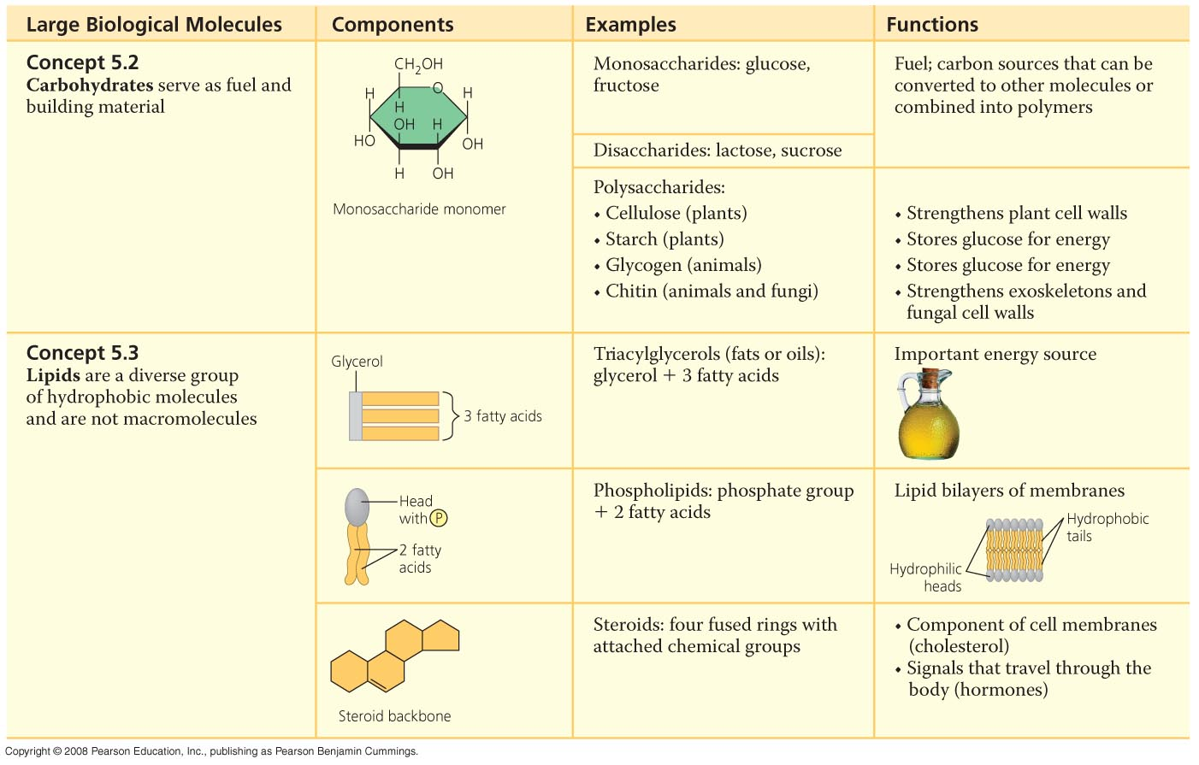
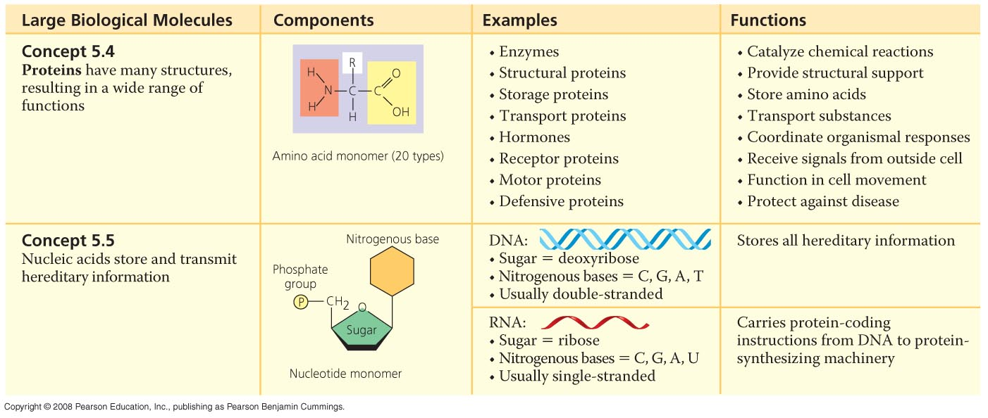
- How can you know that a structure is a carbohydrate and not a lipid?
- What is the difference between a polysaccharide and a disaccharide?
- Triglyceride or neutral fats are terms for the same thing. What is the general structure of them?
- Glycerol, glycogen, glucose????

