**MOVEMENT WS**

Vocabulary 5-4: Movement of Materials Through the Cell Membrane

|  |  |
| --- | --- |
| Homeostasis, p31 |  |
| Diffusion |  |
| Osmosis |  |
| Gradient |  |
| Equilibrium |  |
| Selectively Permeable |  |
| Isotonic |  |
| Hypotonic |  |
| Hypertonic |  |

Text reference pages 100-102

1. How is osmosis involved in homeostasis?
2. Compare and contrast osmosis and diffusion.

[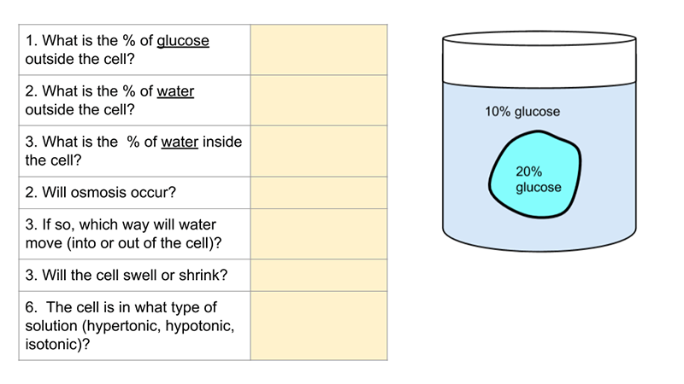](https://docs.google.com/presentation/d/1lCOccZiO5ckp8rxrPXBYdOJRI-wnCJO_WPslYWdz9Go/edit?usp=sharing)

1. Observe the cell in the container below to complete the chart on the right.

[](https://docs.google.com/presentation/d/1lCOccZiO5ckp8rxrPXBYdOJRI-wnCJO_WPslYWdz9Go/edit?usp=sharing)

1. Observe the experiment with a glass U-tube below:



a) Compare side A to side B in terms of tonicity: _________________________________

b) Which way will the following move? Choose either ( A🡪B, or B🡪A, or neither)

Water _________________________________

Glucose ________________________________

c) What happens to the concentration of the glucose of side B as the experiment runs?

1. Describe what would happen if you put a red blood cell into a hypertonic solution?
2. Going further: Check out this osmosis simulation (Grade 12):

<http://video.esc4.net/video/assets/Science/Biology/Gateway%20Resources/cell%20homeostasis%20virtual%20lab%20-%20activity/index.html>

**Transport WS** Chapter 5-4 (read pages 89-104)

|  |  |
| --- | --- |
| Passive Transport |  |
| Active Transport |  |
| Contractile Vacuole |  |
| Carrier Protein |  |
| Facilitated Diffusion |  |
| Active Transport |  |
| Endocytosis |  |
| Phagocytosis |  |
| Pinocytosis |  |
| Exocytosis |  |
| Protein Pump |  |

1. How do active and passive transport different from each other? Give an example of each.
2. Describe the process of endocytosis. What material is moved in this way? Draw and label a diagram illustrating this.
3. What ions are moved across a membrane by pumps?
4. Why would a cell pump certain ions against a gradient?

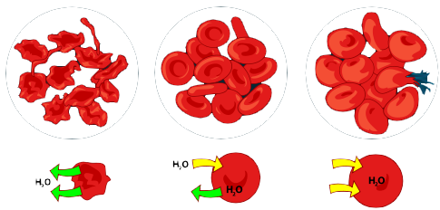**Summary:**

1. Label the three images as either isotonic, hypertonic, or hypotonic

Fill in the blank. Not all choices will be used: Osmosis, diffusion, endocytosis, exocytosis, equilibrium, high, low, equal, Selectively permeable, impermeable, Active, passive, facilitated, energy, phospholipid, bilayer, proteins, molecules, solute, solvent, solution, hypotonic, isotonic, hypertonic, solute, solvent, solution.

2. Movement across the cell membrane that does not require energy is called __________________________transport.  
3. The cell membrane is composed of proteins embedded in a ___________________ bilayer.

4. If there is a concentration gradient, substances will move from an area of high concentration to an area of _________________concentration.

5. The cell membrane is _______________________________  
6. _______________________is the simplest type of passive transport.  
7. The diffusion of water through a selectively permeable membrane is called _____________________.

8. The direction of water movement across the cell membrane depends on the concentration of free water _____________________________

9. A solution that causes a cell to swell is called a __________________________________solution.

11. The process of taking material into the cell by infolding of the cell membrane is called   
______________________________

12. In ___________________________ diffusion, membrane proteins help molecules across the membrane.

15. Facilitated diffusion moves substances down their concentration gradient using _________________

16. In salt water, the salt is the ____________________ and the water is the ___________________.