**MOVEMENT WS**

Vocabulary 5-4: Movement of Materials Through the Cell Membrane

|  |  |
| --- | --- |
| Homeostasis, p31 |  |
| Diffusion |  |
| Osmosis |  |
| Gradient |  |
| Equilibrium |  |
| Selectively Permeable |  |

**Osmosis and Tonicity Practice** Text reference pages 100-102

1. How is osmosis involved in homeostasis?
2. Compare and contrast osmosis and diffusion?
3. [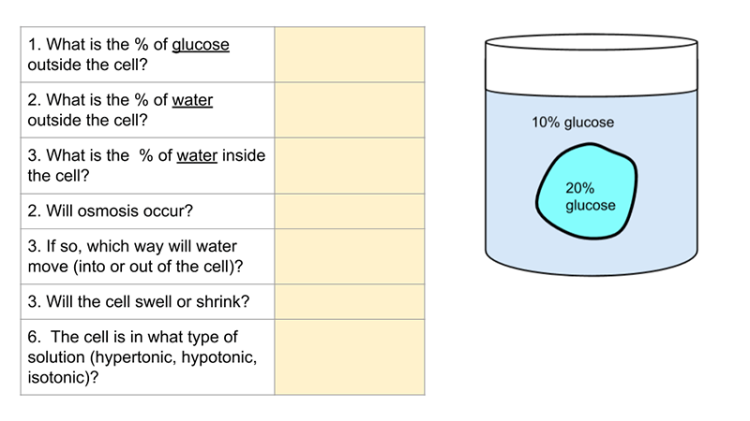](https://docs.google.com/presentation/d/1lCOccZiO5ckp8rxrPXBYdOJRI-wnCJO_WPslYWdz9Go/edit?usp=sharing)Complete the Chart
4. Observe the experiment with a glass U-tube below:



a) Compare side A to side B in terms of tonicity:

_________________________________

b) Which way will the following move? Choose either ( A🡪B, or B🡪A, or neither)

Water _________________________________

Glucose ________________________________

c) Name the process(es) involved in movement.

________________________________________

d) What happens to the concentration of the glucose of side B as the experiment runs?

**Transport WS** Chapter 5-4 (read pages 89-104)

|  |  |
| --- | --- |
| Passive Transport |  |
| Active Transport |  |
| Isotonic |  |
| Hypertonic |  |
| Hypotonic |  |
| Contractile Vacuole |  |
| Carrier Protein |  |
| Facilitated Diffusion |  |
| Active Transport |  |
| Endocytosis |  |
| Phagocytosis |  |
| Pinocytosis |  |
| Exocytosis |  |
| Protein Pump |  |

1. How do active and passive transport different from each other? Give an example of each.
2. Describe the process of endocytosis. What material is moved in this way? Draw and label a diagram illustrating this.
3. What ions are moved across a membrane by pumps?
4. Why would a cell pump certain ions against a gradient?