ES 11 Ocean Acidification Experiment Name:

Purpose:
To understand the affects of ocean acidification, we are going to be doing an experiment with clam and snail shells. Clams and snails are primary consumers, which means they are the second level of the food chain that eats producers like algae and seagrasses. Sometimes they even eat each other and other invertebrates. These organisms are vital food sources for animals higher up in the food chain and are greatly affected by ocean acidification because it makes it difficult for them to create shells. It also breaks down shells that are already formed, which is what you are going to see.
Materials:
- Empty shells from the beach (make sure these are empty and do not have living animals in them)
  - ALTERNATIVE: this activity can also be done with chalk. Chalk is made out of calcium carbonate, just like clam shells.
- Water
- Salt
- Vinegar
- 3 clear containers/glasses
Preparation:
1. Fill one container halfway with fresh water, one with salt water, and one with vinegar. There should be enough solution in the container to completely submerge the shell.
Experiment:
Before you begin the experiment, make some observations about the shells. Record their colour, shape, texture, and durability (are they hard or flexible). You may wish to take pictures of the shells to help remember your observations.
What do you think is going to happen in each of your samples?
After your observations, place one shell in each of the glasses. Leave the shells undisturbed for one hour, then record observations from each of the containers.
Leave the shells in the containers overnight (approximately 12 hours) and record observations again from each of the samples.
Leave the shells again until 24 hours have passed since the start of the experiment. Take your observations again, this time removing the shells from their containers. What do you notice now about the shells in each of the containers?
Observations:
- Are there any bubbles in the water?
- Has there been any change to the colour of the shell?
- Has there been any change to the shape of the shell?
- Has there been any change to the durability of the shell?
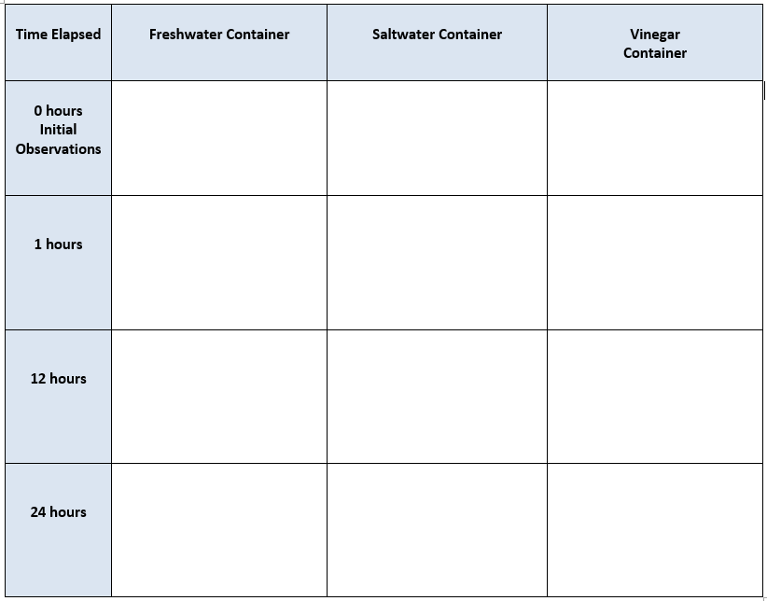

Questions: Name:
1. a) How did the shell change during the 24 hours in the freshwater?
In the salt water?
In the vinegar?
2. Why do clams and crabs have shells? What purpose to their serve for their survival?

3. How would the acidic solution affect a clam living in the ocean? What does a weakened shell mean for the clam?

4. What are your sources of error? What would you need to change to eliminate this error?

5. Do you want to change any of your variables? How do you expect it to change your results?

6. What are the implications of this experiment? How might your results impact the natural world? How might it affect humans?

7. Who benefits from the results of your study?

Who might oppose your findings?

10. Identify sources of carbon production in your life. What reasonable changes can you make to reduce your release of carbon into the atmosphere? Be specific.

