Growing Bacterial Samples from our School

Purpose: To collect bacteria samples from a variety of sources in our School and to grow these samples on a nutrient agar plate.

Materials: 1 nutrient agar plate, 1 permanent felt pen, 4 cotton swabs, 1 incubator

DAY 1: OBTAIN BACTERIAL SAMPLES
Procedure:
- Create a question that you will test by observing bacterial growth.
Testable Question (example: which part of Ms. Wilson’s classroom/the school will yield the most bacteria?)

- Label the bottom edge of your agar plate with your names, date & block. Divide your plate into 4 equal sections along the bottom:
Figure 1:

- One quadrant will be your control (distilled water): Dip a clean cotton swab in a small beaker of water. Slightly open the lid of your plate and gently streak the cotton swab along your agar plate starting by the edge and making an “S” shaped motion towards the middle of the agar plate. Be careful NOT TO PUNCTURE the agar! Put the lid back on immediately. Label this quadrant: CONTROL. Dispose of the swab in the container provided.

- Collect 3 SAMPLES from the school by gently rubbing a NEW, wet cotton swab on a surface. Use a new swab for each location. **DO NOT DISRUPT OTHER CLASSES **.

- Label each quadrant with object/specific location.

- Once you have obtained 3 different samples, tape the lid of your agar plate to the base with 1-2 small pieces of masking tape on opposite edges. Now, place your plate UPSIDE DOWN in the incubator. **It must be upside down so that any condensation will drip into the lid and NOT onto the agar- otherwise the moisture may drown or dissolve bacterial colonies!

DAY 2: OBSERVE BACTERIAL COLONIES

Background Info: Bacteria becomes visible to the human eye after many rounds of cell division / reproduction result in the formation of bacterial colonies. A typical bacterial colony that can be seen has 1 billion bacterial cells! Bacteria reproduce asexually using binary fission. Asexual reproduction produces clones that are exact copies of the original parent cell. Mutations can arise randomly creating some variation.

Observing the characteristics of bacterial colonies is helpful in identifying and classifying bacterial species. The classification process can be helped by observing the colour, elevation and margin of bacterial colonies

Observations:
- Record observations by making a DETAILED sketch (USING A PENCIL) of all the colonies found on your agar plate on Figure 1a below:

- Use the posted diagrams to help describe your colonies observed in the table below.

Table 1: Description of Bacterial Colonies

Location of Sample 1: | Location of Sample 2: | Location of Sample 3: | Location of Sample 4:
Form of Colonies: | Form of Colonies: | Form of Colonies: | Form of Colonies:
Elevation of Colonies: | Elevation of Colonies: | Elevation of Colonies: | Elevation of Colonies:
Margin of Colonies: | Margin of Colonies: | Margin of Colonies: | Margin of Colonies:
Colour: | Colour: | Colour: | Colour:
Other Observations: | Other Observations: | Other Observations: | Other Observations:
Inference about type of bacteria: | Inference about type of bacteria: | Inference about type of bacteria: | Inference about type of bacteria:

Discussion Questions

- Why must bacterial plates be incubated upside down?

- Observe some other groups’ cultures. Which locations yield the most bacteria? Why do you think this is?

- What are some sources of error that occurred during the experiment? How could you expand / improve this experiment in the future?

- How are bacteria able to increase their genetic diversity? (Think of all the ways bacteria reproduce).

- Write a conclusion based on your testable question. Use a CLAIM, EVIDENCE, REASONING format to answer.

Curricular Competency | Emerging | Developing | Proficient
Analyzing Data - Use knowledge of scientific concepts to draw conclusions that are consistent with evidence | Finds patterns in data and makes a limited claim about relationships based on these patterns | Identifies and explains the evidence used to support claims about relationships | Fully and effectively explains and gives detailed reasoning for claims about relationships using specific evidence
Evaluating - Describe specific ways to improve their investigation methods and the quality of the data | Identifies a source of error and explains how it could have been improved. | Identifies multiple sources of error and explains the effect on the data and how to improve | Explains multiple sources of error and suggests appropriate methods to improve investigations

Background Information: These are the possible bacteria that you might find. Use the following to make an educated hypothesis
Type of Bacteria | Possible Habitat | Colony Morphology
Micrococcus | It is very common on skin, and it can also be found in soil, water, and meat products. It is generally a saprophyte (meaning it feeds on dead and decomposing materials) and can cause spoilage of fish. It is an obligate aerobe. | Spherical, occurring in pairs, tetrads, or irregular clusters, not in chains.  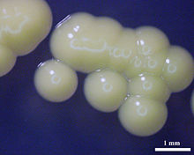
Staphylococcus | Found virtually everywhere. It is very common on skin, and can also be found in the nasal passages, throats, and hair of 50% of healthy individuals. Staphylococcus is able to grow both with and without oxygen. | white, raised, cohesive colonies approximately 1-2 millimeter in diameter  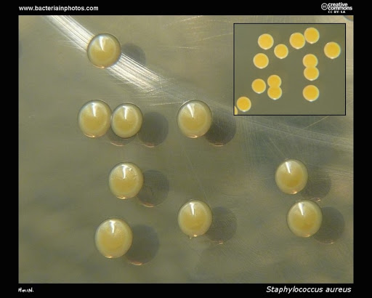
Bacillus | Found in soil, water, dust, and sometimes within the human digestive system. | Flat, slightly convex, irregular edges  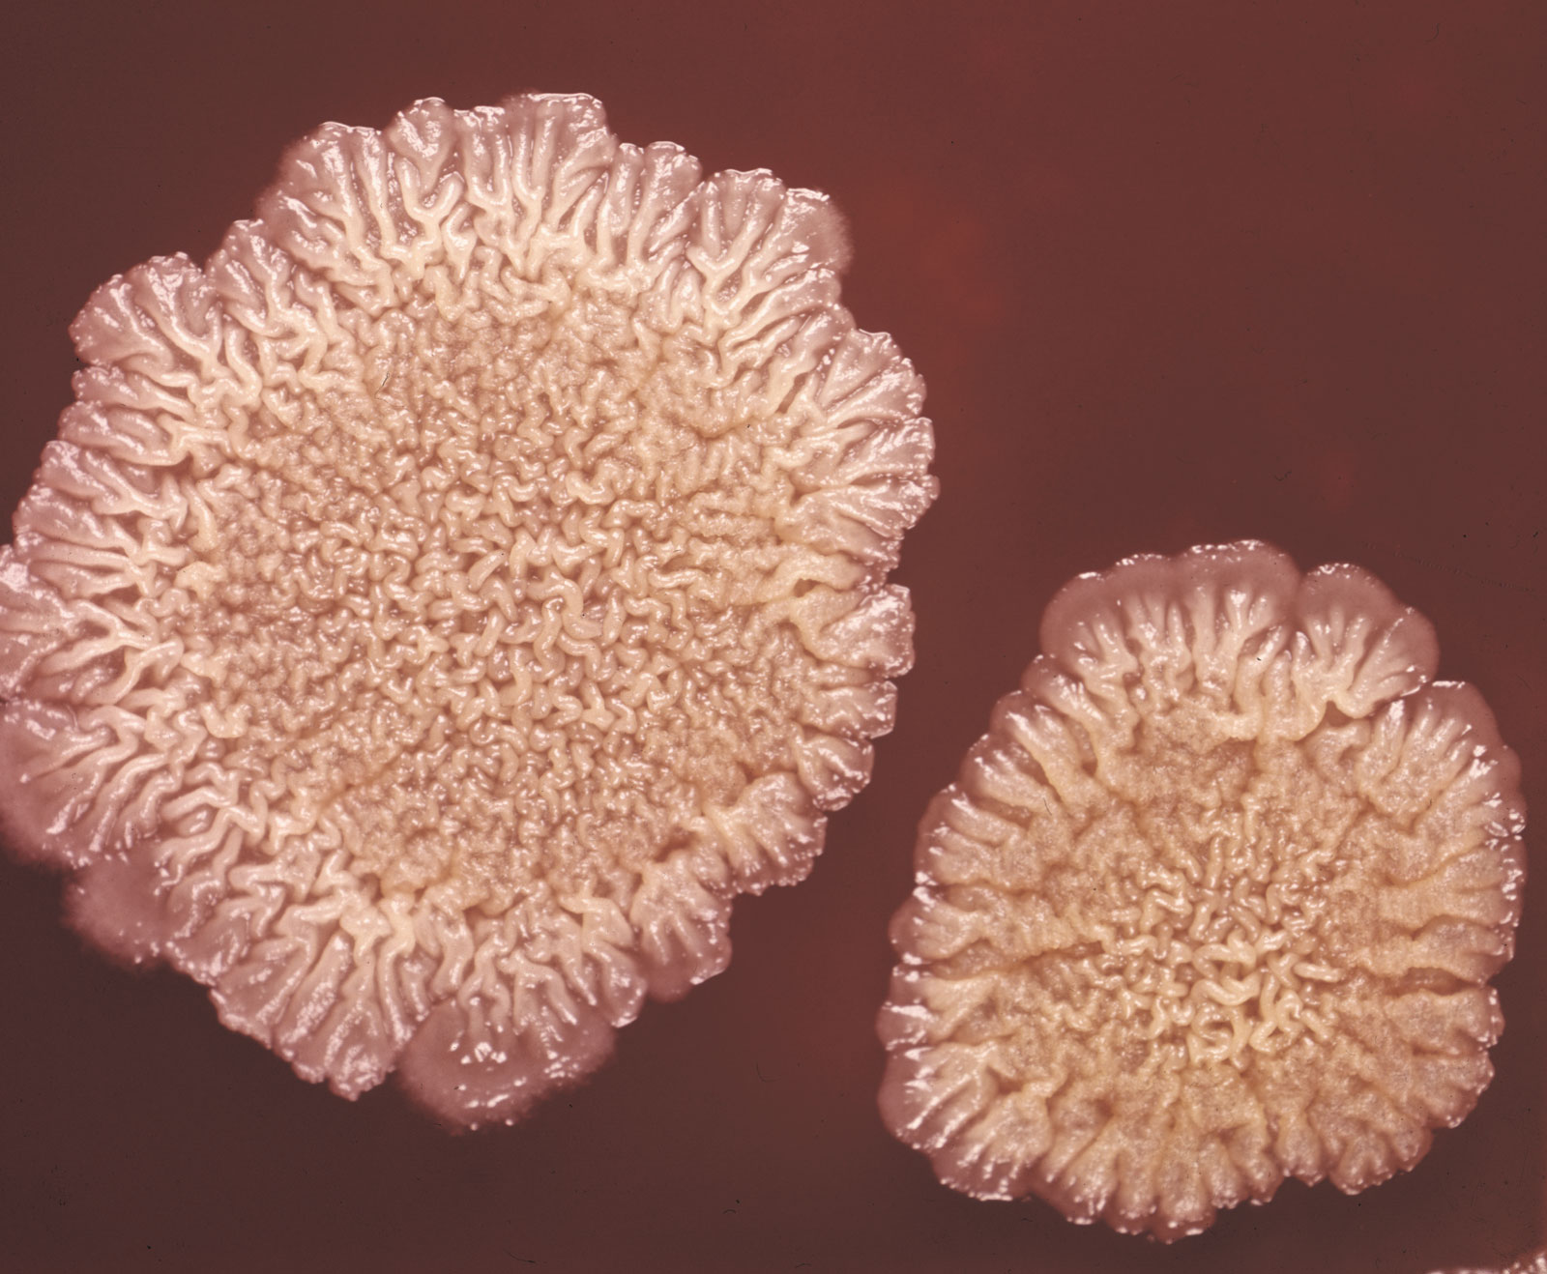
Pseudomonas | Found in soil and water, and on plants. | Circular, Convex, entire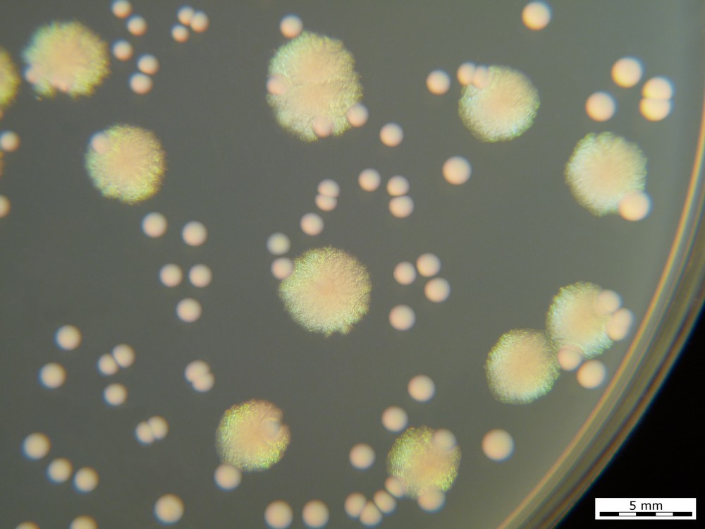
Bacteroidaceae | “Fecal” bacteria or from the gut | Small (2 mm or less), large (over 2 mm) Entire or uneven Raised or convex White, grey or black Opaque or translucent  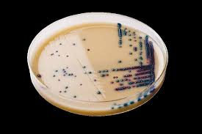
Propionibacteriaceae | Skin bacteria. This family of bacteria is often found in intestinal tracts of animals, and in dairy products, but with humans it makes its home in the pores. It is sometimes associated with acne. | Pigmented in an array of colors from white to red. Usually circular or punctiform colonies.  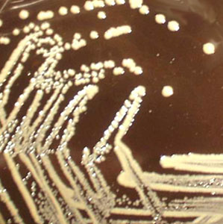
Enterococcus | “Eaters' keyboards” often contain this. Can be found in gut, mouth and bowl | approximately 1 to 2 mm in diameter. Appear as smooth, cream or white. Umbonated.  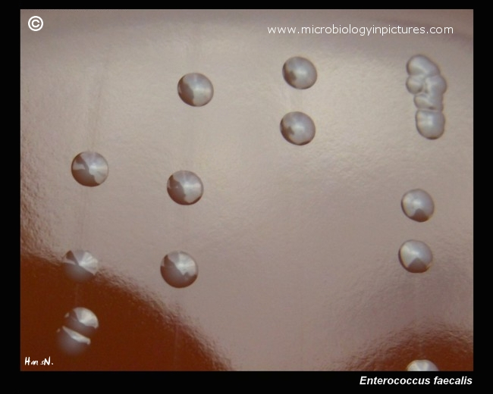

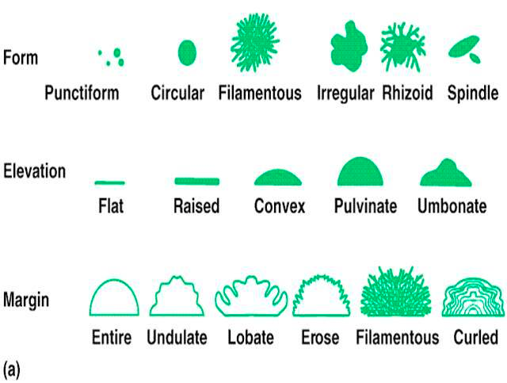

- Give 2 reasons to help explain why bacteria are the most common living thing on Earth.
- What are the possible basic shapes of bacterial cells? How does the scientific name of bacteria relate to the shape? (Hint: streptococcus). Why is this helpful for biologists?
- Microbiologists will often use a Gram Staining Technique to classify bacteria. Explain the difference between Gram-Negative and Gram-Positive Bacteria. Would this be a useful technique in this experiment? Why or why not?
- In this experiment were you able to observe the shape of a single bacterial cell? Why/Why not?

- In this experiment, were you able to identify each of your strains of bacteria? Why or why not?

