Sci 8 Electromagnetic Radiation (EMR) Inquiry Name______________
The various wavelengths of the electromagnetic spectrum are used in a multitude of ways:
https://science.nasa.gov/ems/01_intro
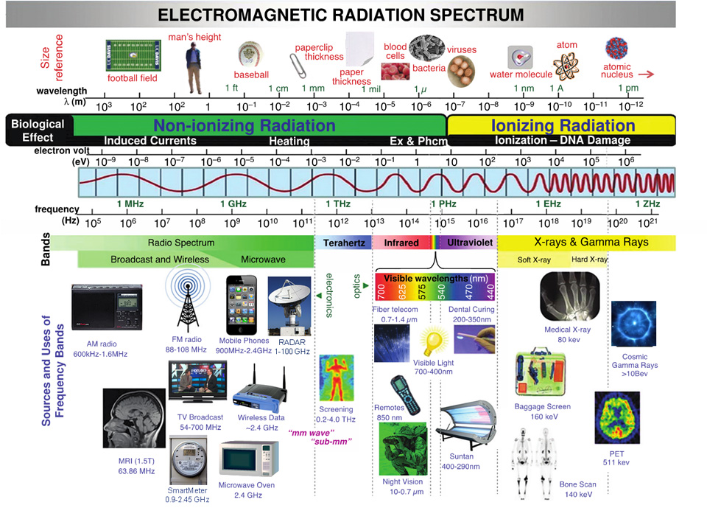

Step 1: Get Curious
- Think of examples from the electromagnetic spectrum that affect your life.
- Think of situations or devices that you use them.
- What are the positive impacts on your life?
- What are the negative impacts?
- What are you curious about? What do you want to know more about?

Step 2: Develop your own thick question- something you are curious about and will deepen your knowledge of the topic.
______________________________________________________________________________
______________________________________________________________________________

Step 3: Student-Teacher Conference and Teacher Approval:

Step 4: Discover. Research your topic. (2 Library classes). Make notes as you go. Use the template to write brief points and ideas, not full sentences. Note your sources as you will need to cite them.

Step 5: Synthesis (Put it all together)

This stage may be difficult as it requires a lot of thinking about your notes.
- You might analyze your information (compare, criticize, examine)
- You might evaluate your information (appraise, defend, judge)
- You might construct or create using your information (design, assemble, formulate)

Step 6: Present your ideas. Share your learning, demonstrate understanding. Turn in written presentation as well as verbally share what you learned to your peers. Each presentation will:
- Introduce your inquiry question.
- Show the importance of your topic (relate to EMR)
- Include SIGNIFICANT aspects such as:
  - Any interesting facts or statistics?
  - Pros/Cons/Dangers/Controversy/Studies
  - How it works
  - Impact on our health/teens – how does it impact you personally?
  - Give examples where applicable
  - Your own thoughts on this topic
  - Visuals - diagrams, charts, pictures, etc.
- Along with your presentation you must submit your properly formatted bibliography with all sources you have used in Step 4.

Criteria:
- Content – all components are covered in detail. Uses at least
2-3 credible sources. / 10
- Visuals – must be colourful, relevant info, show effort. Show
sources. / 5
- Presentation – everyone must speak, loud, clear, interesting,
knowledgeable, prepared, confident / 5
TOTAL / 20

