Bio 12 Cardiovascular Disorders Brochure (20pt)
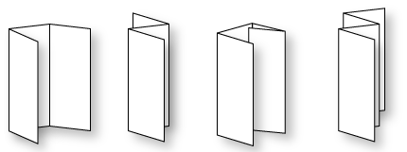

Individually, you will design a brochure describing a common cardiovascular disorder. Brochure must include:
- Overview and facts (and possibly what the condition may result in)
- Signs and Symptoms
- What factors may cause the condition
- Diagnosis and Tests
- Treatment and Care
- Living and Managing
- Stats (preferably Canadian)

- You will need to be concise to fit this all on a standard size (8.5 X 11) paper.
- You will be graded on accuracy, brevity and completeness as well as overall aesthetics and layout.
- You will still need to cite a minimum of two sources (not wiki) but these may be on a separate sheet.
Some suggestions for topics:
Atherosclerosis Congenital Heart Disease
Hypertension Varicose Veins
Heart Attack Arrhythmias and Conduction Disorders
Stroke Marfan Syndrome
Pericarditis Coronary Artery Disease
Lymphatic Disorders Heart Murmur

Rubric
 | 4 | 3 | 2 | 1
Accuracy | All information is accurate | Almost information is accurate | Some information is accurate | Information appears to be more opinion than fact
Concise | All information delivered clearly and concisely. | Most information delivered clearly and concisely. | Some extraneous information that does not contribute to overall point being made. | Too many points. Points too long for brochure style Brochure crammed with needless information
Elements present | All elements present | Most elements present | Some elements present | Missing many elements
Overall layout | Brochure is eye catching, interesting, aesthetically pleasing, good use of space. | Brochure aesthetically pleasing, good use of space. | Brochure is easily read. | Brochure appears crowded or not enough space filled in.

