Graphing Notes
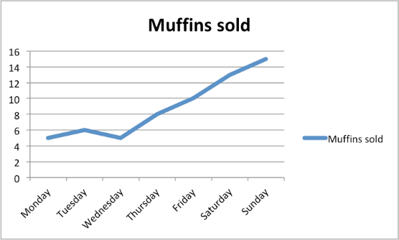
Types of Graphs:
- Line Graphs are used to indicate trends over time and trends.

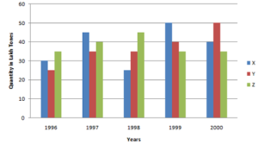
- Bar graphs are usually used to compare groups. Data does not need to be continuous.

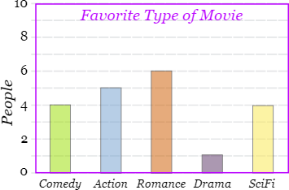

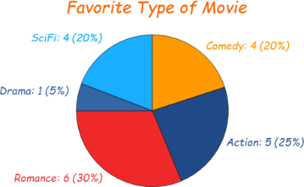
- Pie charts are best to use when you are trying to compare parts of a whole. They do not show changes over time.

NINE COMMANDMENTS FOR MAKING A GRAPH:
- MAKE IT BIG. Graph must take up a minimum of half a page.

- Use GRAPH PAPER.

- Use a RULER to draw the x and y axis.

- TITLE
- concise but descriptive, indicating what the graph is about.
- Don’t just say “distance vs time”.
- Placed above the graph.
- LABEL EACH AXIS, with UNITS
- Dependent (Responding) Variable on the Y-axis (vertical). (DRY)
- (Manipulated) Independent Variable on the X-axis, horizontal (eg. time, temperature, distance). (MIX)

- PROPER SCALE.
- Decided by your minimum and maximum data points for each variable
- Does not have to start with zero.
- X and Y scales may be different from each other.

- INTERVAL
- Decided by your scale
- Subtract and divide by how spaces you have
- 1, 2, or 5 squares are easiest to work with
- X and Y do not need to be the same
- Must be consistent (not change within the graph)

- Connect the dots or draw a “BEST FIT LINE” for a Line Graph.
Colour in you bars for a bar graph.

LEGEND if using more than one data set, use multiple symbols/colours.
TAILS, DRY MIX

