Sci 8 Name:
Mo’ Worksheet Block:
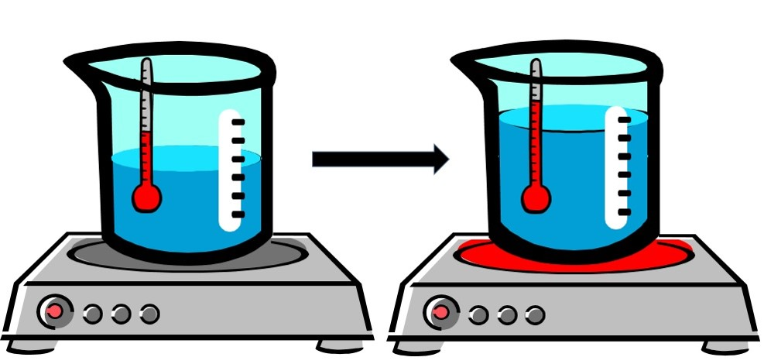

- What is the term used to describe the RISE IN FLUID LEVEL in the beaker in the above image when it is heated?

- In your own words, define the term thermal expansion.

- Describe what’s happening to the air particles inside a balloon in terms of spacing and energy to explain why a balloon in a hot car can expand and eventually pop?

- Why does running a jar under hot water make it easier to open?

- Using the terms thermal expansion and thermal contraction, explain the function of expansion joints in bridges.

- The Eiffel Tower in Paris is 324 meters tall. Would you expect it to be taller or shorter on a hot day?

- What is the difference between a PURE SUBSTANCE and a MIXTURE?

- What is the difference between an ELEMENT and a COMPOUND?

- Describe the two types of mixtures.

- Label each of the following as either PURE substance, COMPOUND, or Mixture.

- Create a mind map of Matter Classification using the following words: Matter, pure substance, mixture, compound, element. Give an example of each.
