Sci 8 Name:
Mo’ Worksheet Block:
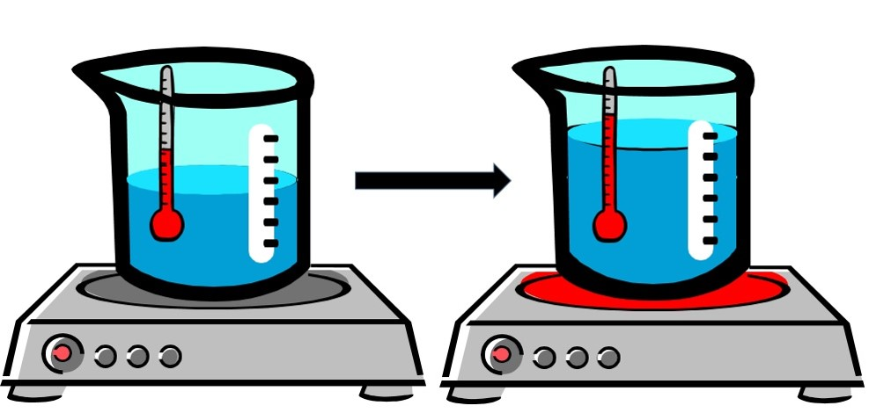

- What is the term used to describe the RISE IN FLUID LEVEL in the beaker in the above image when it is heated? Thermal Expansion

- In your own words, define the term thermal expansion. A substance (solid, liquid or gas) expands due being heated. The heat gives the particles in the substance more energy, causing them to move faster and farther apart, which causes the expansion.

- Describe what’s happening to the air particles inside a balloon in terms of spacing and energy to explain why a balloon in a hot car can expand and eventually pop? The hot air in the car heats up the particles inside the balloon, giving them more energy, causing them to move faster and further apart (thermal expansion).

- Why does running a jar under hot water make it easier to open? Running hot water over the lid, but not the jar, causes the lid to expand, making it loser.

- Using the terms thermal expansion and thermal contraction, explain the function of expansion joints in bridges. During the hot summer, the particles of the bridge move faster and further apart causing it to expand (thermal expansion). During cold weather the particles lose energy and slow down, causing thermal contraction. Because the bridge is so large the expansion and contraction can be quite noticeable. Expansion joints are spaces in sections of the bridge that allow sections to expand without hitting the next section (avoids buckling).

- The Eiffel Tower in Paris is 324 meters tall. Would you expect it to be taller or shorter on a hot day? Taller due to thermal expansion.

- What is the difference between a PURE SUBSTANCE and a MIXTURE?
Pure substance is made up of only ONE TYPE of particle.
Mixture contains MORE than one type of particle.

- What is the difference between an ELEMENT and a COMPOUND?
Element is a pure substance that cannot be broken down into anything simpler.
Compound is a pure substance of more than one element chemically bound together. Can be separated by chemical means.

- Describe the two types of mixtures.
Mixtures – more than one type of particle NOT chemically combined:
Homogeneous mixture – looks the same throughout. Sugar and water.
Heterogeneous mixture – can visually distinguish the different types of particles eg. salad

- Label each of the following as either PURE substance, COMPOUND, or Mixture.

- Create a mind map of Matter Classification using the following words: Matter, pure substance, mixture, compound, element. Give an example of each.
