Sci 8 Name:
Thermal Expansion Worksheet Block:
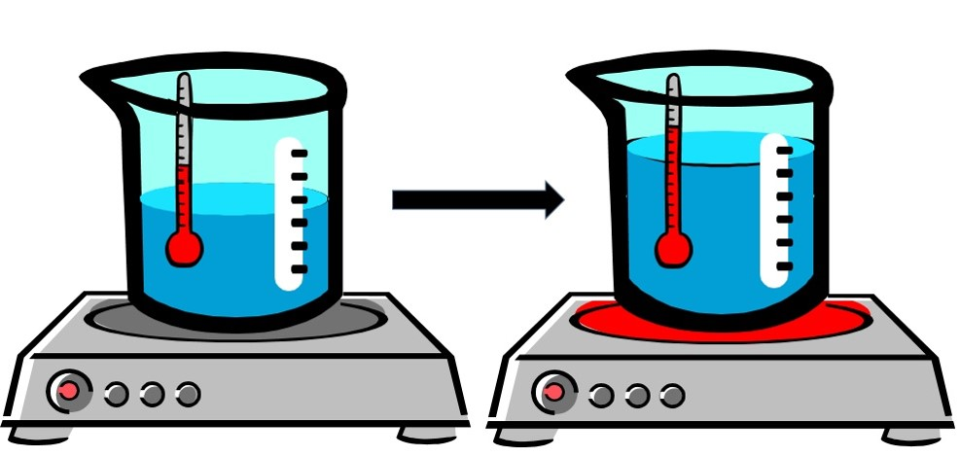

- In your own words, define the term thermal expansion.

- In terms of SPACING and ENERGY, describe what’s happening to the air particles inside a hot air balloon that enables it to rise.

- Why does running a jar under hot water make it easier to open?

- The Eiffel Tower in Paris is 324 meters tall. Would you expect it to be taller or shorter on a hot day?

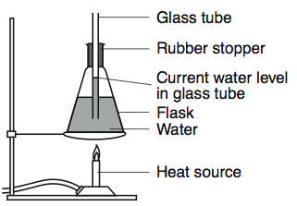 | - If the flask on the left were heated, what evidence would indicate the water expands?  Explain your answer using KMT.
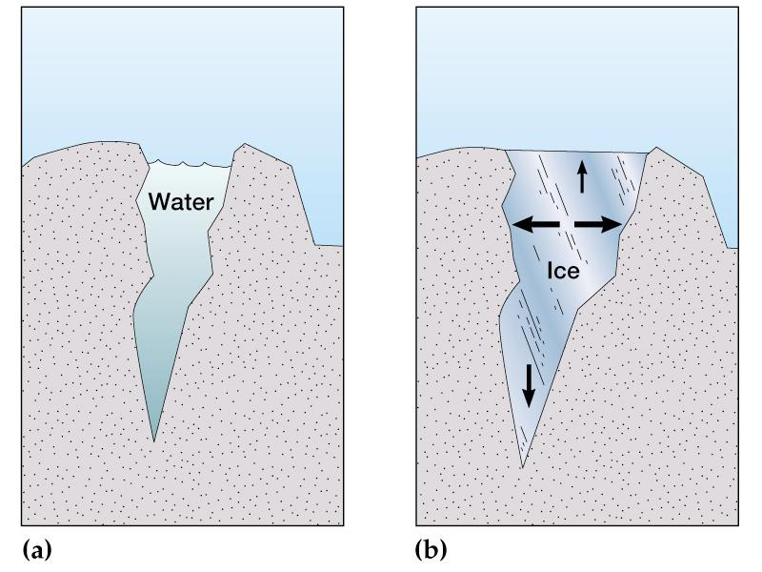 | - Explain using the word volume, how a small amount of water can break rock over time.
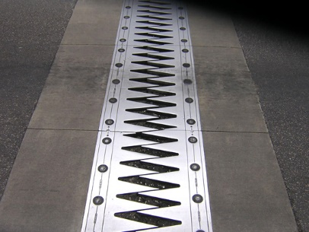 | - What structure is this and why is it important for bridges?

- Water on Earth is constantly being cycled from water vapor in the atmosphere which then falls down as precipitation, collecting in rivers, lakes and oceans and then evaporating back up to the atmosphere again. A significant amount water in the form of ice and snow in the polar ice caps remain frozen year round. What would happen to the ocean levels if these stored sources of water were to melt?

- The average elevation of most areas of New Orleans is 1-2 feet below sea level. Parts of Richmond are at 0 m above sea level. These cities must maintain dykes and levees (embankments) to prevent flooding. What might happen to these cities if the ocean levels rise a few feet?

