Electrical Circuit Symbols
Symbol | Component | Function
- Electrical source
- Longer side is the positive side
- The shorter side is the negative side
 |  | - Opens and closes the circuit
 |  | - Measures voltage through a device
 |  | - Measures current through a device
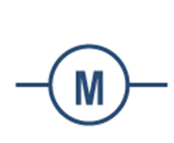 | - Motor | - A type of resistor
 | - Lamp | - Specific load  - Converts electricity to heat and light
 | - Resistor | - General load  - Converts electricity to heat
- Conductor
- Allows electrons to flow

