Name:___________________
Date: ___________________

Air Masses and Fronts

- What is an air mass?_________________________________________________________
______________________________________________________________________________________________________________________________________________________________________________________________________________________________
- Scientists classify air masses according to_________________________________ and
_________________________________________.
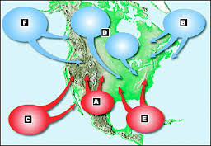
- Use the picture below to fill in the table. Write down the characteristics of the type of air mass shown.

Characteristics (temperature and moisture)
a. | d.
b. | e.
c. | f.

- How are the air masses labeled “C” and “F” in the picture above alike and how are they different? ________________________________________________________________
______________________________________________________________________________________________________________________________________________________________________________________________________________________________
- __________________________air masses form in the tropics and have low pressure.
- Air masses that form over oceans are called _______________________air masses.
- The area where air masses meet and do not mix becomes a(n) _______________________
- _____________________________air masses form over land, in the middle of continents.
- A swirling center of low air pressure is called a(n)________________________________.
- ___________________________________________are high-pressure centers of dry air.

- Label the drawings to indicate a cold front and a warm front.
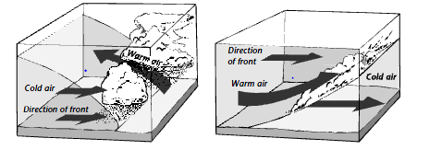

a. ______________________ b. ___________________________

17. Complete chart on type of weather each front will bring:
WeatherPatterns
Type of Front | Symbol | Weather
Cold front
Warm Front
Stationary Front
Occluded Front

18. Which type of front…
A. Brings violent thunderstorms? __________________________
b. Is associated with clouds and rain? ___________________________
c. Brings many days of clouds and precipitation? ____________________
d. Brings fair weather? ________________________________

18. Winds spiral____________________________ toward the center of a cyclone.
- What type of weather is associated with low pressure systems?______________________
__________________________________________________________________________
- Winds in an anticyclone spin ___________________________ in the Northern Hemisphere.
- What type of weather is generally associated with high pressure systems? ______________
__________________________________________________________________________

