Microscope Lab #2 PREPARing A WET MOUNT, comparing PLANT CELL vs Animal cell

Part A: wet mount, SCIENTIFIC DRAWING
Materials: Microscope, glass slide, coverslip, onion, forceps, dropper, iodine, paper towel

Procedure:

- Prepare a WET MOUNT of a small piece of onion by peeling a very thin layer of onion skin off the inside of your onion
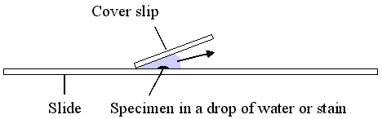
- Place the onion layer on a slide, then add a drop of water and a drop of iodine. Careful: Iodine will stain your clothes.
- Carefully place a cover slip over top of the sample at a 45-degree angle to reduce the amount of bubbles.
- Touch the edge of a paper towel to the edge of the cover slip to absorb any liquid that is outside of coverslip.
- Find and focus on a single layer of onion cells on low power. Then increase to higher power.
- Make a Proper Scientific Drawing of a few onion cells (5-10 together) under High Power.
- Label cell wall and nucleus

Specimen: ____________________

Total Magnification: _____________

- Extending: Remembering the diameter of the Field of View from the last lab, estimate the length of one onion cell.
Length of one onion cell: _________________mm

PART B: OBSERVING PREPARED SLIDE OF ANIMAL CELL
- Obtain a prepared slide of a blood smear or muscle tissue. View under high magnification. Note the difference in the size and shape of a blood cell as compared to the onion cell.
- Draw a few cells under highest power:

Specimen: __________________

- Extending: Estimate the size of a blood cell: ____________ mm.

Questions:
- When preparing a wet mount, how do you prevent bubbles under the coverslip?

- What types of specimens would require wet mount?

- What is the purpose of the coverslip in a wet mount?

- Compare plant and animal cells in terms of size that you saw under the microscope (hint: how much space does your specimen fill when viewed at the same magnification)

- Compare plant (onion) and animal cell (paramecium or blood cell) in terms of shape that you saw under the microscope.

- Name an organelle that you would expect to find a plant cell which makes the cell green but that would not be found in an animal cell.

- Name the process that occurs in this organelle.

- Write the WORD equation for this process.

