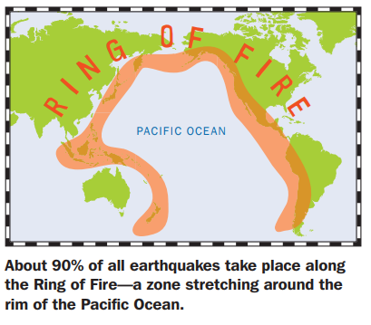
Building for Earthquakes
Intro
Hundreds of millions of people live in places around the world where earthquakes are common. Most of the destruction earthquakes cause is the result of collapsing structures, like skyscrapers, hospitals, and bridges. That’s why earthquake engineering is so important. By designing buildings and other structures that can withstand the violent shaking of an earthquake, engineers save lives.
Two major causes of earthquake damage are 1) the intensity of the shaking ground and (2) the quality of the building and structures.
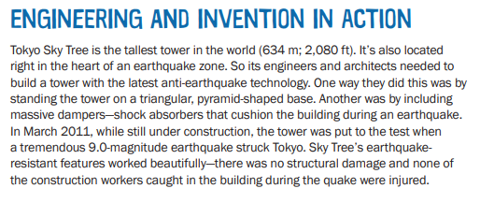
Sometimes moderate earthquakes cause lots of destruction; other times a massive earthquake cause only minor damage – it depends on whether the buildings in the earthquake zone are well designed. That’s why earthquake engineering is so important. While we can’t control eathquakes, we can build better structures that can survive the violent seismic shaking. Engineers all over the world are inventing new ways to design skycrapers, hospitals, schools, and bridges that can withstand earthquakes – saving lives and preventing billions of dollars in damage. But earthquake-safe buildings are expensive – many poorer countries don’t have the financial resources to build them.
As engineers you will desgin and test a “structure” that can withstand an earthquake.

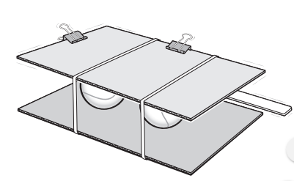
SET UP YOUR OWN EARTHQUAKE SIMULATOR:
Testing will take place on a shake table that you will also construct.
Gather the following materials:
- 2 equally sized pieces of cardboard (These must be larger than the size of the structure you will build so that the structure can rest on it.)
- 4 marbles
- 2 large rubber bands
- Device with the Science Journal app
- Tape
- One of you will need to download the Science Journal App from Google: https://www.sciencebuddies.org/science-journal-app
Evenly place the rubber bands around the two pieces of cardboard. Squeeze the marbles in between the two pieces of cardboard as evenly distributed as possible. If you tug on one of the cardboard pieces, it should shake.
You now have your earthquake simulator! The structure you build will go directly on top to test its earthquake readiness.
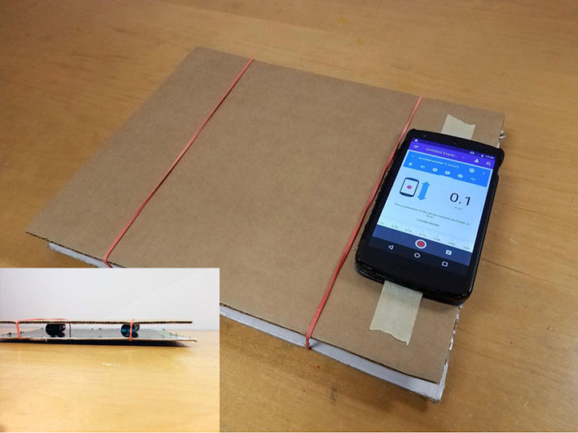
Next, tape your device with the Science Journal app onto the top surface of your earthquake simulator. Make sure to leave plenty of room for the structure you will create. Your setup should look similar to the image below:
Make sure the Science Journal app is measuring acceleration in the appropriate direction and give it a test. You should be able to get at least 6 m/s2 (meters per second squared) worth of vibration from your simulator.

DESIGN AND BUILD YOUR STRUCTURE:
Your structure must be at least 8 inches (20cm) tall. How will you make a sturdy frame that won’t collapse when you shake it? Sketch your ideas on a piece of paper.
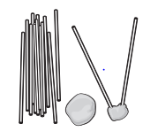
Design features to consider:
- Focus on building a sturdy base before adding height to your structure. A wide, firmly anchored base works best. Make sure each part of the base is connected to one or more other parts.
- Triangles are stronger than rectangles and squares because all three sides of the triangle carry some of the load (weight).
- Adding diagonal supports that reach from one corner of a square to the other turns the square into triangles, making it a stronger shape.
- Dampers help reduce the amount of sway.
- Cross braces help keep the building from breaking.
- Tendon systems under the building help reduce sway.
- Base isolators absorb energy.
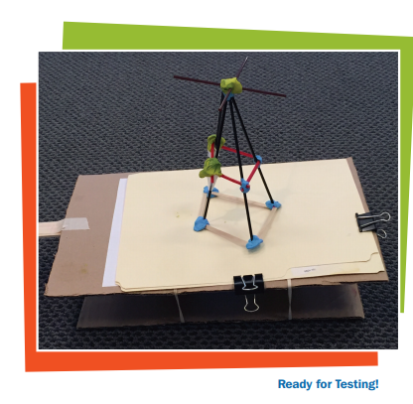
Test your design:
- What did testing help you understand about your structure?
- What are the strengths of your design?
- What are the weaknesses?
- How safe would you feel if you were inside your structure during an earthquake?
- What could you do to make your structure even better at withstand an earthquake?

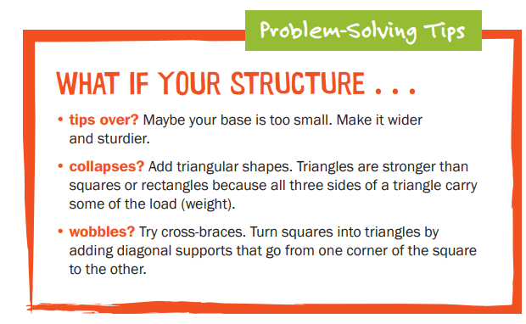
Evaluate and Redesign:
- Did your structure wobble, sway, tip over, or collapses?
- What do you need to do to make your structure more stable?
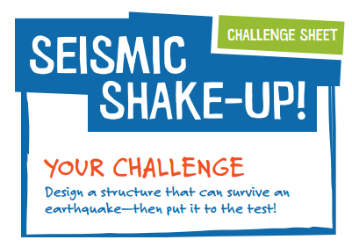
- Can you make it taller?
ES 11 Building for Earthquake Challenge Name:
Partners:
- What are some elements engineers need to consider when designing a building for earthquakes?

- What did testing help you understand about your structure?

- What are the strengths of your design?

- What are the weaknesses of your design?

- How safe would you feel if you were inside your structure during an earthquake?

- What were some of the ways you made your structure strong and stable?

- What do you think is the best feature of your design? Why?

- If you had more time, what design changes would you add to make your structure even more stable?

- Name one thing that YOU did that you are proud of in this project.

- Name one thing you felt you specifically could have done better.

