The Great Quake and the Great Drowning
Go to: https://www.hakaimagazine.com/ Or reading the following:
In the year 1700, on January 26, at 9:00 at night, in what is now northern California, Earthquake was running up and down the coast. “His feet were heavy and when he ran he shook the ground so much it sank down and the ocean poured in. The earth would quake and quake again and quake again,” said the Yurok people. “And the water was flowing all over.” The people went to the top of a hill, wearing headbands of woodpecker feathers, so they could dance a jumping dance that would keep the earthquake away and return them to their normal lives. But then they looked down and saw the water covering their village and the whole coast; they knew they could never make the world right again.
That same night, farther up the coast in what is now Washington, Thunderbird and Whale had a terrible fight, making the mountains shake and uprooting the trees, said the Quileute and the Hoh people; they said the ocean rose up and covered the whole land. Farther north still, on Vancouver Island, dwarfs who lived in a mountain invited a person to dance around their drum; the person accidentally kicked the drum and got earthquake-foot, said the Nuu-chah-nulth people, and after that every step he took caused an earthquake. The land shook and the ocean flooded in, said the Huu-ay-aht people who are part of the Nuu-chah-nulth, and people didn’t even have time to wake up and get into their canoes, and “everything then drifted away, everything was lost and gone.”
Here’s what geologists say: the earthquake that almost certainly occurred on the night of January 26, 1700, ruptured North America’s Pacific Northwest coast for hundreds of kilometers, from northern California, through Oregon and Washington, to southern Vancouver Island. Along this coast, the Juan de Fuca plate was pushing under the larger North American plate, had gotten stuck—locked—but kept pushing until it released, abruptly and violently. The earthquake that resulted was probably a magnitude 9, about as big as earthquakes get. The coast dropped by as much as two meters, and a tsunami brought floods more than 300 meters inland.
Geologists now know that the Pacific Northwest has been having these earthquakes and tsunamis irregularly every 500 years or so; their oldest record in sediments goes back at least 10,000 years. The evidence is massive: subsided marshes, drowned forests, sediment layers showing enormous landslides that flowed out on the ocean floor, seismic profiles of the Juan de Fuca plate, and satellite measurements of a coast deforming from the stress of a plate that’s once again locked. In the next 50 years, the chance of another magnitude 9 earthquake there is 1 in 10.
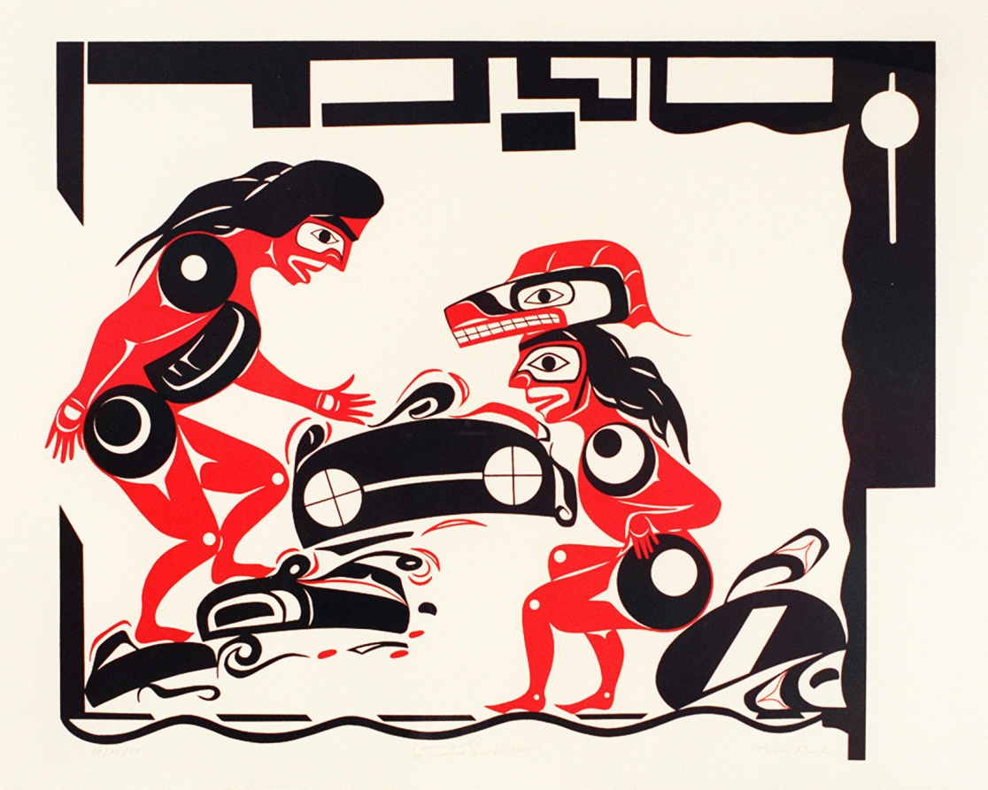
On Vancouver Island, the Nuu-chah-nulth people told tales of mountain dwarves inviting a person to dance around their drum. When the person accidentally kicked the drum—depicted in the illustration above by Nuu-chah-nulth artist Tim Paul—he got earthquake foot and his steps set off vast tremors. Image courtesy of the Royal BC Museum and Archives

In the cities of the Pacific Northwest, the impact will be terrible. Many buildings were built before architects knew the area had earthquakes; later buildings were built with short, sharp California earthquakes in mind, not the Northwest’s longer, larger ones. “The ground’s going to shake for three minutes,” says Thomas Heaton, geophysicist at the California Institute of Technology and one of the first to propose the area’s earthquake potential. “And [in simulations] it’s easy to come up with ground motion that would collapse tall buildings.” Then comes the tsunami, and “with magnitude 9 earthquakes,” says Heaton, “you always get tsunamis.” Governments of course know this: seismic networks and a tsunami warning system are in place; governments and institutions in the Pacific Northwest have emergency plans, are educating the public in how to respond, and have published evacuation maps; buildings and bridges that fail to meet the modern earthquake building codes are being retrofitted.
But all this—the governments’ plans for the next earthquake and geologists’ understanding of the ancient ones—happened only in the last few decades. For the same 10,000-plus years that the Pacific Northwest has been having the earthquakes, indigenous groups have been living there. They have known forever that what the ground did was sudden and violent, that it came accompanied with catastrophic floods, and that it made people die. The questions for us, living in the present, are obvious. What was it like? And what was the impact of millennia of repeated catastrophes on the indigenous groups of the region? The answers seem obvious too, but they aren’t; this turns out to be a story about stories—how they merge into histories, how fragile they are, and how urgent.
What the indigenous people knew all along, geologists have known only since 1984. Thomas Heaton was still in college in 1970 when geologists, who knew that the world’s largest earthquakes occurred where one tectonic plate descended under another one, first recognized that one of these subduction zones ran between the Juan de Fuca and North American plates. But the so-called Cascadia Subduction Zone had no record of ever producing large earthquakes. So, says Heaton, “they thought it was aseismic, just creeping.”
Then in the early 1980s, the US Nuclear Regulatory Commission (NRC) was considering whether to locate nuclear power plants in Washington and Oregon, and, just to be sure, asked the US Geological Survey (USGS) whether the Cascadia Subduction Zone was safe from earthquakes. Heaton, then at the USGS, knew about subduction zones because he’d consulted for Exxon on oil platforms in earthquake-prone Alaska. He compared the Cascadia zone with known earthquake areas and told the NRC, “Well, maybe it is aseismic (no seismic activity), but another interpretation is, it looks like Chile—which is also aseismic, except for the big ones.” Perhaps, Heaton suggested, the Cascadia zone had escaped earthquakes only because it was currently locked.
Heaton published his surmise in 1984, and within a few years, Brian Atwater, also at the USGS, and other geologists found evidence of moving ground and great floods. But building geological evidence into a credible theory can take decades, and in the meantime, a colleague of Atwater’s and Heaton’s named Parke Snavely had been reading stories from the Makah people in Washington that described what sounded like floods. One Makah story in particular resembled the 1700 tsunami. “A long time ago but not at a very remote period,” the story began, the ocean receded quickly, then rose again until it submerged Cape Flattery; canoes were stranded in trees and many people died.
Snavely told Heaton about the stories, and the two of them did something un-geoscientific: they decided to take the Makah story not as myth, but as history. That is, they assumed the Makah were describing a geologically-recent tsunami, compared the Makah narrative with their understanding of Cape Flattery’s geology, found the similarity between story and geology “noteworthy,” and published their findings in the scientific literature. After that, other scientists also went looking in the stories for history. A team of anthropologists, geologists, and indigenous scholars led by geologist Ruth Ludwin of the University of Washington took 40 stories collected from native groups along the entire Cascadia Subduction Zone. They compared the narratives to what was known of the 1700 earthquake and tsunami, and found in effect, that the whole coast had been telling stories about it.
Alan McMillan and Ian Hutchinson—archaeologist and geographer, respectively, from Simon Fraser University in British Columbia—found other stories, most of them undateable, that were probably about other, even earlier earthquakes. The two scientists systematically plotted these coastal stories on a map of the archaeological and geological evidence of all Cascadian earthquakes and tsunamis. Along the coast—from the Yurok and Tolowa in northern California, the Tillamook in Oregon, the Quileute in Washington, to the Nuu-chah-nulth on Vancouver Island—were stories of Earthquake, Thunderbird, and Whale, or the mountain dwarfs and their earthquake drum. The Cowichan people on Vancouver Island, the Squamish in southern British Columbia, and the Makah in Washington each had stories about the earth shaking so violently that no one could stand, or the houses falling apart, or rockslides coming out of the mountains and burying villages. The Nuu-chah-nulth, like the Makah, told stories of the ocean receding suddenly, then flooding back powerfully and killing many, many people.

From the Tolowa people in northern California: one autumn, the earth shook and the water began rising. People began running and when the water reached them, they turned into snakes. But a girl and a boy from the village, both adolescents, outran the water by running to the top of a mountain where they built a fire to keep themselves warm. After 10 days, they went back down and the houses they lived in were gone, all that was left was sand, and all the people and animals were lying on the ground dead. The boy found food for the girl and then set out to look for people and a place to live. But the only people he found were dead ones. The boy came back and said he could find no one else for either of them to marry, so they’d better marry each other. They built a house and after a time, had babies. And many years and many generations later, there were many people who were “scattered everywhere and in every place there was a man living with his wife.”

Many scientific papers say that the indigenous stories are reasonable records, covering an unknowable amount of time, of earthquakes and tsunamis along the entire Cascadia Subduction Zone. They also add that so much destruction repeated for so long must have had a terrific impact on the indigenous groups’ worlds—that given their history, the indigenous people of the Pacific Northwest would have taken catastrophe to heart. You might expect that they’d arranged their culture and lives around disaster. And further, you might hope that the impact on them would have some message, some advice, for us in the 21st century, waiting for our own disaster. But here’s where this storyline goes cold. Any such impact ought to show up in archaeological and anthropological evidence and it just doesn’t.
The people must have lost their houses and villages and livelihoods, they must have been ruined; but afterward they went back to living in the ruined places. McMillan went looking in the archaeological record for evidence of habitation and abandonment over the past 3,000 years in 30 excavated villages along the Washington and Vancouver Island coasts. “The seismic events were catastrophic but short term,” McMillan says. “The evidence is all that the sites were reoccupied afterward.”

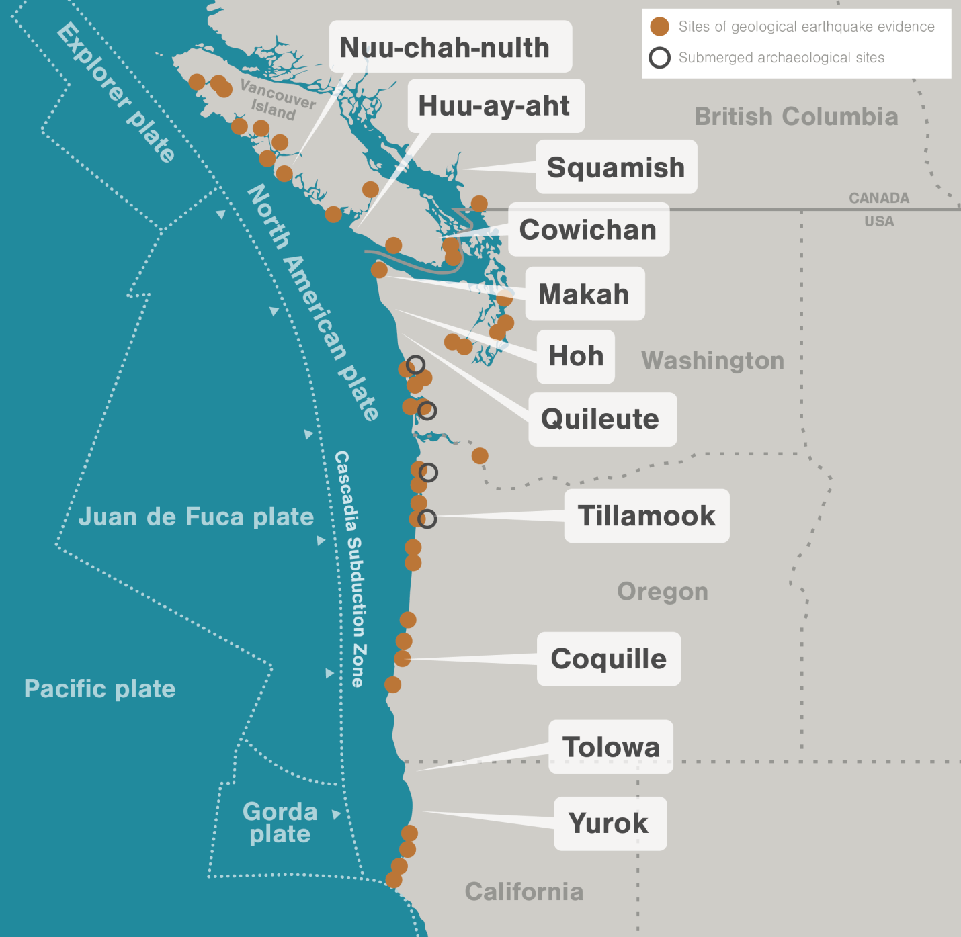

Nor did the people ultimately change the ways they lived. Robert Losey, an anthropologist at the University of Alberta in Edmonton, looked for evidence that after the 1700 earthquake the Tillamook people of Oregon changed what they hunted, what they ate, how their houses were built, and where they lived. “In the short term, the earthquake must have been horribly traumatic,” Losey says. But in the long term, “I don’t think it made a difference.”
Anthropologists and archaeologists seem to agree that not only was it normal to return to the life you already know how to live, but, as Losey says, it was also reasonable. The catastrophes came generations apart. The food that was gathered and hunted apparently rebounded quickly. And the architecture designed for seasonal mobility was generally single-story, made of flexible wood tied with cord, and might as well have been built to modern earthquake codes. “The First Nations did an entirely human thing,” Losey says. “They went right back and settled in harm’s way.” The Pacific Northwest turns out to be, in the long run, a place conducive to resilience.

So the clearest evidence of the impact of earthquakes and tsunamis on the coast’s indigenous people has to be in the stories. Maybe the stories explain how to be resilient, how to outsmart disaster. Maybe they warn the children to warn their own children. The 2004 Indian Ocean earthquake that killed 200,000 people in the Indonesian province of Aceh, killed only seven of the 78,000 people living on the island of Simeulue because the Simeulueans had been telling stories for generations of what to do during tsunamis. That may well have been the case in the Pacific Northwest, but the fact is, nobody knows for sure.
The reason is, the indigenous people of the Pacific Northwest didn’t write down their earthquake stories; the stories were told only face to face. And apparently they’re not told much, if at all, any more.
The only stories that we know for certain still exist are the ones collected and written down by ethnographers—the Yurok stories by A. L Kroeber, for instance, or the Makah stories by Judge James Swan—a century and more ago. Deborah Carver, an independent scholar, followed up the collected Yurok stories by tracking down the descendants of one storyteller and asking if they had heard the stories. “Nobody in the present had,” she says, except for one guy and his grandmother.
David Lewis, an anthropologist, independent scholar, and a member of the Grand Ronde tribe, never heard the old stories growing up, “only in my adult life,” he says, “since I’ve been working for the tribe.” And when someone did tell the stories, it was only “because I asked.” So the existing stories have the same caveats that archeological artifacts do: they’re incomplete, depend on what happened to be collected, and may not accurately represent the folklore at all.
The stories are incomplete in another, more fundamental, way: stories not written but told depend on having a culture that keeps telling them. In the late 1700s, Europeans began turning up regularly in the Pacific Northwest, bringing with them waves of epidemics, most notably smallpox. Since no one knew how many indigenous people lived there then, no one knows for sure how many died, but the estimates are shocking: they range from 30 to 95 percent.
Later Europeans continued what disease began. They wanted the coastal land, the fur of its animals, and the gold underneath it, and thus began the long indigenous history of resettlement onto reservations, re-education in government- and church-run boarding schools, and outright slaughter in warfare. Whatever the motives or intents of European explorers, government agents, fur traders, gold miners, and educators, their result was cultural scorched earth. Jason Younker is an anthropologist at the University of Oregon and a member of the Coquille tribe: growing up, he explains, “my father said to forget what I knew about being Coquille because it will do you no good.”
Kill the culture and the stories die. “If you think about the history of First Nations in the last couple hundred years,” says Losey, “huge amounts of the population were lost even before ethnographers could get to them. We have no idea how many stories existed—ethnographers published a few thousand—but certainly [there were] far more than were written down.” Ruth Ludwin, the geologist at the University of Washington who collected earthquake and tsunami stories, wrote that 95 percent of the stories were lost.

But even in the few stories that are left, earthquakes and tsunamis are still so vivid that the complete range of stories must have been full of them. “There was a great storm and hail and flashes of lightning in the darkened, blackened sky, and a great and crashing ‘thunder-noise’ everywhere,” said the Hoh people of Washington. “There were also a shaking, jumping up and trembling of the earth beneath, and a rolling up of the great waters.”
Younker himself had heard at least one of the stories. He was about to leave home to begin a decade of graduate work in anthropology when his uncle took him to Sundown Mountain along the Oregon coast, and up to a high plateau, where they watched the fog coming off the ocean and moving up through a river valley. “You see, Jason, how the fog is coming in?” the uncle said, and told him a story. Not all that long ago, a great tide came in the same way, the water rushed up the valleys, drowned the villages, and covered the trees. Some people climbed into their canoes, along with long ropes they’d prepared, tied themselves to the tops of the trees, and rode out the flood. The people who hadn’t prepared long ropes were swept away and were never seen again. Younker thinks his uncle told him that story partly so that Younker could tell even younger people how to prepare, and partly to say, “make sure you keep your ropes long and your connections to home are well-maintained so you can pull yourself back to home. Because you really can’t separate the past from the present.”
Robert Dennis, Chief Councillor of the Huu-ay-aht First Nation in British Columbia, had also heard stories. When he was 11 or 12 years old, he used to visit his great-grandfather, who’d been chief of the Huu-ay-aht for decades. “He’d say, ‘I’m going to tell you things that might be important in your life, and this could happen again.’” One of his stories was about his great-grandfather who lived at Pachena Bay, on the west coast of Vancouver Island. One night the land shook, and a big wave smashed into the beach, and the people who lived on the bay were all killed. But the people who lived on high ground, the water couldn’t reach them, and they came out of the tsunami alive. Dennis thought his great-grandfather told him this story so Dennis could someday tell the story himself and because he also would be a leader responsible for his people. So years later when the Huu-ay-aht were planning a community center, they first consulted their elders, then they built the center not down in the flats but up on high ground. Now they have to stock it with food and emergency gear and keep it stocked. “I’m not going to rest,” says Dennis. “I’m going to keep pushing it. So we’re ready.”
The ground moves and doesn’t stop moving, and almost no one survives the tsunami. So get off the beach. Go up into the hills. Build on high ground. Tie your boats with long ropes. Make sure your children know, as Robert Dennis’s great-grandfather said, that this is “what this land does at times.” And don’t bother trying to separate the present from the past.

