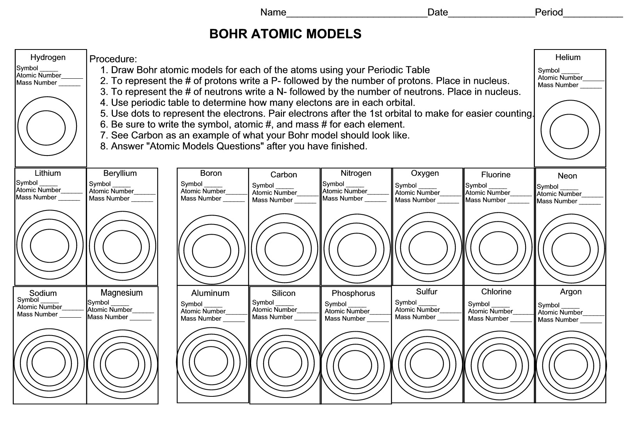

Questions:
- Which elements had complete outer shells? Give name and symbol for each. ________________________
- What do you notice about the location of those elements? _______________________________________
- Which elements had only one valence electron? Give the name and symbol for each. __________________
- What do you notice about the location of these elements? _______________________________________
- What do you notice about the number of valence electrons as you move from left to right across the row or period in the periodic table? (NaMgAlSi P S Cl Ar) ___________________________________
- What do you notice about the number of energy levels or shells as you move down a group or column in the periodic table? (H LiNa) _______________________________________________________________
- Write the name of each family at the top of the column on your periodic table using the following information:
- Alkali Metals – 1 valence electron Halogens - 7 valence electrons
- Alkali Earth Metals - 2 valence electrons Noble Gases - Complete outer shells
- Boron Family – 3 valence electrons Carbon family – 4 valence electrons
- Oxygen family – 6 valence electrons
- What do you notice about the location of the elements in each family? ______________________________
- In what family would you classify hydrogen? Explain your choice. _________________________________
- Predict the number of valence electrons for each element based on its location in the periodic table.
Barium ________ Lead _______ Bismuth _______ Potassium _________

